ST. DAVID’S PCC DISCUSSION EVENING RESPONSE 2013
WHAT NEXT ? - CONGREGATIONAL FEEDBACK

A very productive evening was held discussing various aspects of our church life. On these sheets you will find a list of some of the topics discussed many of which are already in existence and some ideas for us to consider and develop as a Parish. We also had an open discussion on what is good about St. David's and things we need to do differently. Some of the changes will take place soon whilst others will be developed in the coming months and years. We will keep you informed through the weekly bulletin as changes are introduced.

Some of the responses under the various headings are as follows.

WORSHIP

The overwhelming response from the congregation questionnaire was in favour of moving our main Sunday morning service to 10 a.m. This will happen from 22nd September we are hoping that those who said this time would be more difficult will still be able to adjust other Sunday morning commitments to be able to join us at 10 a.m. For those unable to do so we would encourage attendance at other Parish worship offered on Sundays and during the week. The majority of respondents felt this move will be of great benefit to older people and families with young children and will hopefully lead to a growth of those able to attend Sunday worship.

We have also decided from September that we will no longer hold separate Welsh services but make the 10 a.m. service bi-lingual twice a month with the inclusion of readings in Welsh and possibly Welsh hymns. This will rely on Welsh speaking volunteers offering to help us achieve this goal. This will hopefully help lead us towards a more inclusive and united Church family..

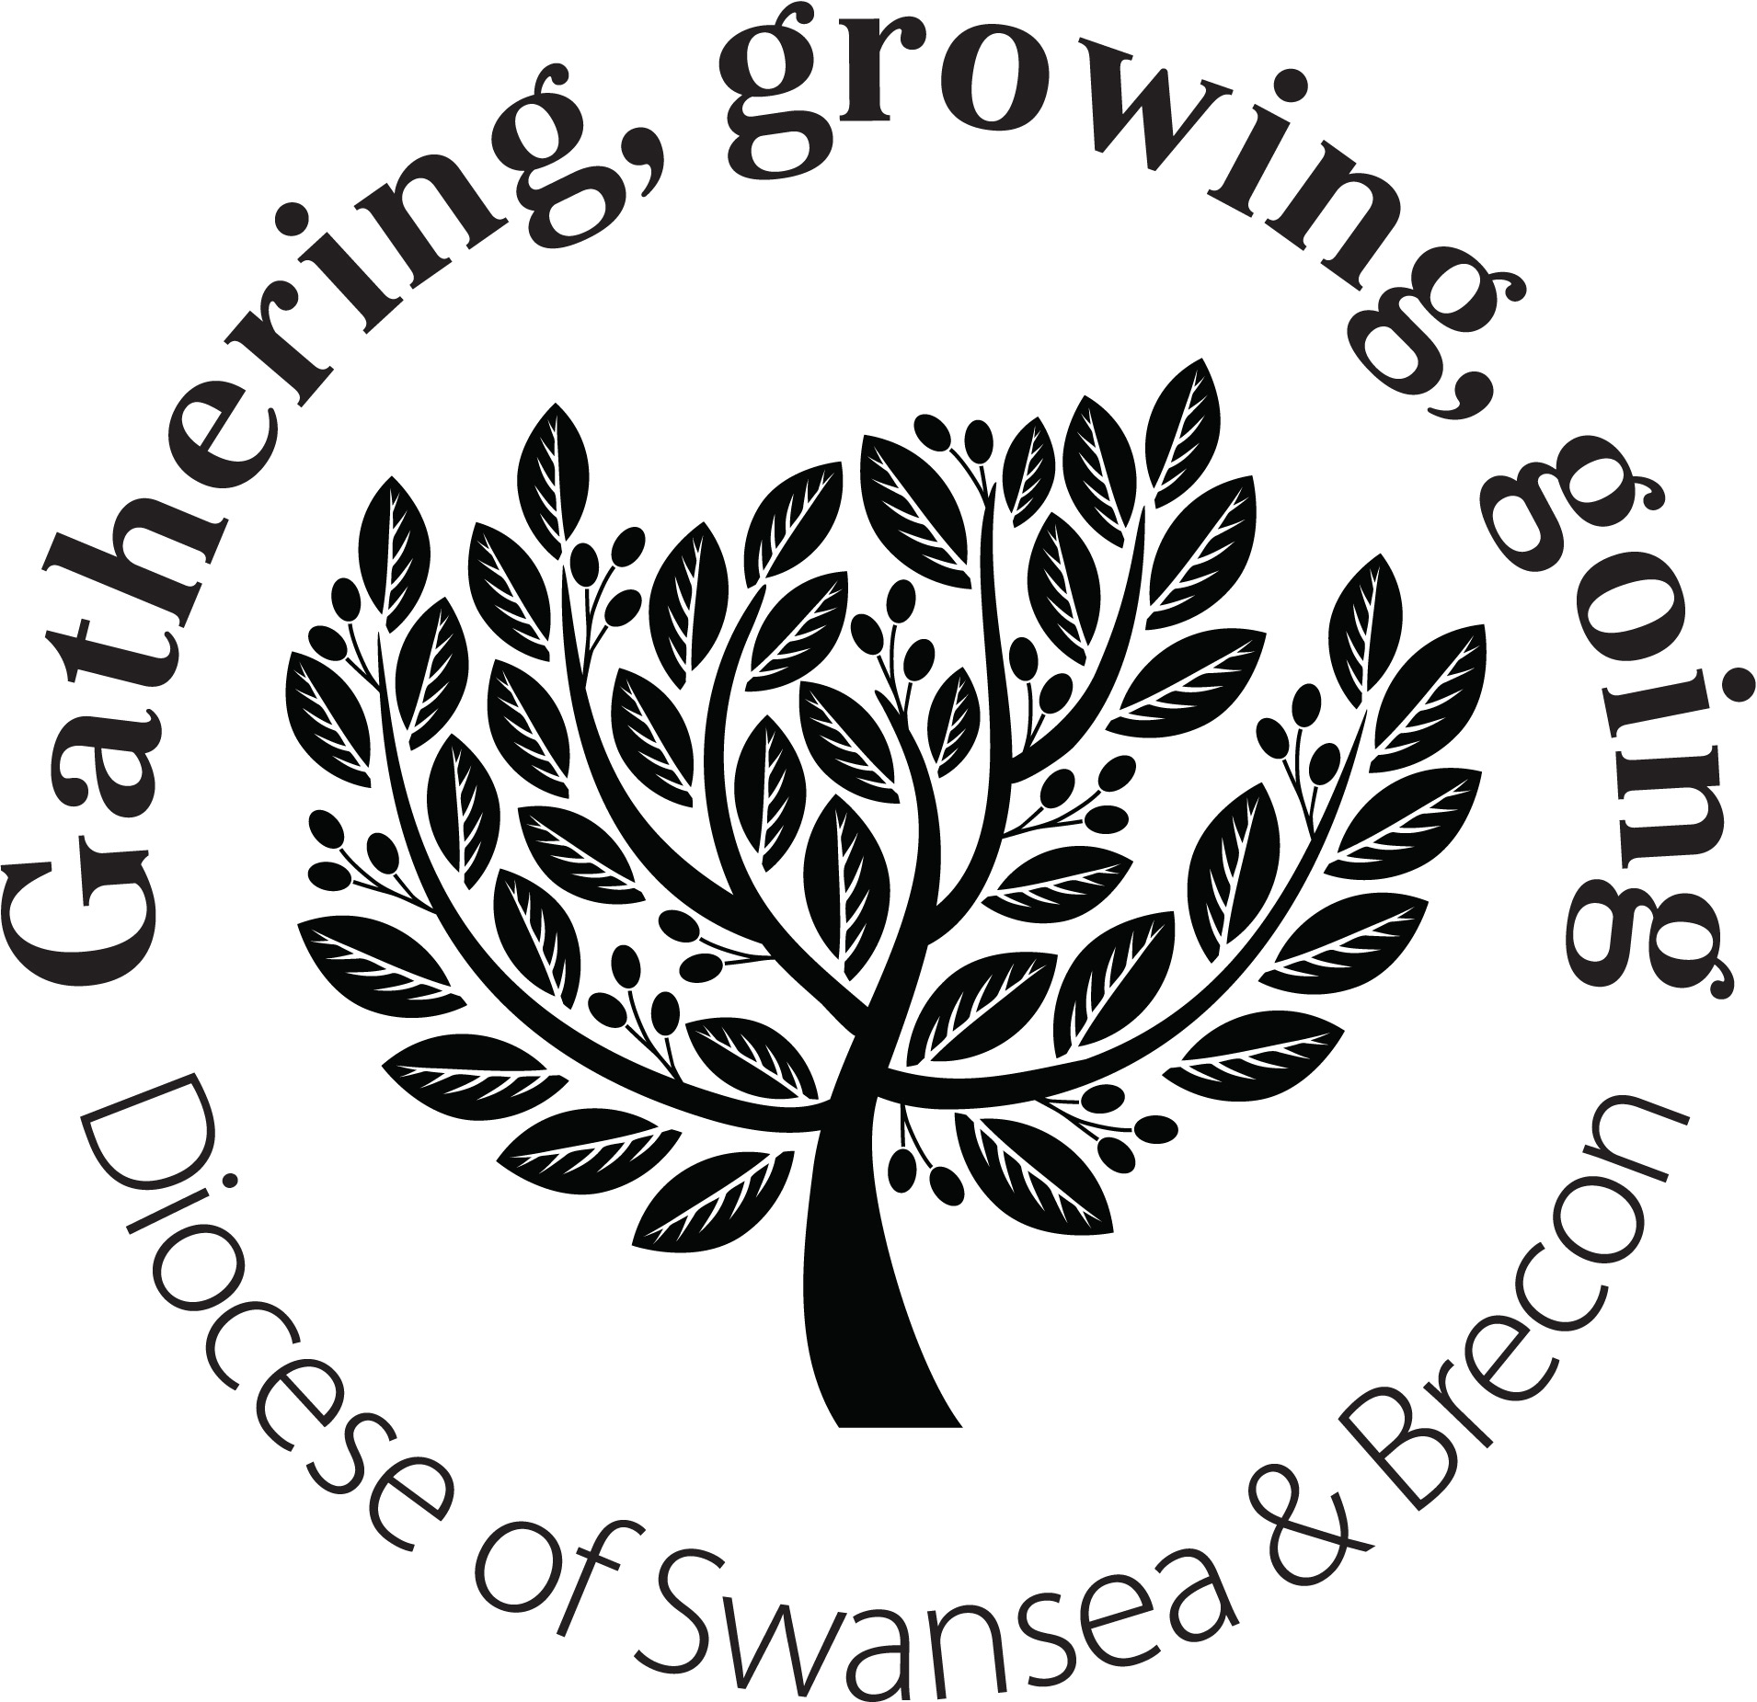
We spoke about making the monthly family service non-Eucharistic ( as for new people coming to church the Eucharist can sometimes be a difficult service as a first step into church life) and encouraging more lay involvement in our worship through leading of intercessions, lay worship leaders and the development of our lay reader ministry.

The majority of respondents to the survey said they would like to keep coffee after morning service only to the first Sunday of the month.

Discussion also took place about the service and hymn books used and the difficulties finding a service that everyone can relate to. This clearly is a very personal matter and sadly any structure put in place will please some and not others !

We would like to develop our Parish Choir ( and possibly a music group ) esp. encouraging some of our young members to join.

Discussion took place about the church entrance door and whether we need to create more space for people to come Into the church for worship. It means finding the balance between makings sure people are welcomed but that they are not intimidated by large numbers of people around the church doorway. We will look at the layout of the tables and display literature to see if we can create more space.

We are also hoping to develop a list of volunteers who drive to church and may have space to offer lifts. This will hopefully enable those without cars to join us.

OUTREACH AND SOCIAL

The parish already has a strong outreach and social programme with good links to community groups and schools. This is to be continually developed. It was felt that we should use our position on Woodfield Street to better effect. With this in mind we are to apply to the Diocese for a grant to purchase advertising boards and banners for our various services and activities.

A social and outreach committee should be formed with volunteers to assist being sought from our congregation to encourage further activities that bring people together as God's family.

PASTORAL

With a large congregation and high levels of home visiting required we are to explore the establishing of a lay ministry team to assist with Parish visiting as it is simply not possible for the clergy to cover all the visiting required. Volunteers will be sought from the church family, with training and all relevant legal checks implemented before this is launched. The balance must be found between simply looking after our current members and the mission of finding new members. The other aspect to bear in mind is that not everyone would wish to be visited in their home, so any development of this aspect of our Church mission must be handled carefully.

CHILDREN AND YOUNG PEOPLE

We have a good range of activities for young people ( but need to address the gap of those aged 11+). All our work with young people is led by volunteers so to continue to develop this aspect of our mission we would need more people to offer their services and time.

We need to develop the links between the various groups in order to have a more coherent approach. Regular meetings should be held between the leaders of the various groups and also to develop a closer working relationship with churches in our Deanery. A reminder was given that all our church activities are conducted within the Safeguarding Framework.

BUILDINGS

The maintenance of our building is a constant worry and drain on resources. We aim to maintain the building as best as we can whilst meeting current building and Health & Safety legislation. Discussion took place as to whether we are making the best use of the building layout. New ways must constantly be sought to make our buildings accessible to the church family and our community.

FINANCE

Money is always a worry but also perhaps the most sensitive of subjects. With rising running costs we wish to encourage people to regularly look at their giving and ask if it is realistic for this day and age.

We wish to encourage all tax payers to sign a gift aid form as the tax can then be recovered with no cost to the giver. Also encourage members to make up their collection if they are missing from Sunday worship as this helps with the budgeting.

Whilst meeting our financial obligations as a parish it was stressed that we would never want to see a situation where people stop attending because they "cannot afford to go to church". Our treasurer will give us an update on our financial position every 6 months.

Over the coming weeks and months these topics will continue to be discussed and monitored with PCC and you as a Church family.

All of us have a role in the Mission of the Church. All of us are called to play our FULL part.

If there are aspects of Church life in which you would like to be involved we would be VERY pleased to hear from you.

If you have any suggestions or ideas to share about how we serve God better in this part of his Kingdom then please let us know !

