7th July 2013

Today is the sixth Sunday after Trinity

Hymns at Eucharist : 137 , 212 , 448 , ( 723 , 553 , 738 ) , 238

TODAY 9.30 am Parish Eucharist with Sunday School

Followed by tea / coffee - all welcome

11.30 am Baptisms

12.30 pm Baptism

6.00 pm Holy Eucharist

MONDAY 9.45 am Deanery Clergy Chapter meeting ( Abercrave)
10.00 am Parent and Toddler group
7.00 pm PCC and Church group leaders meeting
( Mercure Hotel)

WEDNESDAY 7.30 pm Bible Study Group at 2 Mynydd Garnlwydd Road
(2nd and 4th Wednesday each month)

THURSDAY 10.30 am Holy Eucharist (Crypt )
6.00 pm Youth Club for school years 4,5,6 ( Crypt )
6.00 pm Clergy Surgery for booking of baptisms, banns and
weddings etc. No appointments necessary.

FRIDAY 10.15 am Diocesan Clergy Synod Day ( Brecon)
10.00 am Church working party - all welcome

NEXT SUNDAY Deut. 30:9-14, Col. 1:1-14, Luke 10:25-37
9.30 am FAMILY Eucharist

11.15 am Cymun Bendigaid

4.30 pm Confirmation Class

6.00 pm Evensong

PARISH NOTES

Thankyou : to all who were able to support the Coffee morning for the Hope Night Shelter yesterday.

Social Coffee Morning : at the home of Nan Morris on FRIDAY 19th July from 10.30 a.m. to Midday. ALL ARE WELCOME. Tickets now available £1. If you need directions please ask.

Family Services : will take NEXT Sunday when we will be joined by Children from Chernobyl Children’s Lifeline. The service on 21st July will also be a Family service and will be our Sunday School Presentation Sunday.

Visiting Choir: on Sunday 28th July our 9.30 a.m. service will be led by the choir of St. Paul’s Church Sketty. Do try and join us that morning if you can.

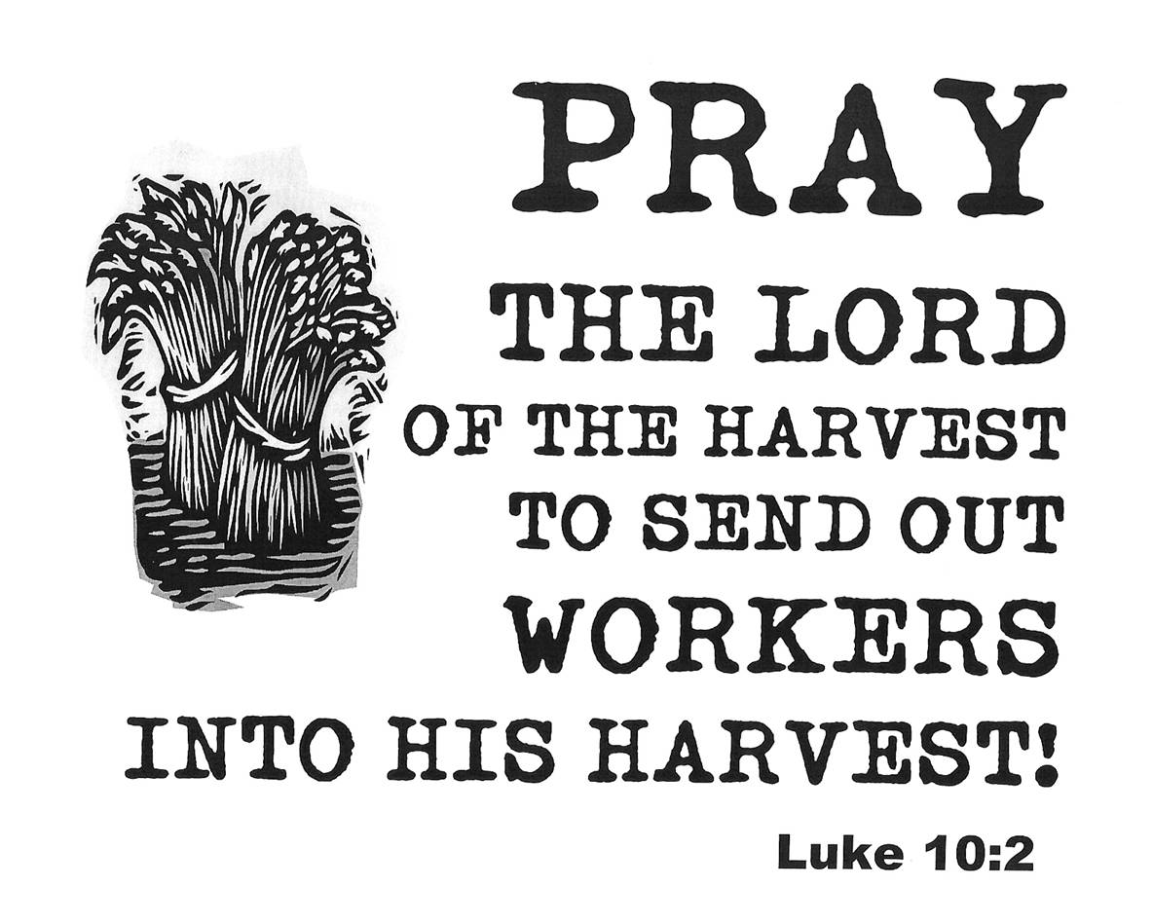
Holidays : we have reached the time of year where there is a lot of coming and going amongst our congregation with holidays. If you are going away may we wish you a very relaxing break. As many are aware there is still a large amount of sickness amongst many of our members. It is difficult trying to keep track of everyone so PLEASE help the clergy by letting us know of visits needed and keeping in touch with those you know who are missing from our service. YOUR HELP IN THIS IS GREATLY APPRECIATED.
Parish of Morriston
Weekly Bulletin
St. David’s Church
www.churchinwales.org.uk
www.stdavidsmorriston.co.uk
Registered Charity : 1131686
Vicar : Rev. Hugh Lervy
Tel. : (01792) 771329
Mobile : 07976 725644
e-mail : hughlervy@sky.com

Assistant Curate:
Rev. Andrew Perrin
Tel. 428080
The Church is open Monday to Friday from 10 a.m. to 12 Midday for private prayer
and quietness.

Fairtrade : Don’t forget there are a wide range of Fairtrade products available at the back of the church and we are hoping all groups that use the church will use Fairtrade products whenever possible. Purchase of these goods makes a huge difference in the lives of farmers in developing countries.

Thankyou : to all who have given such great support to our Curate Andrew and to all who were able to join us for his first Eucharist last Sunday. Thankyou also to Rev. Peter Brooks who joined us as the preacher last Sunday.

200 Club draw for June: First. No. 115 Sheila Thomas, Second. No. 74. Claire Lewis , Third.No. 61. Ethan Davies . Congratulations to the winners.

New Appointment: we welcome to appointment of Canon Dewi Roberts as the new Rector of Ystradgynlais in our Deanery. The induction service will take place in September and we hold Dewi and his family, and the Parish of Ystradgynlais in our prayers.

I went to Buckingham Palace to cut Prince William's hair. I said to the policeman, 'Can you let me in to the car park, I'm here to cut Prince William's hair?' The policeman said 'Have you got a permit?' -
I said, 'No, just a bit off the back!!!!

