9th June 2013

Today is the second Sunday after Trinity

Hymns at Eucharist : 12 , 386 , 29 , ( 553 , 620 , 108 ) , 716

TODAY 9.30 am Parish Eucharist with Sunday School

11.15 am Cymun Bendigaid

2.00 pm Baptism

6.00 pm Evensong

MONDAY 10.00 am Parent and Toddler group
7.00 pm Evening M.U. River Tawe Trip

TUESDAY 2.00 pm Mother’s Union : Speaker : Louise Scannell
on”The Welsh Dragons Burns Club”

WEDNESDAY 7.30 pm Bible Study Group at 2 Mynydd Garnlwydd Road
(2nd and 4th Wednesday each month)

THURSDAY 10.30 am Holy Eucharist (Crypt )
Followed by a Charity Coffee morning in aid
of the Gideons.
6.00 pm Youth Club for school years 4,5,6 ( Crypt )
6.00 pm Clergy Surgery for booking of baptisms, banns and
weddings etc. No appointments necessary.

FRIDAY 10.00 am Church working party - all welcome

NEXT SUNDAY 2 Sam. 11:26-12:15, Gal. 2:15-21, Lk. 7:36-8:3
9.30 am Parish Eucharist with Sunday School
11.15 am Baptism
6.00 pm Evensong

PARISH NOTES

Home Communions: with so many of our members unwell at the moment can I remind you that we have a team of licensed Eucharistic Assistants who would be happy to bring communion to those unable to attend church ( short or long term). If you would like to receive the sacrament at home would you please let the Vicar know.

Shopping Trip : to Worcester on Saturday 22nd June. Leaving Church at 8.30 a.m. and then leaving Worcester at 5 p.m. Cost is £15 person (£5 deposit please). All are welcome. Please speak to jane Gimlett to book your place.

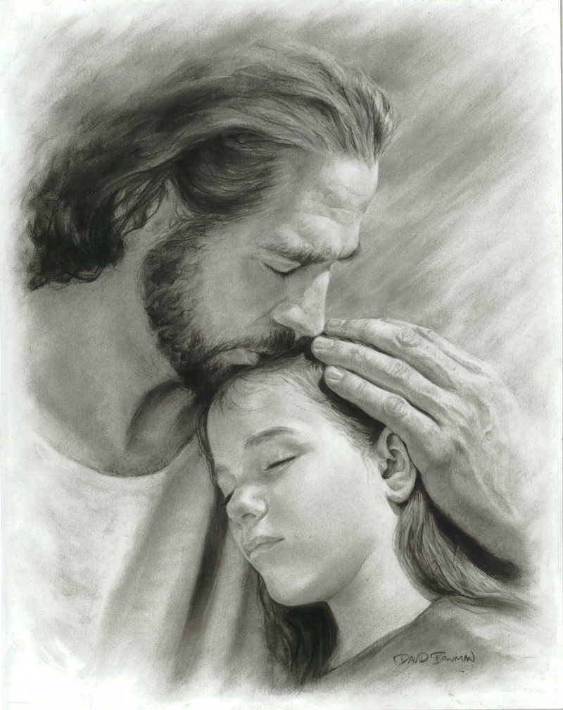
Charity Coffee Morning : in aid of the Gideons this Thursday following the mid-week Eucharist. Tickets / admission £1. All welcome. If you can help to sell tickets it would be appreciated.
Parish of Morriston
Weekly Bulletin
St. David’s Church
www.churchinwales.org.uk
www.stdavidsmorriston.co.uk
Registered Charity : 1131686
Vicar : Rev. Hugh Lervy
Tel. : (01792) 771329
Mobile : 07976 725644
e-mail : hughlervy@sky.com

Assistant Curate:
Rev. Andrew Perrin
Tel. 428080
The Church is open Monday to Friday from 10 a.m. to 12 Midday for private prayer
and quietness.

Open Church : a reminder that the Church is open Monday to Friday for private prayer or quietness. Do let people know that they are welcome to come in.

Council of Churches Coffee morning : in aid of The Hope Night Shelter will take place in the crypt on Saturday 6th July from 10 a.m. to midday. Tickets are now available.

Thankyou : my parents have asked me to express their sincere gratitude for all the prayers and support shown in recent weeks from our Church members and also from many people throughout our community.

Happy ‘special’ birthday: to Mildred Edwards for tomorrow from all your friends in St. David’s.

Fairtrade : at PCC meeting last week we re-affirmed ourselves as a Fairtrade Church. Don’t forget there are a wide range of Fairtrade products available at the back of the church and we are hoping all groups that use the church will use Fairtrade products whenever possible. Purchase of these goods makes a huge difference in the lives of farmers in developing countries.

PCC and Church Group leaders : are asked to meet on Monday 8th July from 7 - 9 p.m. as we look at various aspects of our Church life and Mission. The venue will be announced soon. Please keep the date free if possible, and sign the list at the back of church to say if you will be able to attend.

He said "Your obsession with cats is out of control. I can't handle it anymore." She cried, "You're kicking meeeowt?"

