17th February 2013 Today is the first Sunday of Lent

Hymns at Eucharist : 190 , 379 , 74 , ( 532 , 378 , 506 ) , 503

Psalm 91:1-2, 9-end BCP p. 571

TODAY 9.30 am Parish Eucharist with Sunday School

11.15 am Baptism

3.30 pm Licensing of Ven. Alan Jevons as Archdeacon of

Brecon (Cathedral)

6.00 pm LENT TALK (CRYPT)
“Rooted in Christ”

MONDAY 10.00 am Parent and Toddler group
1.00 pm Funeral of Meuryl Lewis (church) followed by
committal at the Crematorium at 2 p.m.

TUESDAY 2.00 pm Mother’s Union: Speaker : Gwyn Lewis
“Rooted in Christ”

WEDNESDAY 7.30 pm Bible Study Group at 2 Mynydd Garnlwydd Road
(2nd and 4th Wednesday each month)

THURSDAY 10.30 am Holy Eucharist
Followed by refreshments in the crypt
6.00 pm Youth Club for school years 4,5,6 ( Crypt )
6.00 pm Clergy Surgery for booking of baptisms, banns and
weddings etc. No appointments necessary.

FRIDAY 10.00 am Prayer Fellowship Group (crypt) -
all welcome
10.00 am Church working party - all welcome

SATURDAY 2.00 pm Wedding

NEXT SUNDAY Readings : Gen. 15:1-18, Phil. 3:17-4:1. Lk. 13:31-35
9.30 am Parish Eucharist with Sunday School
11.15 am Cymun Bendigaid
6.00 pm Lent Talk (crypt)
“Transforming Lives”

PARISH NOTES

LENT TALKS : do try and join us for the series of Lent Talks that will take place on Sunday evenings in Lent. The talks are based on the Diocesan Vision.

Thankyou : to Anne Lewis who co-ordinated the Shrove Tuesday supper - we hope you all enjoyed.

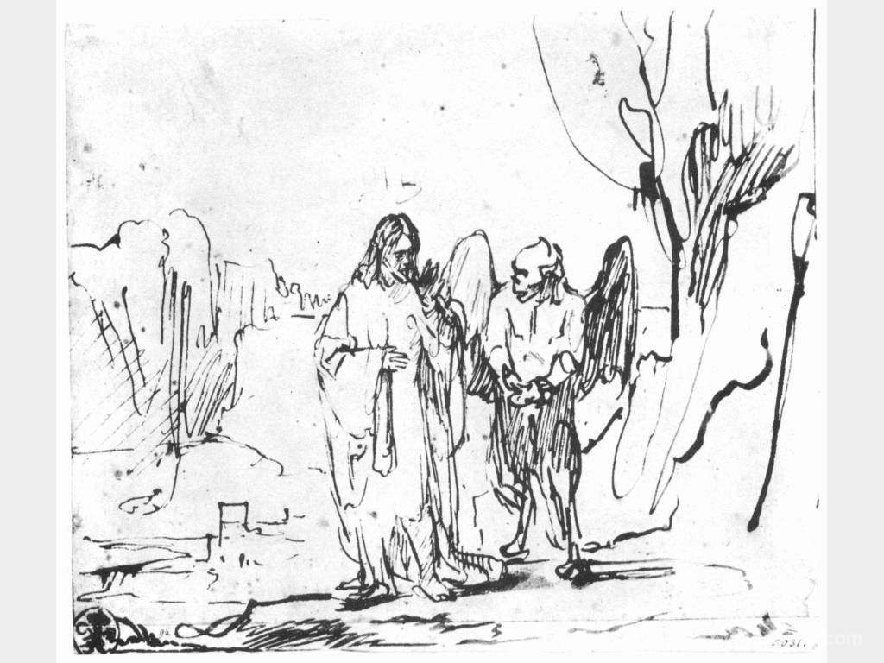
Confirmation Service 2013 : the Bishop has kindly agreed to join us in the Parish later this year to conduct a Confirmation Service. This is a preliminary request to see how many would like to be confirmed this year. There are application forms near the door - if you could complete a form and hand it in as soon as you can we will then be able to judge how many wish to be confirmed. (The minimum age is 11 ).
Parish of Morriston
Weekly Bulletin
St. David’s Church
www.churchinwales.org.uk
www.stdavidsmorriston.co.uk
Registered Charity : 1131686
Vicar : Rev. Hugh Lervy
Tel. : (01792) 771329
Mobile : 07976 725644
e-mail : hughlervy@sky.com

Assistant Curate:
Rev. Andrew Perrin
Tel. 428080

Lent Appeal : once again this year the Bishop has launched a Lent Appeal for various charities for us to support as a Diocese. This year the charities being supported are : The Welsh Dragon’s Burns Club , Kaleidoscope and Zane. Information about these charities will be given in our services next week. A plate can be found near the door for donations to the Lent Appeal and will remain there until Easter.

St. David’s Day : Friday 1st March. Holy Eucharist will be celebrated at 10.30 a.m.

Mothering Sunday : 10th March : a cream tea and Songs of Praise will take place in the crypt at 4 p.m. ALL ARE WELCOME. Invitation will be given out in the coming weeks.

Charity Coffee Morning : in aid of the Old Mill Foundation will take place following the Thursday morning service on 14th March. Tickets are £1 - please help to sell them. Thankyou.

A prayer for Lent : Blessed are you, Lord God of our salvation, to you be glory and praise for ever. In the darkness of our sin you have shone in our hearts to give the light of the knowledge of the glory of God in the face of Jesus Christ. Open our eyes to acknowledge your presence, that freed from the misery of sin and shame we may grow into your likeness from glory to glory. Blessed be God, Father, Son and Holy Spirit. Amen

Doctor News: The doctor took his patient into his office and said, "I have some good news and some bad news." The patient said, "Give me the good news." The doctor said, "They're going to name a disease after you."

