13th January 2013 Today is the Baptism of Christ

Hymns at Eucharist : 57 , 527 , 114 , ( 615 , 541 , 506 ) , 259

TODAY 9.30 am Parish Eucharist with Sunday School

11.15 am Cymun Bendigaid

6.00 pm Evensong

MONDAY 10.00 am Parent and Toddler group
11.30 am Deanery Clergy Chapter Meeting (Trebanos)
7.30 pm Evening M.U. : Speaker Rev. Gill Evans :
A talk on India

TUESDAY 2.00 pm Mother’s Union AGM

WEDNESDAY 7.30 pm Bible Study Group at 2 Mynydd Garnlwydd Road
(2nd and 4th Wednesday each month)

THURSDAY 10.30 am Holy Eucharist
Followed by refreshments in the crypt
6.00 pm Youth Club for school years 4,5,6 ( Crypt )
6.00 pm Clergy Surgery for booking of baptisms, banns and
weddings etc. No appointments necessary.

FRIDAY 10.00 am Church working party - all welcome

SATURDAY 10.30 am Open Prayer meeting for
Week of Prayer for Christian Unity

NEXT SUNDAY Readings : Is. 62:1-5, 1 Cor. 12:1-11, Jn. 2:1-11
9.30 am Parish Eucharist with Sunday School
4.30 pm PCC Meeting
6.00 pm Evensong
Thankyou : to Diane who organised our Cheese and Wine evening last night. We hope you all enjoyed.

Christian Unity Service : organised by the Council of Churches will take place on Tuesday 22nd January at 7.30 p.m. in the Hospital Chapel. All are welcome.

Area Deanery Conference : Sunday 27th January in Ystalyfera CHurch. the meeting will begin at 4.30 p.m. followed by a Deanery service at 6 p.m. The theme is “Managing Change” and this meeting is open to all PCC members.

Advent Smarties : tubes of Smarties with your 20p pieces can be returned at any of our services until NEXT SUNDAY. Money raised will be given to Children’s Charities. Thankyou to all who have been collecting through Advent.

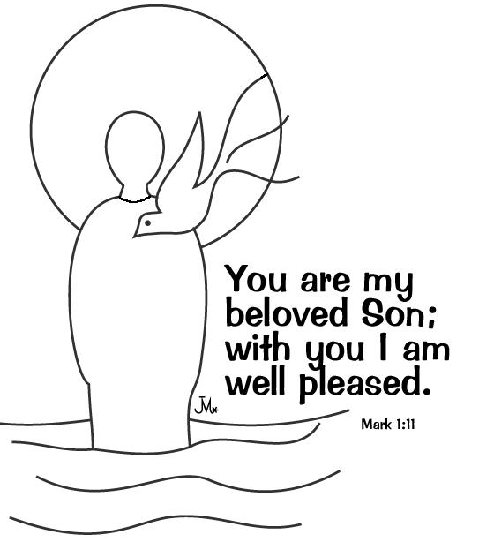
Mother’s Union Subs : are now due for the coming year. Could members please pay your £14 as soon as possible. Thankyou.
Parish of Morriston
Weekly Bulletin
St. David’s Church
www.churchinwales.org.uk
www.stdavidsmorriston.co.uk
Registered Charity : 1131686
Vicar : Rev. Hugh Lervy
Tel. : (01792) 771329
Mobile : 07976 725644
e-mail : hughlervy@sky.com

Assistant Curate:
Rev. Andrew Perrin
Tel. 428080

Chernobyl Children’s Lifeline concert : on Sunday February 3rd at 5 pm. The programme Includes the Gwalia Singers, Soloist Keely Morgan and the Cwmrhydyceirw Primary School Choir. Tickets £4 on sale at back of church.

Collection Envelopes : firstly a big thankyou to everyone who has contributed so generously and regularly to our church funds in 2012 helping us to meet our financial targets. Envelopes for 2013 are now available. Once again we face increases in the various aspects of Parish costs and we thank all who are helping us to meet these.

Swansea Philharmonic Choir Concert : which had to be postponed before Christmas will now take place on Saturday 9th February at 7 p.m. in the Brangwyn Hall. For details please see the poster or speak to Eira ( who can also reserve tickets for you ).

Evensong : resumes tonight at 6 p.m. Can I encourage you to make the evening service part of your weekly devotions. It is a traditional and very contemplative service which is always a lovely ending to a Sunday.

Annual Report : could those who run our various Church groups please submit articles for the report in the coming weeks. Many thanks.

Men’s Society: will resume on Tuesday 5th February at 6.30 p.m. in the Eagle, If you would like to come along please speak to John Richardson.

Visiting : with so many away for Christmas and the New year it it difficult to keep track of who is away and who is not in our services for other reasons ( e.g. sickness ). Please do keep in touch with those missing and PLEASE let the clergy know of those in need of visits.

"Did you hear about the cross eyed headmaster?"
He couldn't control his pupils

