23rd December 2012

Today is the fourth Sunday of Advent

Hymns at Eucharist : 152 , 265 , 740 , ( 759 , 655 ) , 631

TODAY 9.30 am Parish Eucharist with Sunday School

11.15 am Cymun Bendigaid

4.00 pm Christingle and Nativity Service
- DO TRY AND COME ALONG.

MONDAY CHRISTMAS EVE

5.00 pm Family Eucharist led by our
Sunday School

10.00 pm SUNG EUCHARIST “MIDNIGHT MASS”

TUESDAY CHRISTMAS DAY

10.00 am HOLY EUCHARIST
(said service with Carols)

THURSDAY NO MIDWEEK EUCHARIST TODAY

NEXT SUNDAY Readings : 1 Sam. 2:18-26, Col. 3:12-17, Lk. 2:41-52
9.30 am Parish Eucharist with Sunday School

NO EVENING SERVICE
PARISH NOTES

Advent Smarties : tubes of Smarties with your 20p pieces can be returned at any of our service over the next 2 weeks. Money raised will be given to Children’s Charities. Thankyou to all who have been collecting through Advent.

Collection Envelopes : firstly a big thankyou to everyone who has contributed so generously and regularly to our church funds in 2012 helping us to meet our financial targets. Envelopes for 2013 are now available. Once again we face increases in the various aspects of Parish costs and we thank all who are helping us to meet these.

Cheese, Wine and Entertainment Evening : Saturday 12th January at 7 p.m. in the Crypt. Tickets are £5 and all are welcome.

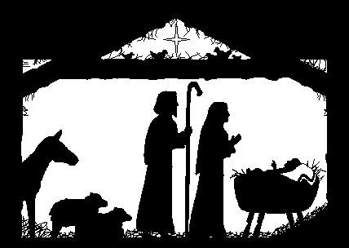
Please Note : there will be NO midweek service on Thursday and that next Sunday and Sunday 6th January the only service will be the 9.30 a.m. Parish Eucharist. There WILL be a midweek service on Thursday 3rd January.
Parish of Morriston
Weekly Bulletin
St. David’s Church
www.churchinwales.org.uk
www.stdavidsmorriston.co.uk
Registered Charity : 1131686
Vicar : Rev. Hugh Lervy
Tel. : (01792) 771329
Mobile : 07976 725644
e-mail : hughlervy@sky.com

Assistant Curate:
Rev. Andrew Perrin
Tel. 428080

Council of Churches AGM : Tuesday 8th January at 7.15 p.m. in Aenon.

200 Club Christmas Draw winners : 1st no. 113 Bob Elvins, 2nd. no. 42 Anne Dawson, 3rd no.8 Bruce Lervy. Congratulations to the winners.

Thankyou : to Jill who organised our Sunday School trip to the Pantomime last week. Thankyou to everyone who helped with the craft morning and putting the Christingles together yesterday.

Postage Stamps: Don’t forget we have a box at the back of Church where used stamps can be placed and these are used raise funds to help the work of the RNIB. When cutting them from envelopes please leave 1cm around the stamp. Many thanks.

HAPPY CHRISTMAS

to you all from the Clergy and Officers of St. David’s.
We wish you the peace and joy of the season.
If you are not away for Christmas DO TRY TO JOIN US FOR OUR CHRISTMAS SERVICES AS WE WITNESS TO CHRIST IN OUR COMMUNITY.

The dress : Betty was soon to be married. More than anything, she wanted to wear the wedding dress her mother was married in. Betty's mother was beaming with pride as she gave her consent. Later in the evening, the family gathered in the living room to wait while Betty tried on the dress. When Betty entered the room, there was a chorus of approval. The dress fit perfectly and looked wonderful on her. Tears ran down the face of Betty's mother. Seeing this, Betty said, "Don't worry Mum, you're not losing a daughter, your gaining a son." "Forget about that!" she said with a sob. "I used to fit into that dress!"

