9th December 2012 Today is the second Sunday of Advent

Hymns at Eucharist : 527 , 949 , 259 , ( 553 , 428 , 406 ) , 646

TODAY 9.30 am Parish Eucharist with Sunday School

11.15 am Cymun Bendigaid

6.00 pm Evening Worship

MONDAY 10.00 am Parent and Toddler group Christmas Party
7.30 pm Evening M.U. Christmas Dinner

TUESDAY 1.00 pm Cwmrhydyceirw School Carol Service (church)
6.00 pm Cwmrhydyceirw School Carol Service (church)

WEDNESDAY 2.30 pm Funeral of Morfydd Bennett (Crematorium)
7.00 pm Bereavement Carol Service (here in St.
David’s) - organised by ABM Hospital Board
Chaplaincy Dept. - All are welcome to attend.
7.30 pm Bible Study Group at 2 Mynydd Garnlwydd Road
(2nd and 4th Wednesday each month)

THURSDAY 10.30 am Holy Eucharist
Followed by refreshments in the crypt
6.00 pm Youth Club for school years 4,5,6 ( Crypt )
6.00 pm Clergy Surgery for booking of baptisms, banns and
weddings etc. No appointments necessary.

FRIDAY 10.00 am Church working party - all welcome

SATURDAY 11.00 am Council of Churches Carol Singing in our grounds all welcome to join them.
2.00 pm Sunday School Trip to the Pantomime
(Pontardawe Arts Centre)
NEXT SUNDAY Readings : Zeph. 3:14-20, Phil. 4:4-7, Lk. 3:7-18
9.30 am Parish Eucharist with Sunday School
6.00 pm CHRISTMAS PRAISE SERVICE - with the Salvation Army, the
Bay Choir and the Maranatha Singers - DO TRY AND JOIN US
FOR WHAT IS ALWAYS AND UPLIFTING SERVICE

Thankyou : to all who worked hard and to those who supported our Christmas Fete on Friday.

Thankyou : after many years as a server Kurt has decided to step down - as he is now working. Our sincere thanks for all he has contributed to our church through serving.

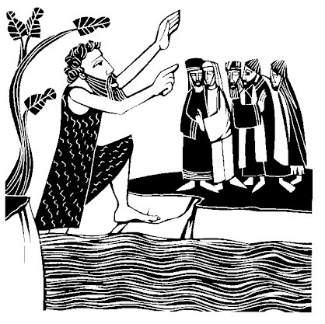
Christmas Cards : a board is now available at the back of church if you wish to place a card to all your friends in church.
Parish of Morriston
Weekly Bulletin
St. David’s Church
www.churchinwales.org.uk
www.stdavidsmorriston.co.uk
Registered Charity : 1131686
Vicar : Rev. Hugh Lervy
Tel. : (01792) 771329
Mobile : 07976 725644
e-mail : hughlervy@sky.com

Assistant Curate:
Rev. Andrew Perrin
Tel. 428080

RIP: we have been saddened to learn of the passing away of Morfydd Bennett. We remember her and the family in our prayers. May the souls of the departed through the love and mercy of God rest in peace.

Flowers : can I remind you that Jean Davies will be stepping down as co-ordinator at the end of the year. We still need a volunteer to take on this role. Please give some thought and let us know if you can help.

200 Club Winners Nov.: 1st. no. 159 John Griffiths, 2nd. no. 139 Elizabeth West, 3rd. no. 19 Mary Williams. Congratulations to the winners.

Advent Smarties : tubes of Smarties are available for our Advent collection. Eat the Smarties and then collect your 20p pieces in the tube - these can be returned at our Christmas services. All money raised will be for Children’s Charities.

Christmas Craft Morning : for children on Saturday 22nd December from 10 a.m. to Midday. If you can give a hand with the activities we would be VERY pleased for your assistance - please let Jill know.

Morriston Comprehensive School : carol service will be held here on Monday 17th December at 7 p.m. All are welcome to come along.

Christingle and Nativity Service : Sunday 23rd December at 4 p.m. ( we will be putting the Christingles together on Saturday 22nd December at 10 a.m. - - the more who can help the easier it is !!)

Christmas Eve : Tuesday 24th December. A family Eucharist led by our Sunday SChool will take place at 5 p.m. Our late Holy Eucharist will begin at 10 p.m.

Christmas Morning : Holy Eucharist will be celebrated at 10 a.m.

Please Note : there will be NO midweek service on Thursday 27th December and that on Sunday 30th December the only service will be the 9.30 a.m. Parish Eucharist.

