2nd December 2012

Today is the first Sunday of Advent

Hymns at Eucharist : 263 , 128 , 405 , ( 303 , 655 , 66 ) , 757

TODAY 9.30 am Parish Eucharist with Sunday School

Followed by tea / coffee - all welcome

6.00 pm ADVENT SERVICE OF PRAYER AND

REFLECTION - DO TRY AND JOIN US.

MONDAY 10.00 am Parent and Toddler group

TUESDAY 10.00 am Pente’rgraig School (Church visit)
2.00 pm Mother’s Union “Symposium”
6.30 pm Men’s Society Christmas Dinner (The Eagle)

WEDNESDAY 7.30 pm Bible Study Group at 2 Mynydd Garnlwydd Road
(2nd and 4th Wednesday each month)

THURSDAY 10.30 am Holy Eucharist
Followed by refreshments in the crypt
6.00 pm Youth Club for school years 4,5,6 ( Crypt )
6.00 pm Clergy Surgery for booking of baptisms, banns and
weddings etc. No appointments necessary.
7.00 pm Holy Eucharist

FRIDAY 4.30 pm Switching on of Tree of Light with Carol
Singing

5.00 pm CHRISTMAS FETE (see notes)

NEXT SUNDAY Readings : Bar. 5:1-9, Phil. 1:3-11, Lk. 3:1-6
9.30 am Parish Eucharist with Sunday School
11.15 am Cymun Bendigaid
6.00 pm Evening Worship

PARISH NOTES

Christmas Fete : THIS Friday at 5 p.m. - we are collecting items for the stalls - tins / craft items / toiletries/ Raffle prizes etc. We would appreciate any help you can give. On Friday the Crypt will be open from 10 a.m. to midday and then 2.30 p.m. onwards to set up. Raffle tickets should be returned by Friday ( folded individually if possible). IF YOU CAN HELP ON THE STALLS IT WOULD BE APPRECIATED. PLEASE COME AND SUPPORT US. Thankyou.

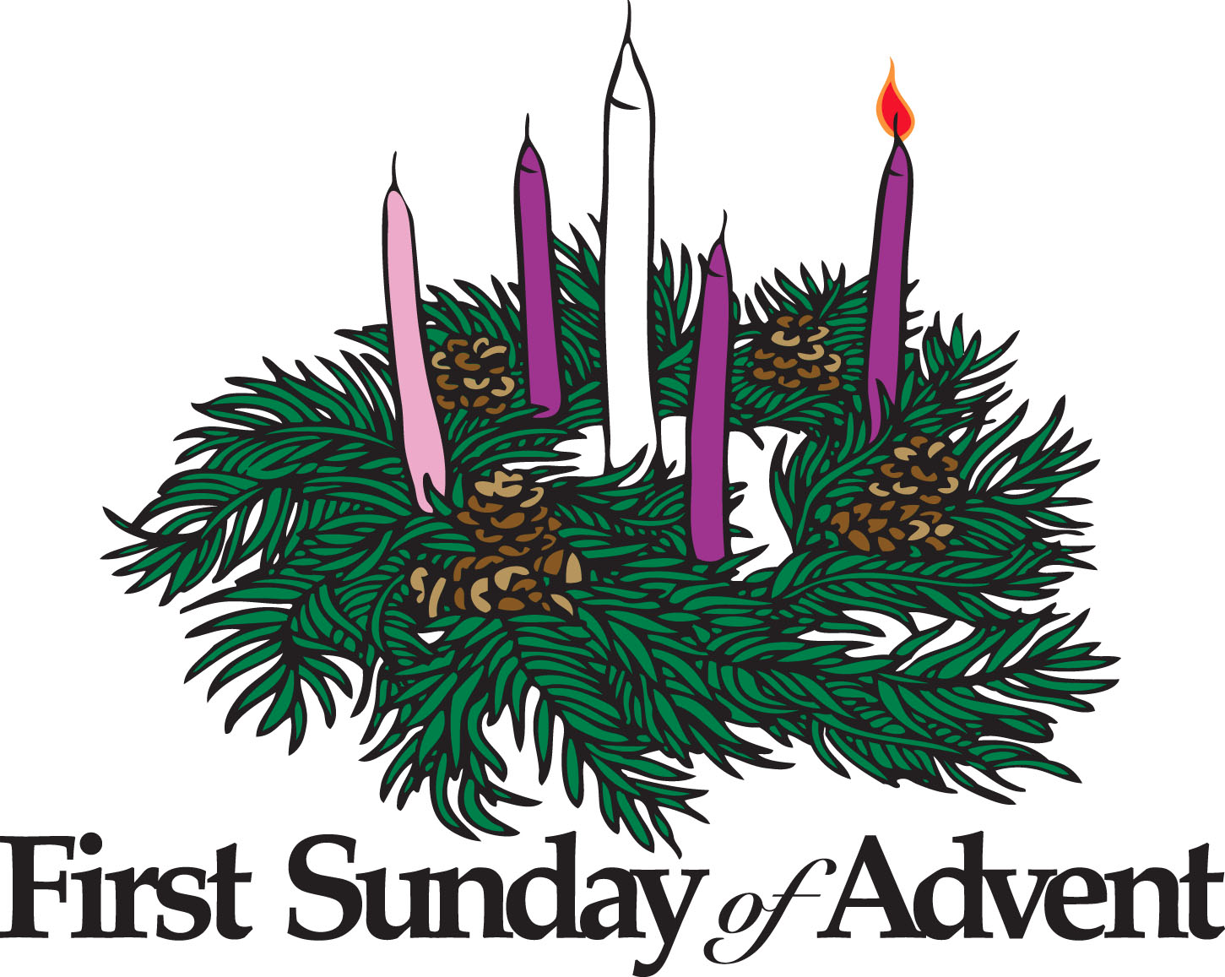
Advent Smarties : tubes of Smarties are available today for our Advent collection. Enjoy the Smarties and then through Advent collect your 20p pieces in the tube - these will be returned at our Christmas services. All money raised will be for Children’s Charities.
Parish of Morriston
Weekly Bulletin
St. David’s Church
www.churchinwales.org.uk
www.stdavidsmorriston.co.uk
Registered Charity : 1131686
Vicar : Rev. Hugh Lervy
Tel. : (01792) 771329
Mobile : 07976 725644
e-mail : hughlervy@sky.com

Assistant Curate:
Rev. Andrew Perrin
Tel. 428080

Christmas Craft Morning : for children on Saturday 22nd December from 10 a.m. to Midday. If you can give a hand with the activities we would be VERY pleased for your assistance. Please stay for a short meeting at the end of the morning service TODAY if you can help.

Swansea Philharmonic Choir Christmas Concert: on Saturday 1st December at 7.30 p.m. in the Brangwyn. For details / tickets please speak to Eira ( 528322 )

Coffee Morning : £250 has been given to Chernobyl Children’s Lifeline. Thankyou to all who contributed.

Men’s Society Christmas Dinner : this Tuesday. Could those attending please pay John Richardson for your meal Today.

Christmas Praise Service : with the Salvation Army and the Bay choir on Sunday 16th December at 6 p.m. - please let people know - this is always an enjoyable service.

Carol Service for the Bereaved : organised by the Chaplains of ABM Hospital - to be held here on Wednesday 12th December at 7 p.m. This service is open to any wishing to attend.

Council of Churches Carol Singing : outside our Church on Saturday 15th December at 11 a.m. - if any can help out please meet here on the day.

Morriston Comprehensive School : carol service will be held here on Monday 17th December at 7 p.m. All are welcome to come along.

Christingle and Nativity Service : Sunday 23rd December at 4 p.m.

