25th November 2012 Today is the feast of Christ the King

Hymns at Eucharist : 12 , 1 , 137 , ( 448 , 195 , 644 ) , 438

TODAY 9.30 am Parish Eucharist with Sunday School

11.15 am Cymun Bendigaid

2.00 pm Baptism

6.00 pm Evensong

MONDAY 10.00 am Parent and Toddler group
7.30 pm Evening M.U.: Speaker Moira Evans on
“Family History”

TUESDAY 2.00 pm Mother’s Union: Speaker : Andre Scoville
(see notes)

WEDNESDAY 7.30 pm Bible Study Group at 2 Mynydd Garnlwydd Road
(2nd and 4th Wednesday each month)

THURSDAY 10.30 am Holy Eucharist
Followed by refreshments in the crypt
6.00 pm Youth Club for school years 4,5,6 ( Crypt )
6.00 pm Clergy Surgery for booking of baptisms, banns and
weddings etc. No appointments necessary.

FRIDAY 10.00 am Church working party - all welcome
10.00 am Prayer Fellowship Group (crypt)
- all welcome

NEXT SUNDAY Advent 1
Readings : Jer. 33:14-16, 1 Thes. 3:9-13, Lk 21:25-36
9.30 am Parish Eucharist with Sunday School
6.00 pm ADVENT SERVICE OF REFLECTION
- DO TRY AND JOIN US.
PARISH NOTES

Mother’s Union : on Tuesday this week at 2 p.m. the speaker will be Andre Scoville who will give a talk called “Morriston as you have never seen it before”. he will be sharing rare photos and video of Morriston. If you wish to join the Mother’s union members for this talk you would be very welcome.

Christmas Fete : Friday 7th December at 5 p.m. Over the coming weeks we will be collecting items for the stalls - tins / craft items / toiletries/ Raffle prizes etc. We would appreciate any help you can give. Raffle tickets are available to sell - please take a book with you and do your best to sell them. Thankyou.

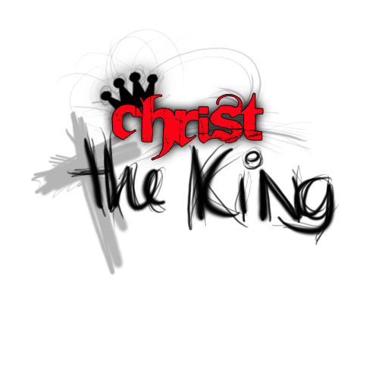
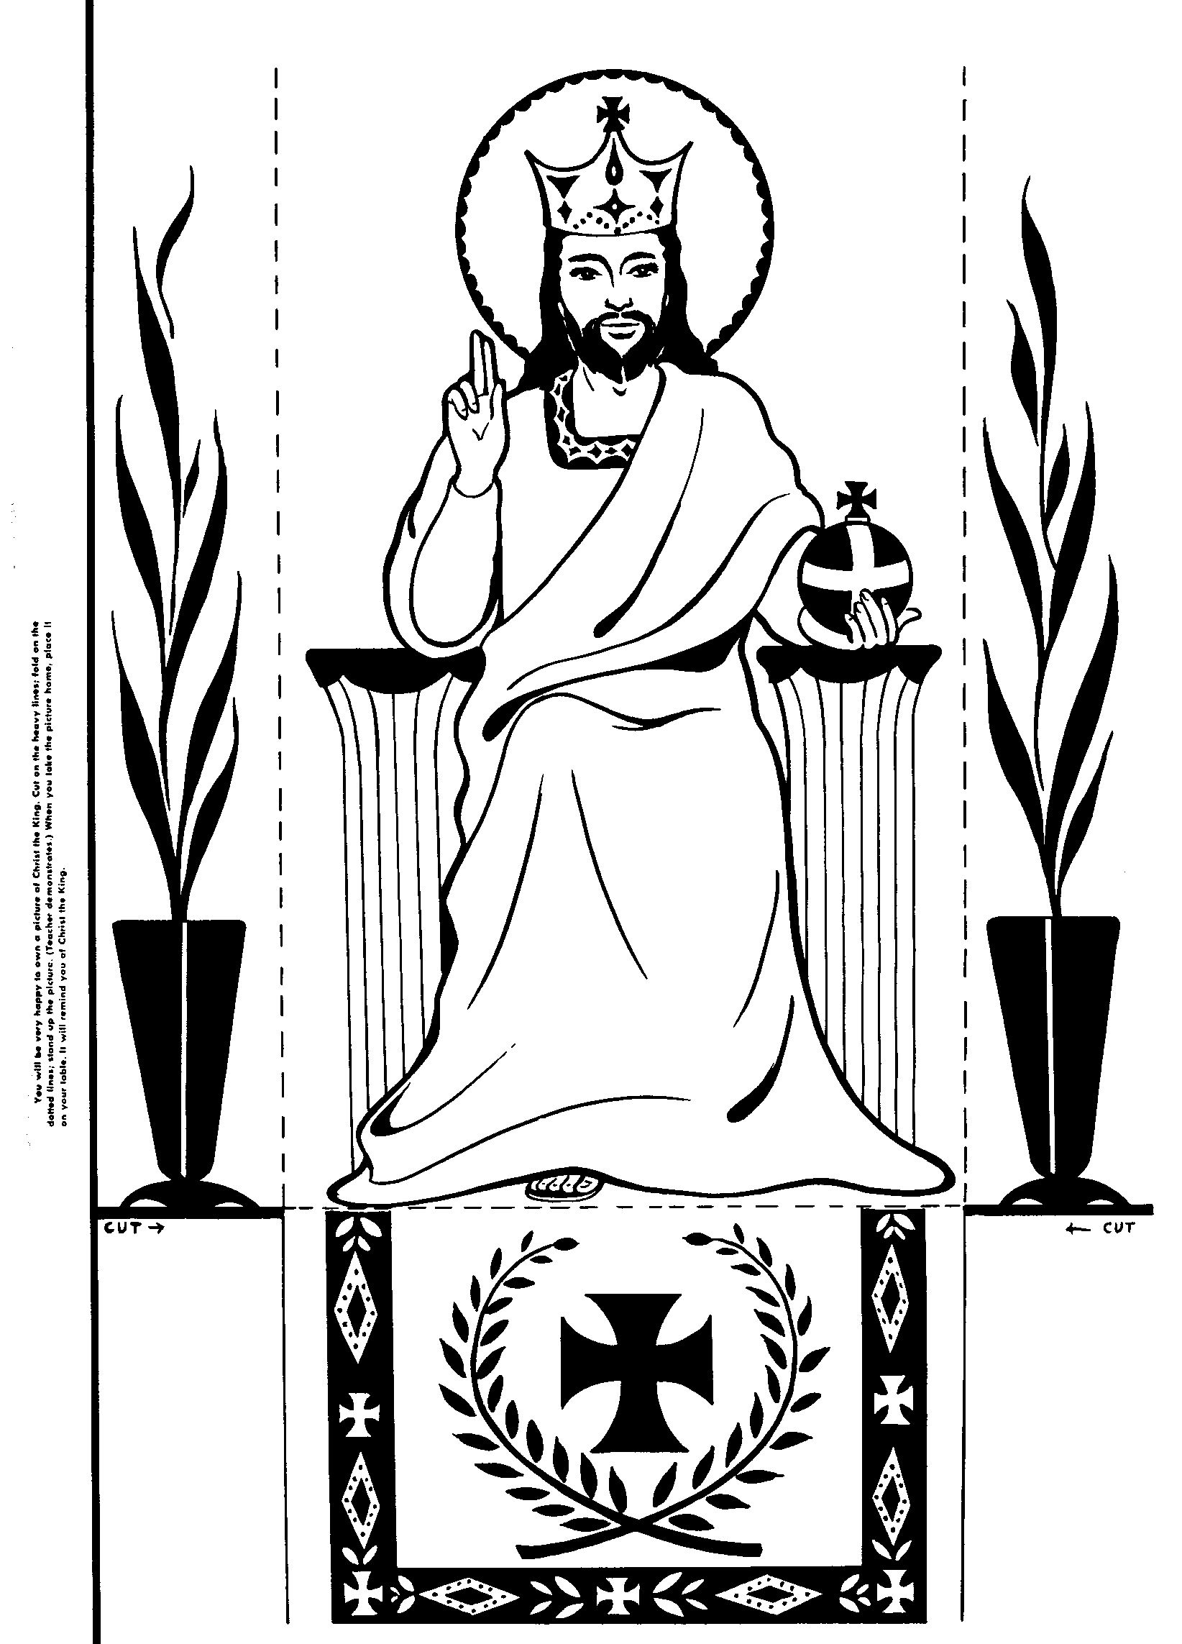
Sunday School trip : to the Pantomime on Saturday 15th December. Please let Jill know final numbers TODAY. Adult tickets are £8.
Parish of Morriston
Weekly Bulletin
St. David’s Church
www.churchinwales.org.uk
www.stdavidsmorriston.co.uk
Registered Charity : 1131686
Vicar : Rev. Hugh Lervy
Tel. : (01792) 771329
Mobile : 07976 725644
e-mail : hughlervy@sky.com

Assistant Curate:
Rev. Andrew Perrin
Tel. 428080

Christmas Craft Morning : for children on Saturday 22nd December from 10 a.m. to Midday. If you can give a hand with the activities we would be VERY pleased for your assistance. Please stay for a short meeting at the end of the morning service next Sunday if you can help.

Thankyou : to all who were able to support the Coffee morning in aid of Chernobyl Children’s Lifeline on Thursday. At our PCC meeting in January we will be deciding which charities we will support next year. If you have any suggestions please write them down and let me know.

Thankyou : to Jane Gimlett who organised the trip to Bristol yesterday. We hope you had a good day.

Tree of Light : will be switched on Friday 7th December at 4.30 p.m. Sponsorship forms are now available. ( sponsorship money will be for Oakwood Playroom in Morriston Hospital and the Welsh Dragon’s Burns Club )

Traidcraft : copies of the Christmas Catalogue are now available on the table at the back of Church. If you would like to order any items from this would you please let Joan Lewis know as soon as you can. Thankyou.

Swansea Philharmonic Choir Christmas Concert: on Saturday 1st December at 7.30 p.m. in the Brangwyn. For details / tickets please speak to Eira ( 528322 )

Advent Sunday : NEXT SUNDAY: An Advent service of reflection will be held at 6 p.m. Leaflets with details of Advent and Christmas Services are available. Please take copies if you can also help distribute them to family, friends and neighbours over the coming weeks.

Men’s Society Christmas Dinner : Tuesday 4th December at 6.30 p.m. in the Eagle. If you would like to come along please speak to John Richardson.

If at first you don't succeed, destroy all evidence that you tried.

