18th November 2012

Today is the second Sunday before Advent ( Kingdom 3 )

Hymns at Eucharist : 137 , 169 , 662 , ( 752 , 487 , 582 ) , 419

Psalm 16 BCP p. 459

TODAY 9.30 am Parish Eucharist with Sunday School

6.00 pm Evensong

MONDAY 10.00 am Parent and Toddler group

TUESDAY 2.00 pm Mother’s Union: Speaker : Canon Brian Jones on
“Sacred Space”

WEDNESDAY 7.30 pm Bible Study Group at 2 Mynydd Garnlwydd Road
(2nd and 4th Wednesday each month)

THURSDAY 10.30 am Holy Eucharist (crypt)
Followed by a Charity Coffee morning in aid
of Chernobyl Children’s Lifeline.
6.00 pm Youth Club for school years 4,5,6 ( Crypt )
6.00 pm Clergy Surgery for booking of baptisms, banns and
weddings etc. No appointments necessary.

FRIDAY 10.00 am Church working party - all welcome

SATURDAY 8.30 am Shopping Trip to Bristol (bus leaving from
the Church) - have a good day !

NEXT SUNDAY Christ the King
Readings : Dan. 7:9-14, Rev. 1:4-8, Jn. 18:33-37
9.30 am Parish Eucharist with Sunday School
11.15 am Cymun Bendigaid
2.00 pm Baptism
6.00 pm Evensong

Happy “special” birthday : to Meuryl Lewis and David Gould for yesterday.

Charity Coffee Morning : in aid of Chernobyl Children’s Lifeline this Thursday following the 10.30 Service - do try and join us.

Christmas Fete : Friday 7th December at 5 p.m. Over the coming weeks we will be collecting items for the stalls - tins / craft items / toiletries/ Raffle prizes etc. We would appreciate any help you can give. Raffle tickets are available to sell - please take a book with you and do your best to sell them. Thankyou.

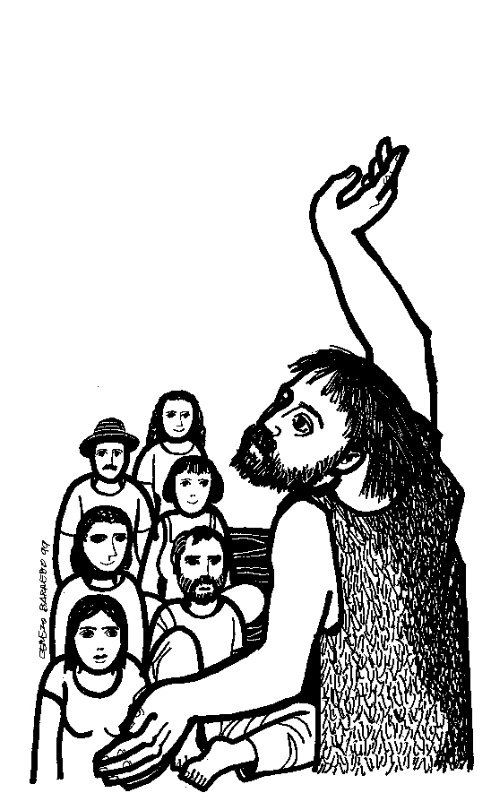
Tree of Light : will be switched on Friday 7th December at 4.30 p.m. Sponsorship forms for the Tree in Memory of loved ones will be available soon. ( sponsorship money will be for Oakwood Playroom in Morriston Hospital and the Welsh Dragon’s Burns Club )
Parish of Morriston
Weekly Bulletin
St. David’s Church
www.churchinwales.org.uk
www.stdavidsmorriston.co.uk
Registered Charity : 1131686
Vicar : Rev. Hugh Lervy
Tel. : (01792) 771329
Mobile : 07976 725644
e-mail : hughlervy@sky.com

Assistant Curate:
Rev. Andrew Perrin
Tel. 428080

Traidcraft : copies of the Christmas Catalogue are now available on the table at the back of Church. If you would like to order any items from this would you please let Joan Lewis know as soon as you can. Thankyou.

Church Trip : there are a few places still available for the trip next Saturday. Please speak to Jane Gimlett if you would like to go. Could your payment please be made to Jane this week.

Swansea Philharmonic Choir Christmas Concert: on Saturday 1st December at 7.30 p.m. in the Brangwyn. For details / tickets please speak to Eira ( 528322 )

Advent Sunday : 2nd December. An Advent service of reflection will be held at 6 p.m. Leaflets with details of Advent and Christmas Services are available. Please take copies if you can also help distribute them over the coming weeks.

Church Family : Audrey Jefferson would like her friends in Church to know that she is now resident in Swn Y Mor Care home in Aberavon.

Men’s Society Christmas Dinner : Tuesday 4th December at 6.30 p.m. in the Eagle. If you would like to come along please speak to John Richardson.

Coffee Stir : A diner was agitated that the waiter had brought him no spoon with his coffee. "This coffee," he said loud enough for most of the other patrons to hear, "is going to be pretty hot to stir with my fingers." The waiter reddened, made a hasty retreat to the kitchen and returned shortly with another cup of coffee. "This one isn't so hot, sir," he beamed.

