4th November 2012

Today is the All Saints Sunday ( Kingdom 1 )

Hymns at Eucharist : 314 , 77 , 177 , ( 659 , 686 , 673 ) , 876

Hymns at Evensong : 646 , 690 , 332 , 249

Psalm 146 BCP p. 647

TODAY 9.30 am Family Eucharist led by our Sunday School

Followed by tea / coffee - all welcome

6.00 pm Deanery Evensong and Area Dean Licensing.

Preacher : Bishop John (who we welcome to St.

David’s along with Archdeacon Robert )

Followed by tea / coffee - all welcome.

MONDAY 10.00 am Parent and Toddler group

TUESDAY 2.00 pm Mother’s Union: Speaker : Rev. Andrew Perrin
6.30 pm Men’s Society (The Eagle)
7.00 pm Church in Wales Review Meeting (Brecon
Cathedral) - all welcome.

WEDNESDAY 7.30 pm Bible Study Group at 2 Mynydd Garnlwydd Road
(2nd and 4th Wednesday each month)

THURSDAY 10.30 am Holy Eucharist
Followed by refreshments in the crypt
6.00 pm Youth Club for school years 4,5,6 ( Crypt )
6.00 pm Clergy Surgery for booking of baptisms, banns and
weddings etc. No appointments necessary.

FRIDAY 10.00 am Church working party - all welcome
NEXT SUNDAY REMEMBRANCE SUNDAY
Readings : Jon. 3:1-5,10, Heb. 9:24-28, Mk. 1:14-20
9.30 am Parish Eucharist with Sunday School
11.15 am Cymun Bendigaid
6.00 pm Evensong

Welcome : to all who join us for our Family Eucharist this morning and all who join us for our Deanery Evensong this evening.

Remembrance Sunday : next Sunday : acts of remembrance will take place during our morning services.

Diocesan Vision Meeting : will take place on Monday 12th November at St. Illtyd’s Church, Fforestfach 6.30 - 8 p.m. All are welcome to attend - but especially PCC members - please let me know if you intend going.

Charity Coffee Morning : in aid of Chernobyl Children’s Lifeline on Thursday 22nd November following the 10.30 Service. Tickets now available.

Council of Churches Meeting : Tuesday 13th November at 7.15 in Aenon.

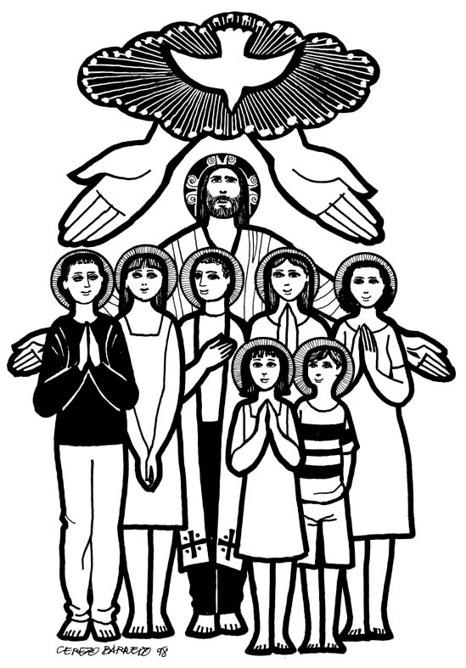
Christmas Fete : Friday 7th December at 5 p.m. Over the coming month we will be collecting items for the stalls - tins / craft items / toiletries/ Raffle prizes etc. We would appreciate any help you can give. Raffle tickets are available to sell - please take a book with you and do your best to sell them. Thankyou.
Parish of Morriston
Weekly Bulletin
St. David’s Church
www.churchinwales.org.uk
www.stdavidsmorriston.co.uk
Registered Charity : 1131686
Vicar : Rev. Hugh Lervy
Tel. : (01792) 771329
Mobile : 07976 725644
e-mail : hughlervy@sky.com

Assistant Curate:
Rev. Andrew Perrin
Tel. 428080

Traidcraft : copies of the Christmas Catalogue are now available on the table at the back of Church. If you would like to order any items from this would you please let Joan Lewis know as soon as you can. Thankyou.

Morriston Trader’s Christmas Fete : in our Crypt on Saturday 17th November 10 a.m. to 3 p.m. A variety of craft sellers will be represented. Free Admission.

200 Club Winners Oct. 12 : 1st no. 72 June Stoker, 2nd no. 68 Bruce Lervy, 3rd no. 69 Molly Caton. Congratulations to the winners.

Wish for Understanding : A man walking along a Swansea beach was deep in prayer. All of a sudden he said out loud, "Lord grant me one wish." Suddenly the sky clouded above his head and in a booming voice the Lord said, "Because you have TRIED to be faithful to me in all your ways, I will grant you one wish" The man said, "Build a bridge to France so I can drive over anytime I want." The Lord said, "Your request is very materialistic. Think of all the challenges for that kind of undertaking. The supports are required to reach the bottom of the Ocean! The concrete and steel it would take! I can do it, but it is hard for me to justify your desire for such worldly things. Take a little more time and think of another wish, a wish that would honour and glorify me." The man thought about it for a long time. Finally he said, "Lord I wish that I could understand women. I want to know how they feel inside, what they are thinking when they give me the silent treatment, why they cry, what they mean when they say 'nothing', and how can I make a woman truly happy." The Lord replied, "You want two or four lanes on that bridge?"

