7th October 2012

Today is the eighteenth Sunday after Trinity (HARVEST FESTIVAL)

Hymns at Eucharist : 719 , 900 , 184 , ( 736 , 856 , 872 ) , 221

Hymns at Evensong : 133 , 184 , 566 , 696 Psalm 65 BCP p. 527

TODAY 10.00 am Family Eucharist led by our Sunday School

Followed by tea / coffee

12.30 pm Lunch at Manor Park

6.00 pm Harvest Evensong with a talk on the work of

the Cyrenians.

MONDAY 10.00 am Parent and Toddler group
7.30 pm Evening M.U.: Speaker : Mike Anthony on
Fostering

TUESDAY 2.00 pm Mother’s Union: Speaker : Nan Morris on
Life in the Vicarage
7.00 pm Diocesan Evening at Llansamlet Church on
“Becoming a Generous People”

WEDNESDAY 2.30 pm M.U. Deanery service ( here in St. David’s)
7.30 pm Bible Study Group at 2 Mynydd Garnlwydd Road
(2nd and 4th Wednesday each month)

THURSDAY 10.30 am Holy Eucharist
Followed by refreshments in the crypt
6.00 pm Youth Club for school years 4,5,6 ( Crypt )
6.00 pm Clergy Surgery for booking of baptisms, banns and
weddings etc. No appointments necessary.

FRIDAY 10.00 am Church working party - all welcome

NEXT SUNDAY Readings : Amos 5:6-15, Heb. 4:12-16, Mk. 10:17-31
9.30 am Parish Eucharist with Sunday School
11.15 am Cymun Bendigaid
6.00 pm Deanery Service in Ystalyfera Church: The preacher will be Archdeacon Robert on the work of the Diocesan Widows. Orphans and Dependants Charity.

Welcome :
to all who join us for our Harvest services today. Thankyou to all who prepared the church for our Services. Donations of dried food and money given today will be passed to the Cyrenians for their work.

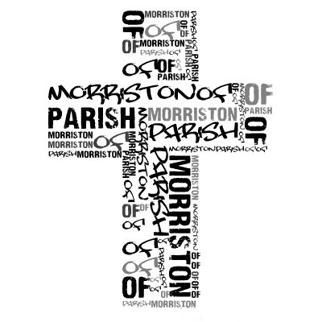
RIP : we have been saddened this week to learn of the passing away of two of our Church family : Joan Davies and Eleri Eynon. We offer our prayers for them and their families at this time. May the souls of the departed through the love and mercy of God rest in peace.
Parish of Morriston
Weekly Bulletin
St. David’s Church
www.churchinwales.org.uk
www.stdavidsmorriston.co.uk
Registered Charity : 1131686
Vicar : Rev. Hugh Lervy
Tel. : (01792) 771329
Mobile : 07976 725644
e-mail : hughlervy@sky.com

Assistant Curate:
Rev. Andrew Perrin
Tel. 428080

Parish 200 Club : The October draw will be the first of the new subscription year and £20 membership for the year is now due for those wishing to join. Please let the Churchwardens have your subs. All are welcome to join.

Shopping Trip : to Bristol on Saturday 24th November. The cost is £12 per person (£5 deposit by 14th October). All are welcome ( inc. family and friends). To book your place please speak to Jane Gimlett on 796585.

Thankyou : very much to all who have helped out on the rota to open the Church each weekday morning through the Summer months. Although the church will not be opening each day if anyone would like access for quietness / prayer please ask and the Church will be opened for you.

Diocesan Family Day : on Saturday 3rd November in Brecon cathedral. All are welcome. For details and to book your place please speak to Jill Lewis.

Area Dean Licensing: Bishop John and Archdeacon Robert will be joining us on Sunday 4th November at 6 p.m. to licence me as the new Area Dean for Cwmtawe. This is a Deanery service at which all would be welcome.

All Saints Day : Thursday 1st November. Holy Eucharist will take place at 10.30 and 7 p.m.

All Soul’s Day : Friday 2nd November. Holy Eucharist will take place at 10 a.m. If you would like the names of any of the departed to be remembered during the service please PRINT their names on the list at the back of Church.

Returned Glasses : A woman walks in a store to return a pair of glasses that she had purchased for her husband a week before. "What seems to be the problem, madam?" "I'm returning these glasses I bought for my husband. He's still not seeing things my way."

