20th May 2012

Today is the seventh Sunday of Easter (Sunday after Ascension)
Dedicated by the Church in Wales as Ministry and Calling Sunday.

Hymns at Eucharist : 255 , 84 , 16 , ( 12 , 540 , 937 ) , 644
Psalm 1 BCP p. 445

TODAY 9.30 am Parish Eucharist with Sunday School

11.15 am Baptism

2.00 pm Baptism

6.00 pm Evensong

MONDAY 10.00 am Parent and Toddler group

TUESDAY 2.00 pm Mother’s Union: Speaker : Nan Morris
“Around the world in 40 Minutes”

WEDNESDAY 7.30 pm Bible Study Group at 2 Mynydd Garnlwydd Road
(2nd and 4th Wednesday each month)

THURSDAY 10.30 am Holy Eucharist
Followed by refreshments in the crypt
6.00 pm Youth Club for school years 4,5,6 ( Crypt )
6.00 pm Clergy Surgery for booking of baptisms, banns and
weddings etc. No appointments necessary.

FRIDAY 10.00 am Prayer Fellowship Group (Crypt)
- all welcome
10.00 am Church working party - all welcome

SATURDAY 7.00 pm Cambrian Male Choir Annual Concert (church)

NEXT SUNDAY PENTECOST
Readings : Acts 2:1-21, Rom. 8:22-27, Jn. 15:26-16:15
9.30 am Parish Eucharist with Sunday School
11.15 am Cymun Bendigaid
4.00 pm Pentecost Praise Service with the Council of Churches (here in St. David’s)
Parish Meal : will be held at Morriston Golf Club on FRIDAY 1st JUNE ( 7 for 7.30 ). The cost will be £13.50 ( 3 courses ). Entertainment will be provided for us by Kate Harwood. We do hope as many as possible will be able to join us. Do invite family and friends to come along. For details and to book your place / meal please see the form at the back of Church. Please let us know if you are coming TODAY PLEASE.

Christian Aid Week : thankyou to all who have helped to collect for Christian Aid this week. If there are further donations could we please have them as soon as possible.

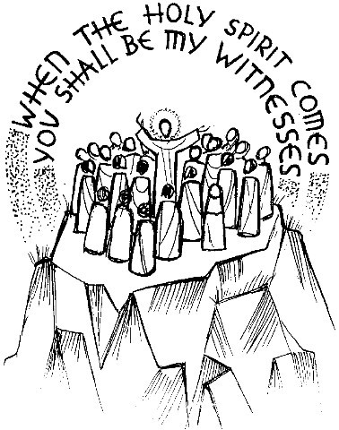
Pentecost Sunday: NEXT SUNDAY: The Council of Churches are organising a Pentecost Praise Service. It will begin at 4 p.m. and take place with us here is St. David’s. ( Due to problems with insurance we are unable to hold the event in the Park this year )
Parish of Morriston Weekly Bulletin
St. David’s Church
www.churchinwales.org.uk
www.stdavidsmorriston.co.uk
Registered Charity : 1131686
Vicar : Rev. Hugh Lervy
Tel. : (01792) 771329
Mobile : 07976 725644
e-mail : hughlervy@sky.com

Thankyou : The next Family Eucharist will be on the first Sunday in June at which the Sunday School will lead us in a reflection of thanksgiving for the Queen’s Diamond Anniversary. If anyone has any photos from the Coronation or through her reign, Jill would be pleased to borrow them for a display. The originals will be copied and returned to you. Many thanks.

Men’s Society : a quick reminder that because of the extra Bank holiday at the beginning of June our next meeting of the Men’s society has been brought forward a week to Tuesday 29th May at 6.30 p.m. in the Eagle. All men are welcome to join us - please see John Richardson for details.

Ordination : our new Curate (Andrew Perrin) will be ordained Deacon at Brecon Cathedral on Saturday 30th June. the service starts at 12 midday. We hope as many as possible from the Parish will be able to join us at this service. If you are going could you please put your name on the list. Could you indicate if you are taking a car ( and if you are able to offer lifts ) or if you would prefer to travel by bus ( probably c. £8 per head ).

Charity Coffee Morning : in aid of the Diocesan Widows, Orphans and Dependents Fund will take place on Thursday 14th June following the 10.30 service. Tickets are now available at £1.

Morriston Park 100th Birthday : on Saturday 9th June from 1.30 to 7 p.m. there will be stalls / entertainment/ music etc taking place in the park. It should be a good day out for all the family.

Ministry and Calling Sunday : We all have something that only we can do. All of us have particular talents and abilities. We do them because we enjoy them but more importantly because they give us a sense of fulfilment. We get the sense that somehow they are what we are meant to do. A vocation is something that we believe God calls us to do. Every single one of us has a calling, a vocation and we all need to try and work out what it is. Today we pray for the Vocation and Calling of all God’s people. For further details please see the Church in Wales Website.

