29th April 2012 Today is the fourth Sunday of Easter

Hymns at Eucharist : 565 , 734 , 87 , ( 156 , 297 , 114 , 752 ) , 525

TODAY 10.00 am Parish Eucharist with Confirmation and

Sunday School.

Followed by Tea / Coffee - all welcome.

4.00 pm Baptism

6.00 pm Evensong

MONDAY 10.00 am Parent and Toddler group

TUESDAY 2.00 pm Mother’s Union. Speaker : Mr/ Ridge on the
“Weavers of Gower”
6.30 pm Men’s Society at the Eagle

WEDNESDAY 7.30 pm Bible Study Group at 2 Mynydd Garnlwydd Road
(2nd and 4th Wednesday each month)

THURSDAY 10.30 am Holy Eucharist
Followed by refreshments in the crypt
6.00 pm Youth Club for school years 4,5,6 ( Crypt )
6.00 pm Clergy Surgery for booking of baptisms, banns and
weddings etc. No appointments necessary.
7.00 pm Holy Eucharist

FRIDAY 10.00 am Church working party - all welcome

NEXT SUNDAY Acts 8:26-40, 1 Jn. 4:7-21, Jn. 15:1-8
9.30 am Family Eucharist
Followed by tea / coffee
11.15 am Baptism
2.00 pm Baptism
6.00 pm Holy Eucharist
Welcome : to Bishop John and all who join us in worship today to support those being Confirmed.

Confirmation Service :
Please hold those to be confirmed in your prayers :
Ian Davies, Lynne Evans, Marian Ley , Richard Leigh,
Miriam Leigh, Morgan Hunt, Laura Smedley, Mark Roberts,
Katherine Roberts and Eve Smith.

Come Holy Spirit, renew the hearts of your faithful servants

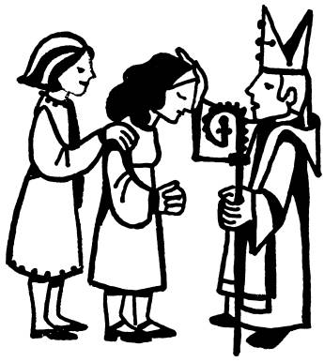
Parish Meal : will be held at Morriston Golf Club on FRIDAY 1st JUNE ( 7 for 7.30 ). The cost will be £13.50 ( 3 courses ). We do hope as many as possible will be able to join us. Do invite family and friends to come along. For details and to book your place / meal please see the form at the back of Church or speak to Anne Lewis. Please let us know if you are coming as soon as you can ( by 20th May at the latest) . Thankyou.
Would you please let the Vicar know of people who
need visiting at home or in hospital. Thankyou
Parish of Morriston Weekly Bulletin
St. David’s Church
www.churchinwales.org.uk
www.stdavidsmorriston.co.uk
Registered Charity : 1131686
Vicar : Rev. Hugh Lervy
Tel. : (01792) 771329
Mobile : 07976 725644
e-mail : hughlervy@sky.com

THE CHURCH IS OPEN MONDAY TO FRIDAY FROM
10 a.m. to MIDDAY FOR
QUIET PRAYER.

Mother’s Union Diocesan Festival : Wednesday 16th May at 2.30 p.m. in Brecon Cathedral. Please let Jean Beddoe know this week if you would like to attend.

Cathedral Friends : Meuryl is now collecting the subs for the coming year if anyone would like to join the Friends of Brecon Cathedral - Please speak to Meuryl for details.

PCC and Churchwarden Affirmation Prayers : will take place during the 9.30 service on Sunday 13th May. Could new PCC members please try to be present. Thankyou.

Diocesan Choral Festival : takes place on Saturday 12th May in Brecon Cathedral. It is open to any wishing to become involved. Please ask for details.

Christian Aid Week : 13th - 19th May. If you can help with the Street Collection or door to door collecting please let Harry know. All help is greatly appreciated.

Preaching : "I hope you didn't take it personally, Vicar," an embarrassed woman said after a church service, "when my husband walked out during your sermon." "I did find it rather disconcerting," the preacher replied. "It's not a reflection on you, sir," insisted the churchgoer. "Ralph has been walking in his sleep ever since he was a child."

