Parish of Morriston
St. David’s Church
Weekly Bulletin
www.churchinwales.org.uk
www.stdavidsmorriston.co.uk
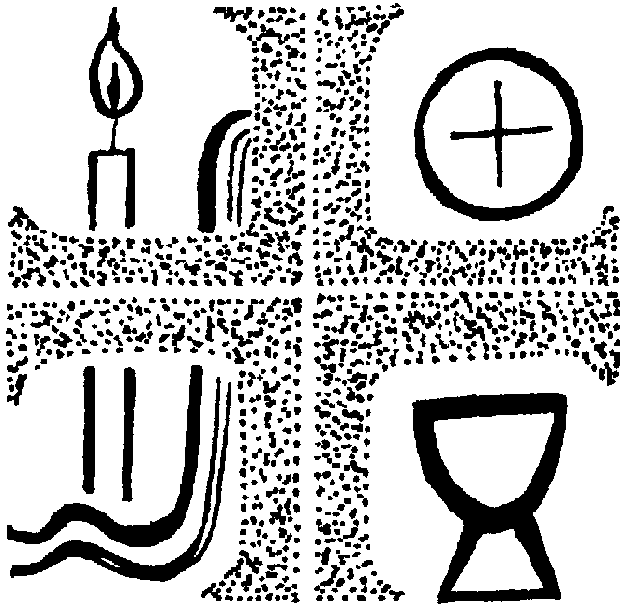

Vicar : Rev. Hugh Lervy

Tel. / Fax. : (01792) 771329

Mobile : 07976 725644

e-mail : thevicar@fsmail.net

Curate:
Rev. Edwin Phillips
(01639) 886784

Would you please let the Vicar know of people who
need visiting at home or in hospital. Thankyou
The Church is open Monday to Friday from 10 a.m. to 12 Midday those wishing to call in for a time of quiet prayer.

7th September 2008 Today is the sixteenth Sunday after Trinity

Hymns at Eucharist : 97 , 288 , 118 , 88 , ( 455 , 332 , 87 , 277 ) , 741

Welcome to all who join us for our service today –especially Bishop John and the families of those to be confirmed. We hope you can join us for tea / coffee at the back of church at the end of our service today.

TODAY 10.00 am Parish Eucharist with Confirmation

Preacher and Celebrant : The Bishop

4.30 pm PCC Meeting

6.00 pm Healing Eucharist

MONDAY 10.00 am Parent and Toddler group restarts

TUESDAY 2.00 pm Mother’s Union restarts : Open Meeting

WEDNESDAY 7.00 pm M.U. Diocesan Quiet Hour ( St. David’s )

THURSDAY 10.30 am Holy Eucharist
Followed by refreshments in the crypt
6.00 pm Clergy Surgery for booking of baptisms, banns and
weddings etc. No appointments necessary.

SATURDAY 12.00 pm Wedding
3.00 pm Installation of the Very Rev. Geoffrey Marshall as
the Dean of Brecon Cathedral

NEXT SUNDAY Holy Cross Day
Readings : Num. 21:4-9, 1 Cor. 1:18-24, Jn. 3:13-17
9.30 am Parish Eucharist with Sunday School
11.15 am Cymun Bendigaid
6.00 pm Evening Worship
200 Club 2008 /9 : If you would like to join for the coming twelve months the subscription is £20. Family and friends are welcome to join. There are three prizes in the monthly draw of £50, £25 and £15. Could subscriptions please be paid by the end of September.

Church Garden : Prayers to dedicate the garden will take place following the 9.30 service next Sunday.

Charity Coffee Morning : in aid of “Tumaini” ( which works with children with HIV / AIDS in Kenya will take place on Thursday 18th September at 11 a.m. Tickets are £1.

Thursday Night Youth Club : restarts on the 18th September.

Council of Churches meeting : Tuesday 16th September at 7.30 p.m. in Aenon. The Council of Churches Harvest service will take place at Pentremalwed Church on Tuesday 23rd September at 7.30 p.m.

Harvest Festival : Sunday 5th October. Our morning service will begin at 10 a.m. and will be a family Eucharist led by our Sunday School. This will be followed by our Harvest lunch ( tickets now available at £3 ) – all are welcome. At 6 p.m. the guest preacher at our Harvest Evensong will be the new Dean on Brecon Cathedral the Very Rev. Geoffrey Marshall. This year cash donations will be made to Shelter Cymru, and the young people may bring dried and tinned food which will be given to local charities working with the homeless.

New bus route from NEXT SUNDAY: This is a FREE service for you and we hope it is well used. 8.45 am : Clydach Road ( lay-by near Christopher Road ), Llanllienwen Rd ( 2 stops ) , Rhodfa Fadog, Rhodfa Eos , Heol Y Fran , Heol Maes Eglwys, Maes y Gwernen estate entrance, Cwmrhydyceirw Rd, Camelia Drive, Heol Rhosyn , Brayley Rd , Vicarage Rd, left at Carmel Chapel , Clyndu Street , Morfydd Street, St. David’s. The return journey will follow the same route but will also go up to Francis Road.

Three lots of thanks : to those who helped with church and grounds cleaning last week , to those who supported the Open the Book Service last Sunday night and to those who joined us for the launch of the Men’s Society on Tuesday.

Training Course : Barbara Williams is to run a course on Core Skills in the Crypt on various Monday evenings in the Autumn Term. This course will target Sunday School Teachers and further develop our skills with children. Please give your name to Diane Richardson if you wish to join. The first meeting will be on 22nd September and it is hoped that other parishes will join us.

