8th January 2012

Today is Epiphany Sunday

Carols at Eucharist : 26 , 3 , 22 , ( 25 ) , 6

TODAY 9.30 am Parish Eucharist

11.15 am Cymun Bendigaid

6.00 pm Evensong

MONDAY 10.00 am Parent and Toddler group
7.30 pm Evening M.U. ( every fortnight )

TUESDAY 2.00 pm Mother’s Union AGM
7.15 pm Council of Churches AGM (Aenon) - all welcome

WEDNESDAY 7.30 pm Bible Study Group at 2 Mynydd Garnlwydd Road
(2nd and 4th Wednesday each month)

THURSDAY 10.30 am Holy Eucharist
Followed by refreshments in the crypt
6.00 pm Youth Club for school years 4,5,6 ( Crypt )
6.00 pm Clergy Surgery for booking of baptisms, banns and
weddings etc. No appointments necessary.

FRIDAY 10.00 am Church working party - all welcome

NEXT SUNDAY 1Sam.3:1-20, Rev.5:1-10, Jn. 1:43-51
9.30 am Parish Eucharist with Sunday School
11.15 am Baptism
4.30 pm PCC Meeting
6.00 pm Evensong

PARISH NOTES

Happy New Year : as this is the first bulletin of 2012 may I take this opportunity to wish you all a very Happy New Year.

Thankyou : very much for the many cards and gifts received in the Vicarage over Christmas - it was very kind of you all. ( We did receive card with money in for the boys but the card was not signed so we are unable to acknowledge it personally - it was handmade card - if you sent it I would be very grateful to know so we can thank you ! )

Concert : will be held here in St. david’s in aid of Chernobyl Children’s Lifeline on Sunday 5th February at 6 p.m. For details and tickets please speak to Ingrid or Roy.

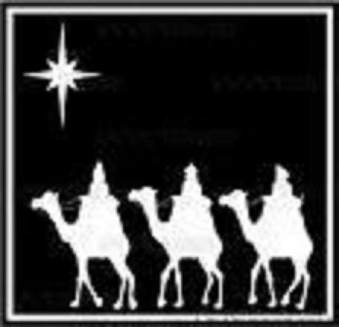
Week of prayer for Christian Unity : several services have been organised by the Morriston Council of Churches. On Saturday 21st January from 10.30 a.m. there will be a quiet prayer hour here in St. David’s. Then on Tuesday 24th January the United service will take place in the New Chapel at Morriston Hospital at 7.30 p.m. All are welcome to these services.
Would you please let the Vicar know of people who
need visiting at home or in hospital. Thankyou
Parish of Morriston Weekly Bulletin
St. David’s Church
www.churchinwales.org.uk
www.stdavidsmorriston.co.uk
Registered Charity : 1131686
Vicar : Rev. Hugh Lervy
Tel. : (01792) 771329
Mobile : 07976 725644
e-mail : hughlervy@sky.com

Thankyou : to all who worked so hard over the Christmas period with our various services and activities. It was lovely to be able to welcome so many people into our Church and your commitment has been greatly appreciated. Feedback to the Christmas Eve Service times has been very positive.

PCC Meeting : next Sunday at 4.30 p.m. We will be setting dates for the coffee mornings for the coming year and deciding which four charities we will be supporting this year. If you have suggestions to put forward please let us know by next Sunday.

200 Club Winners December Christmas Draw : 1st no. 120 Nessie Isaac, 2nd 43 Barbara Edwards , 3rd no. 84 Joh Perrott. Congratulations to the winners.

RIP : we extend our condolences and prayers to Mair Jones and family following the passing away of Brian just before Christmas. May the souls of the departed through the love and mercy of God rest in peace.

Thankyou : to Edwin who led the mid-week service for me on Thursday this week.

Advent Collection : if there are any further donations to be made to our Advent appeal for Children’s Charities we would be grateful to receive them as soon as possible. We will let you know the total raised soon.

