4th December 2011 Today is the second Sunday of Advent

Hymns at Eucharist : 128 , 734 , 259 , ( 428 , 263 , 372 ) , 646

TODAY 9.30 am Parish Eucharist with Sunday School

Followed by tea / coffee

11.00 am Sunday School Christmas Party (crypt)

6.00 pm Holy Eucharist

MONDAY 10.00 am Parent and Toddler group
6.30 pm Men’s Society Christmas Dinner at the
Eagle - please note the change of night.
TUESDAY 2.00 pm Mother’s Union End of Session
“Christmas Symposium”

WEDNESDAY 7.30 pm Bible Study Group at 2 Mynydd Garnlwydd Road
(2nd and 4th Wednesday each month)

THURSDAY 10.30 am Holy Eucharist (in the crypt)
Followed by a charity coffee morning in aid
of the Cardiomyopathy Support Group
6.00 pm Youth Club for school years 4,5,6 ( Crypt )
6.30 pm Communities First Lantern Parade ending
with Carol Singing in our Church Grounds -
all welcome.
6.00 pm Clergy Surgery for booking of baptisms, banns and
weddings etc. No appointments necessary.

FRIDAY 10.00 am Church working party - all welcome

SATURDAY 11.00 am Council of Churches Carol Singing outside
St. David’s - all are welcome.

NEXT SUNDAY Readings : Is. 61:1-11, 1 Thes. 5:16-24, Jn. 1:6-28
9.30 am Parish Eucharist with Sunday School
11.15 am Cymun Bendigaid
6.00 pm CHRISTMAS PRAISE - see notes
Thankyou : to all who worked hard and helped with the Christmas Fete on Friday.

Thankyou : to Diane Richardson who organised the shopping trip yesterday. I hope you all enjoyed.

Christmas Cards : a board has been placed at the back of church for any wishing to send a card to all friends in church (rather than sending many individual cards). Can I remind you to collect your used stamps over the Christmas period (cutting 1 cm around the stamp). A box is at the back of Church for stamps which are used to raise funds for the RNIB.

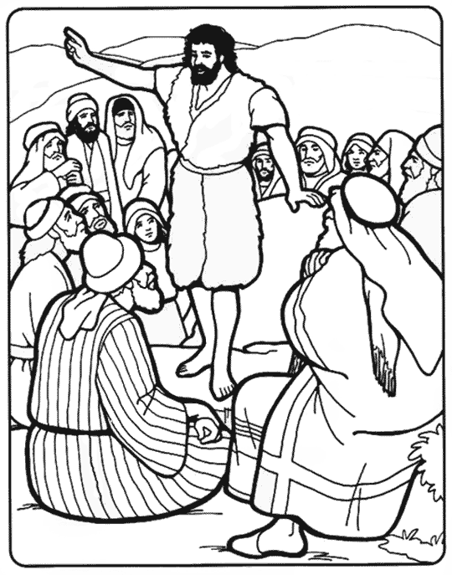
Advent Collection : once again this year we are collecting your 20p pieces in the Smarties Tubes - please help yourself to one. Your donations can be returned during our Christmas Services - all money raised will be given to local children’s Charities.
Parish of Morriston Weekly Bulletin
St. David’s Church
www.churchinwales.org.uk
www.stdavidsmorriston.co.uk
Registered Charity : 1131686
Vicar : Rev. Hugh Lervy
Tel. : (01792) 771329
Mobile : 07976 725644
e-mail : thevicar@fsmail.net

Coffee Morning : in aid of the Cardiomyopathy Support Group on Thursday this week at 11 a.m. Tickets are available at £1. Please help to sell them. Do come and join us if you can.

Christmas Praise Service with the Salvation Army and the Bay Choir : NEXT SUNDAY at 6 p.m. - one not to miss !! The service will be followed by Coffee and Mince Pies.

Carol Service for the Bereaved : Wednesday 14th December at 7 p.m. here in St. David’s. It is arranged by ABM Hospital Board and is open to any wishing to attend.

Christingle and Nativity Service : Sunday 18th December at 4 p.m. - do invite family and friends to join this very special Christmas Service. ( we will be putting the Christingles together on the morning of Saturday 17th - volunteers to help with this would be most welcome).

Morriston Comprehensive School Carol Service : will take place in St. David’s on Monday 19th December at 7 p.m. There is an open invitation to anyone wishing to come along.

Christmas Services : On Christmas Eve a Family Eucharist will be led for us by the Sunday School - this year it will begin at 5 p.m. Our late service of Holy Eucharist ( Midnight Mass ) will then begin at 10 p.m. On Christmas Morning : Holy Eucharist with Carols will begin at 10 a.m. - do try and and join us for our Christmas Services and invite along family and friends.

Home Communion : with so many unable to attend Church at the moment through ill health can I remind you that if anyone would like to receive communion at home ( because health prevent them attending our Church services ) please let me know and we will arrange to bring you the sacrament. If for other reasons you find yourself unable to attend your usual services do try and join us at other services that take place each week.

Half the people you know are below average.

