20th November 2011

Today is the feast of Christ the King

Hymns at Eucharist : 12 , 580 , 448 , ( 644 , 274 , 649 ) , 137
Psalm 97 : 1-7 BCP p. 576

TODAY 9.30 am Parish Eucharist with Sunday School

6.00 pm Evensong

MONDAY 10.00 am Parent and Toddler group

TUESDAY 2.00 pm Mother’s Union : Speaker : Clive Williams on
“Vienna 1750”

WEDNESDAY 7.30 pm Bible Study Group at 2 Mynydd Garnlwydd Road
(2nd and 4th Wednesday each month)

THURSDAY 10.30 am Holy Eucharist
Followed by refreshments in the crypt
6.00 pm Youth Club for school years 4,5,6 ( Crypt )
6.00 pm Clergy Surgery for booking of baptisms, banns and
weddings etc. No appointments necessary.

FRIDAY 10.00 am Prayer Fellowship Group (Crypt)
- all welcome
10.00 am Church working party - all welcome

NEXT SUNDAY Advent Sunday
Readings : Is. 64:1-9, 1 Cor. 1:3-9, Mk. 13:24-37
9.30 am Parish Eucharist with Sunday School
11.15 am Cymun Bendigaid
2.00 pm Baptism
6.00 pm ADVENT SERVICE OF PRAYERS, READINGS AND HYMNS - DO TRY AND JOIN US.

Sunday School Teacher’s Meeting : a meeting will take place following the morning service today to look at the Craft Morning - please stay if you can help.

Congratulations: to Ian and Nicola Morris on the safe arrival of baby Leo on Friday 11th November. With love from all your friends in church.

Traidcraft : if anyone would like to order from the Traidcraft Christmas Catalogue, would you please let Joan Lewis have your orders TODAY. Thankyou

Confirmation Service 2012 : If anyone would like to be Confirmed in the early part of 2012 would you please complete and return an application form as soon as possible. If you wish to know more about what is involved please ask.

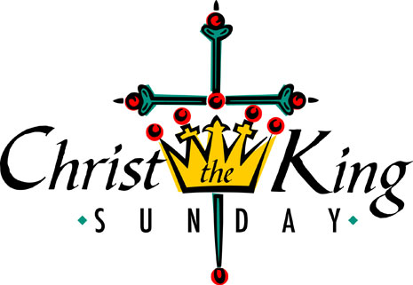
Christmas Concert : by the Swansea Philharmonic Choir on Saturday 3rd December at 7.30 p.m. in the Brangwyn Hall ( inc. Gounod : St. Celia Mass and Dvorak : Te Deum ). If you would like tickets please speak to Eira ( 528322 )
Would you please let the Vicar know of people who
need visiting at home or in hospital. Thankyou
Parish of Morriston Weekly Bulletin
St. David’s Church
www.churchinwales.org.uk
www.stdavidsmorriston.co.uk
Registered Charity : 1131686
Vicar : Rev. Hugh Lervy
Tel. : (01792) 771329
Mobile : 07976 725644
e-mail : thevicar@fsmail.net

Advent Service of Hymns and Readings : NEXT SUNDAY at 6 p.m. - do try and join us. Leaflets are now available with full details of the Advent and Christmas Services. Please take spare copies if you can help distribute them to family and friends. Can I draw your attention to the times of the Christmas Eve services which have changed this year.

Christmas Fete : Friday 2nd December at 5 p.m. Items for the stalls ( tins / toiletries / cards and crafts etc ) would be appreciated. POSTERS ARE ALSO AVAILABLE IF YOU CAN HELP TO DISPLAY THEM AROUND OUR COMMUNITY. Please help to sell raffle tickets if you can. The Tree of Light will be switched on the same evening at 4.30 p.m. Sponsorship forms are now available if you wish to remember someone by name through the Glantawe Lions sponsorship scheme.

Sunday School Christmas Party : on Sunday 4th December - please let our young members know, and let Jill know if they can come along.

Coffee Morning : in aid of the Cardiomyopathy Support Group on Thursday 8th December at 11 a.m. Tickets are now available at £1. Please help to sell them.

Christmas Praise Service with the Salvation Army and the Bay Choir : on Sunday 11th December at 6 p.m. - one not to miss !!

Taxes : A tax collector went to a tannery. "Why haven't you paid your taxes?" the collector asked the owner of the tannery. "Business has been very bad," answered the tanner. "Do you mind if I check around the place?" asked the tax man. "Go ahead," invited the owner. "You'll see I have nothing to hide."

