Parish of Morriston
St. David’s Church
Weekly Bulletin
www.churchinwales.org.uk
www.stdavidsmorriston.co.uk
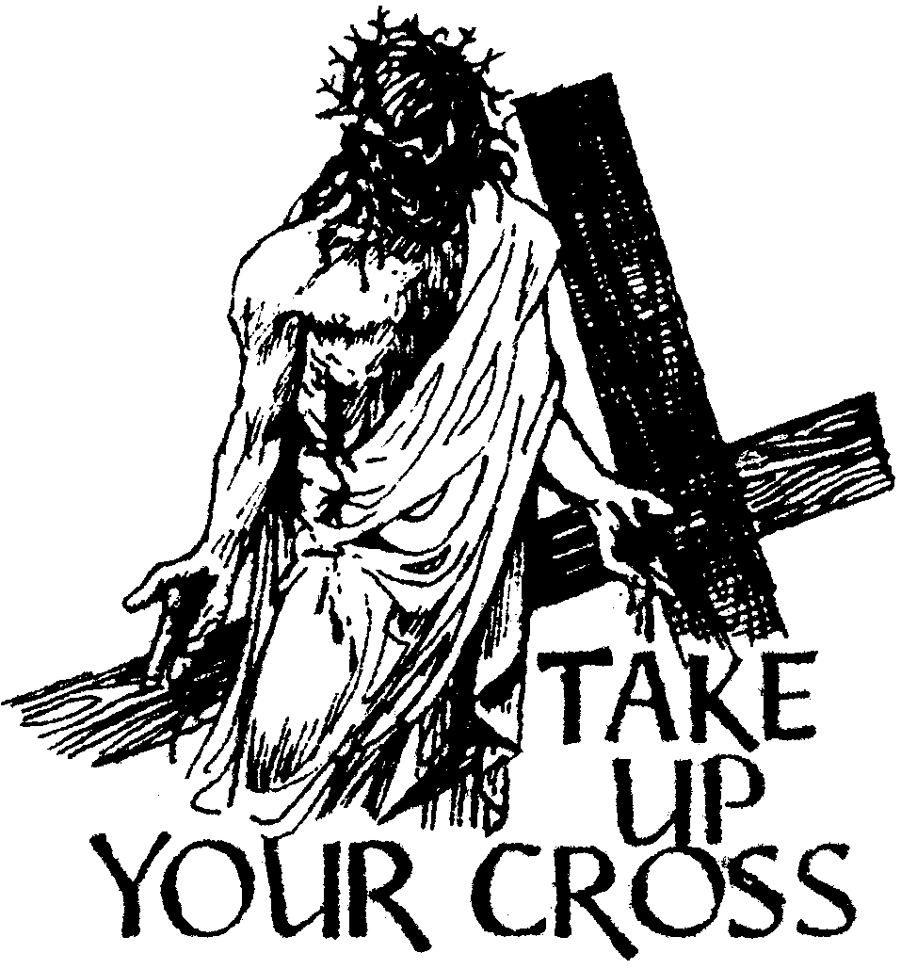

Vicar : Rev. Hugh Lervy

Tel. / Fax. : (01792) 771329

Mobile : 07976 725644

e-mail : thevicar@fsmail.net

Curate:
Rev. Edwin Phillips
(01639) 886784

Would you please let the Vicar know of people who
need visiting at home or in hospital. Thankyou
The Church is open Monday to Friday from 10 a.m. to 12 Midday those wishing to call in for a time of quiet prayer.

31st August 2008

Today is the fifteenth Sunday after Trinity

Hymns at Eucharist : 570 , 45 , 176 , ( 659 , 318 , 67 ) , 172

TODAY 9.30 am Parish Eucharist with Sunday School

11.15 am Baptism

1.30 pm Baptism

6.00 pm A service to launch the OPEN THE BOOK

PROJECT. Preacher : Archdeacon Robert

Williams. DO TRY AND JOIN US.

MONDAY 10.00 am Parent and Toddler group

TUESDAY 7.00 pm The first meeting of our Men’s Society at the
Welcome Inn

THURSDAY 10.30 am Holy Eucharist
Followed by refreshments in the crypt
5.00 pm Confirmation Rehearsal
6.00 pm Clergy Surgery for booking of baptisms, banns and
weddings etc. No appointments necessary.
7.00 pm Holy Eucharist with Baptisms

NEXT SUNDAY Readings : Ez. 33:7-11, Rom 13:8-14, Mt. 18:15-20
10.00 am Parish Eucharist with Confirmation.
Preacher and Celebrant : The Bishop
4.30 pm P.C.C. Meeting
6.00 pm Healing Eucharist

PARISH NOTES

200 Club 2008 /9 : The September draw will be the last for the coming year. If you would like to join for the coming twelve months the subscription is £20. Family and friends are welcome to join. There are three prizes in the monthly draw of £50, £25 and £15. Could subscriptions please be paid by the end of September.

Mother’s Union Festival : Wednesday 10th September at 7 p.m.

Church Garden : thankyou to all who contributed to the garden. Prayers to dedicate the garden will take place following the 9.30 service on the 14th September.

Charity Coffee Morning : in aid of “Tumaini” ( which works with children with HIV / AIDS in Kenya will take place on Thursday 18th September at 11 a.m. Tickets are £1.

Council of Churches meeting : Tuesday 16th September at 7.30 p.m. in Aenon. The Council of Churches Harvest service will take place at Pentremalwed Church on Tuesday 23rd September at 7.30 p.m.

Harvest Festival : Sunday 5th October. Our morning service will begin at 10 a.m. and will be a family Eucharist led by our Sunday School. This will be followed by our Harvest lunch ( tickets available soon ). At 6 p.m. the guest preacher at our Harvest Evensong will be the new Dean on Brecon Cathedral the Very Rev. Geoffrey Marshall. This year cash donations will be made to Shelter Cymru, and the young people may bring dried and tinned food which will be given to local charities working with the homeless.

New bus route from 14th September : the following route will be followed in response to requests made. If any changes are needed please ask and we will do our best to accommodate you. This is a FREE service for you and we hope it is well used. 8.45 am : Clydach Road ( lay-by near Christopher Road ), Llanllienwen Rd ( 2 stops ) , Rhodfa Fadog, Rhodfa Eos , Heol Y Fran , Heol Maes Eglwys, Cwmrhydyceirw Rd, Camelia Drive, Heol Rhosyn , Brayley Rd , Vicarage Rd, left at Carmel Chapel , Clyndu Street , Morfydd Street ., St. David’s. The return journey will follow the same route but will also go up to Francis Road.

"A horse may be coaxed to drink, but a pencil must be lead."

