6th Nov. 2011 Today is the third Sunday before Advent ( Kingdom 2 )

Hymns at Eucharist : 286 , 45 , 883 , ( 915 , 70 , 819 ) , 201

TODAY 9.30 am Family Eucharist led by our Sunday School

Followed by tea / coffee - all welcome

11.15 am Baptism

4.30 pm RD Conference (crypt) : Speaker : Janet

Russell (The Diocesan Missioner)

6.00 pm Deanery Eucharist (Celebrant : the Area

Dean) - do try and join us.

MONDAY 10.00 am Parent and Toddler group

TUESDAY 9.30 am Cwmrhydyceirw School Church visit
for a “Wedding”
2.00 pm Mother’s Union: Speaker : Mr. Warren on
“The day I burnt a Million pounds”.

WEDNESDAY 2.00 pm Church in wales Review Meeting (Cathedral)
- see notes
7.30 pm Bible Study Group at 2 Mynydd Garnlwydd Road
( alternate weeks)

THURSDAY 10.30 am Holy Eucharist
Followed by refreshments in the crypt
6.00 pm Youth Club for school years 4,5,6 ( Crypt )
6.00 pm Clergy Surgery for booking of baptisms, banns and
weddings etc. No appointments necessary.

FRIDAY 10.00 am Church working party - all welcome

NEXT SUNDAY Remembrance Sunday
Readings : Zeph. 1:7-18, T Thes. 5:1-11, Mt. 25:14-30
9.30 am Parish Eucharist with Sunday School
11.15 am Cymun Bendigaid
6.00 pm Evening Worship
Remembrance Sunday : Next Sunday : acts of Remembrance will take place during our morning services.

Confirmation Service 2012 : If anyone would like to be Confirmed in the early part of 2012 would you please complete and return an application form as soon as possible. Please remember that Confirmation is a serious commitment ( the minimum age is 11 ). If you wish to know more about what is involved please ask.

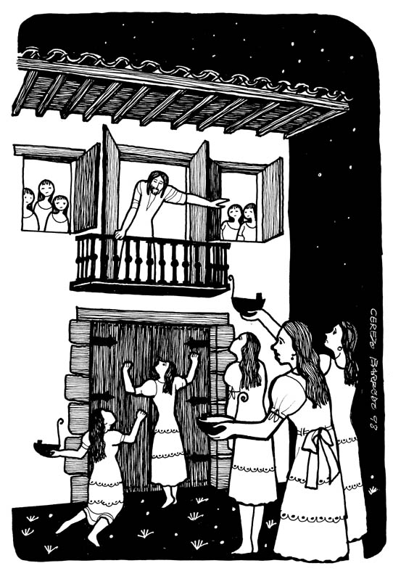
Absent Friends Concert : in aid of Macmillan. On Saturday 12th November at 6 pm. in All Saints Church, Mumbles. Tickets £10 ( tel. 361302)
Would you please let the Vicar know of people who
need visiting at home or in hospital. Thankyou
Parish of Morriston Weekly Bulletin
St. David’s Church
www.churchinwales.org.uk
www.stdavidsmorriston.co.uk
Registered Charity : 1131686
Vicar : Rev. Hugh Lervy
Tel. : (01792) 771329
Mobile : 07976 725644
e-mail : thevicar@fsmail.net

Christmas Concert : by the Swansea Philharmonic Choir on Saturday 3rd December at 7.30 p.m. in the Brangwyn Hall ( inc. Gounod : St. Celia Mass and Dvorak : Te Deum ). If you would like tickets please speak to Eira ( 528322 )

Church in Wales Review Meeting : this Wednesday in Brecon Cathedral at 2 p.m. This is an open meeting for anyone wishing to share views on the life and structure of the Church in Wales. All are welcome to attend and to hear and share views on the direction the Church should take in the coming years as it continues it’s mission in our Province in often challenging times.

Safeguarding Training Event : on Monday 14th November at 7 p.m. ( until 9 p.m. ) in St. Illtyd’s Church, Fforestfach. All are welcome to attend ( esp. those involved with groups with Children and young people ). The focus of the evening will be esp. looking at Internet and Mobile Phone bullying and grooming.

Missionaries of Charity : who are based on the Strand in Swansea and who work with the homeless of our City are asking for gifts of Hats/ Scarves / gloves and toiletries for their Christmas appeal. If anyone can help please speak to Ingrid.

200 Club Winners Oct. : 1st. no. 149 Peter Davies, 2nd no. 1 The Vicar , 3rd no. 116 Janet Owen .

Evening Mother’ Union : the visit to the Norwegian Church will take place on Monday 14th November meeting at St. David’s at 6.30 p.m. Please speak to Gaynor Demery if lifts are required. The Christmas Dinner will be at the Eagle in Treboeth. Please speak to Gaynor or Myra to book your place.

Advent Service of Hymns and Readings : Sunday 27th November at 6 p.m.

Why is it called lipstick if you can still move your lips?

