2nd October 2011

Today is the fifteenth Sunday after Trinity ( HARVEST FESTIVAL )

Welcome to all who join us for our Harvest Festival today.

Hymns at Eucharist : 25 , 108 , 773 , ( 235 , 236 , 216 , 166 ) , 525

Hymns at Evensong : 133 , 719 , 696 , 474 Psalm : 67 BCP p. 530

TODAY 10.00 am Family Eucharist led by our Sunday School

12.30 pm Harvest Lunch at the Treetops

6.00 pm Harvest Evensong. Speaker : Mr. Peter

Nicholls on the work of Barnardos.

MONDAY 10.00 am Parent and Toddler group
7.00 pm Council of Churches Harvest Service in
Tabernacle (CRC) Preacher : Rev. Eirion Wyn

TUESDAY 2.00 pm Mother’s Union Holy Eucharist to celebrate
MU being formed in the Parish for 100 years.
All are welcome to join this service.

WEDNESDAY 7.30 pm Bible Study Group at 2 Mynydd Garnlwydd Road
( alternate weeks)

THURSDAY 10.30 am Holy Eucharist
Followed by refreshments in the crypt
6.00 pm Youth Club for school years 4,5,6 ( Crypt )
6.00 pm Clergy Surgery for booking of baptisms, banns and
weddings etc. No appointments necessary.
7.00 pm Holy Eucharist

FRIDAY 10.00 am Church working party - all welcome

SATURDAY 10.15 am Diocesan Conference (Brecon Cathedral)

NEXT SUNDAY Readings : Is. 25:1-9, Phil. 4:1-9, Mt. 22:1-14
9.30 am Parish Eucharist with Sunday School
11.15 am Cymun Bendigaid
6.00 pm Evensong

Harvest Donations : cash donations given through Harvest envelopes today will be given to Barnardos. Thankyou to all who have given donations and gifts for them to use in their vital work.

Thankyou : to all who helped to prepare the Church for our Harvest Festival today. Thankyou also to the teachers and children of our Sunday School who have worked so hard to prepare our worship this morning.

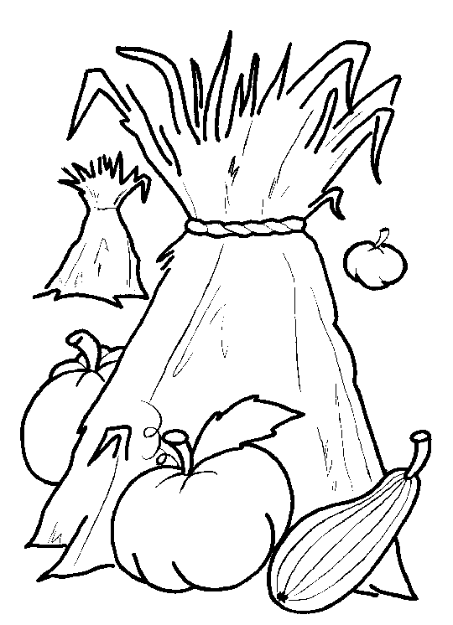
Thankyou : June and John Stoker would like to thank everyone for their kind cards, gifts and messages on the occasion of their Golden Wedding Anniversary.
Would you please let the Vicar know of people who
need visiting at home or in hospital. Thankyou
Parish of Morriston Weekly Bulletin
St. David’s Church
www.churchinwales.org.uk
www.stdavidsmorriston.co.uk
Registered Charity : 1131686
Vicar : Rev. Hugh Lervy
Tel. : (01792) 771329
Mobile : 07976 725644
e-mail : thevicar@fsmail.net

The Church is open Monday to Friday 10 a.m. to Midday for private prayer / quietness.

Coffee Morning : following our coffee morning for Ty Olwen recently we have given £300 to the hospice. Thankyou to all who gave donations.

Disaster Box: following the mining tragedy in Pontardawe we have sent a donation of £500 to the appeal. Thankyou to all who give through this box helping us to respond quickly to International, National and local disasters.

Thankyou : to all who joined us last Sunday evening for our service led by Rev. Lionel Hopkins.

Cheese and Wine : thankyou to all who supported this evening and those who prepared it for us. £268 was raised for our Church funds.

200 Club Winners September : 1st.no 16 Betty Williams , 2nd 73 Margaret Jones, 3rd 42 Anne Dawson. Congratulations to this months winners. To be included in the draws for the coming twelve months subscriptions of £20 should be paid as soon as possible.

Church Roof : following two very bad winters issues have developed with some of the stones on the Church roof. As a matter of urgency we are going to carry out the repair work in the next few weeks. The cost of the work will be about £15,000. Due to the urgency we do not have time to fundraise for this work, however, if anyone would like to help with the costs all donations would be very gratefully received.

Harvest Lunch : Checking the menu, a restaurant customer ordered a bowl of vegetable soup. After a couple of spoonfuls, he saw a circle of wetness right under the bowl on the tablecloth. He called the waitress over and said, "The tablecloth is all wet. The bowl must be cracked." The waitress said, "You ordered vegetable soup, didn't you?" "Yes." "Maybe it has a leek in it!"

