Parish of Morriston
St. David’s Church
Weekly Bulletin
www.churchinwales.org.uk
www.stdavidsmorriston.co.uk
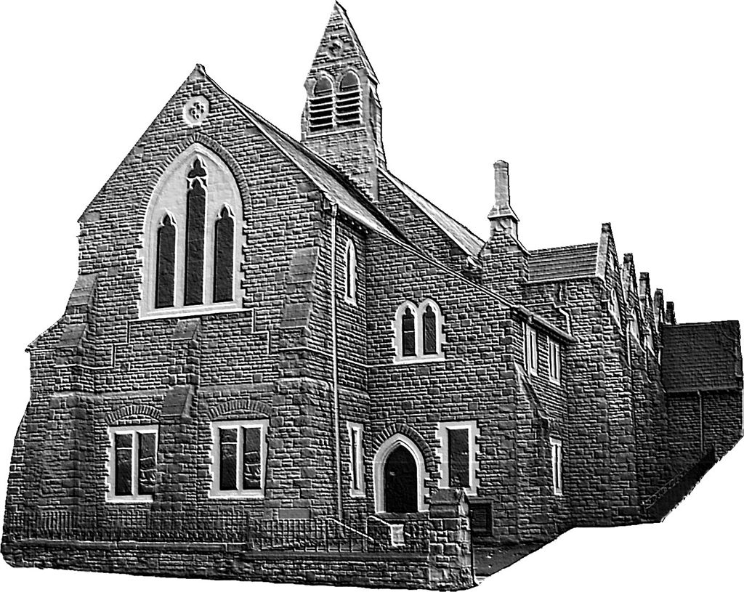

Vicar : Rev. Hugh Lervy

Tel. / Fax. : (01792) 771329

Mobile : 07976 725644

e-mail : thevicar@fsmail.net

Curate:
Rev. Edwin Phillips
(01639) 886784

Would you please let the Vicar know of people who
need visiting at home or in hospital. Thankyou
The Church is open Monday to Friday from 10 a.m. to 12 Midday those wishing to call in for a time of quiet prayer.

24th August 2008 Today is the fourteenth Sunday after Trinity

Hymns at Eucharist : 174 , 47 , 448 , ( 682 , 734 , 541 ) , 636

TODAY 9.30 am Parish Eucharist

11.15 am Cymun Bendigaid

6.00 pm Evensong

MONDAY Bank Holiday
9.00 am Mother’s Union Wave of Prayer – all are welcome
to join MU members in this hour of prayer

WEDNESDAY 11.00 am Wedding Blessing

THURSDAY 10.30 am Holy Eucharist
Followed by refreshments in the crypt
6.00 pm Clergy Surgery for booking of baptisms, banns and
weddings etc. No appointments necessary.

FRIDAY 10.00 am Prayer fellowship group – all welcome –
please ask if you need a lift.

SATURDAY 10.00 am Church and Grounds cleaning. ALL
VOLUNTEERS WOULD BE VERY WELCOME.

NEXT SUNDAY Readings : Jer. 15:15-21, Rom. 12:9-12, Mt. 16:21-28
9.30 am Parish Eucharist with Sunday School
11.15 am Baptism
1.30 pm Baptism
6.00 pm A service to launch the OPEN THE BOOK project in Morriston. Do try and join us. The preacher will be Archdeacon Robert Williams.
200 Club August 2008 : 1st no. 149 , 2nd no. 45 Victoria Beddoe, 3rd. no. 146 J & E Hughes. Congratulations to this month winners. The September draw will be the last for the coming year. If you would like to join for the coming twelve months the subscription is £20. Family and friends are welcome to join. There are three prizes in the monthly draw of £50, £25 and £15. Could subscriptions please be paid by the end of September.

Thankyou : Maureen and Dennis England would like to thank everyone for the cards and good wishes on the occasion of their 40th Anniversary and Maureen’s “special” birthday.

Confirmation Service : Sunday 7th September at 10 a.m. (please note start time ). Do try and join us that morning as we welcome the Bishop to the Parish and share in this important time for the confirmees and our Parish. Please hold all to be confirmed in your prayers. The rehearsal for those who are being confirmed will take place on Thursday 4th August at 5p.m. Those who are to be baptised before confirmation will be baptised during the 7 p.m. service on Thursday 4th August.

Congratulations : to David and Maureen Morgans who yesterday celebrated their Golden Anniversary.

P.C.C. Meeting : Sunday 7th September at 4.30 p.m.

Healing Eucharist : Sunday 7th September at 6 p.m.

Mother’s Union Festival : Wednesday 10th September at 7 p.m.

Church Garden : thankyou to all who contributed to the garden. Prayers to dedicate the garden will take place following the 9.30 service on the 14th September.

Charity Coffee Morning : in aid of “Tumaini” ( which works with children with HIV / AIDS in Kenya will take place on Thursday 18th September at 11 a.m. Tickets are £1.

The Billboard : A local priest and pastor stood by the side of the road holding up a sign that said, "The End is Near! Turn yourself around now before it's too late!" They planned to hold up the sign to each passing car. "Leave us alone, you religious nuts!" yelled the first driver as he sped by. From around the curve they heard a big splash. "Do you think," said one clergy to the other, "we should just put up a sign that says 'bridge out' instead?"

