7th August 2011

Today is the seventh Sunday after Trinity

Hymns at Eucharist : 467 , 316 , 297 , ( 144 , 374 , 553 ) , 238

TODAY 9.30 am Parish Eucharist

11.30 am Baptism

6.00 pm Holy Eucharist

THURSDAY 10.30 am Holy Eucharist
Followed by refreshments in the crypt
6.00 pm Clergy Surgery for booking of baptisms, banns and
weddings etc. No appointments necessary.

FRIDAY 10.00 am Church working party - all welcome

NEXT SUNDAY Readings: Is. 56:1-8, Rom. 11:1-2, 29-32, Mt. 15:10-28
9.30 am Parish Eucharist
11.15 am Gwasanaeth Yn Y Bore
6.00 pm Evensong

PARISH NOTES

Welcome back : and thankyou to Edwin who is leading worship today and for the next two Thursdays - I am very grateful for his help.

Oxfam Appeal for East Africa : If you would like to support this appeal please place donations in the disaster box over the coming weeks as we assist with this unfolding humanitarian crisis.

Mother’s Union Wave of Prayer Service : Monday 22nd August from 2 till 3 p.m. in Church. All are welcome to join Mother’s Union Members for this time of prayer.

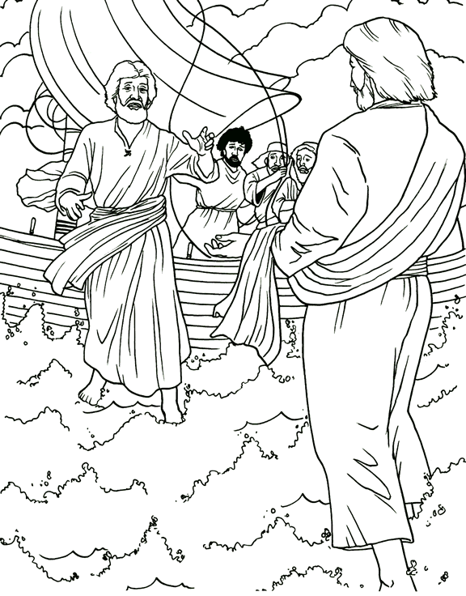
Thankyou : to Laurence and Gaynor who organised the Parent and Toddler group trip to Folly Farm last Monday - I hope you all had a good day. Thankyou to all who give of their time to run this very important group in our church family. The Parent and Toddler group will now take a break until September.
Would you please let the Vicar know of people who
need visiting at home or in hospital. Thankyou
Parish of Morriston Weekly Bulletin
St. David’s Church
www.churchinwales.org.uk
www.stdavidsmorriston.co.uk
Registered Charity : 1131686
Vicar : Rev. Hugh Lervy
Tel. : (01792) 771329
Mobile : 07976 725644
e-mail : thevicar@fsmail.net

The Church is open Monday to Friday 10 a.m. to Midday for private prayer / quietness.

Cheese and Wine Evening : Saturday 10th September at 7 p.m. Tickets are £5 and are now available. All are welcome. Please speak to Diane Richardson for details.

Charity Coffee Morning : in aid of Ty Olwen. Thursday 15th September following the 10.30 a.m. service. Tickets are £1 please help to sell them. Thankyou.

Diocesan Mission and Ministry Service : in Brecon Cathedral on Saturday 24th September at 12 midday. All are welcome to attend.

The Timid Witness : After being appointed to the church's outreach committee, one particular member was quite nervous at having to make home visits. His Vicar comforted him by suggesting that he pray. "If you spend a few minutes talking with God prior to visiting someone, it should help." When the committee met again, the nervous parishioner approached the Vicar and said, "Thank-you so much for suggesting prayer. I tried it before I went on my visit and it really worked!" "I'm so pleased to hear that," the Vicar answered. "Why don't you share your experience with the rest of the committee so others may know of the power of prayer?"
"Well," he replied, "I prayed that the people wouldn't be home, and they weren't."

