31st July 2011

Today is the sixth Sunday after Trinity

Hymns at Eucharist : 252 , 87 , 381 , ( 82 , 387 , 367 ) , 565

TODAY 9.30 am Parish Eucharist

6.00 pm Evensong

MONDAY 10.00 am Parent and Toddler group Trip to Folly Farm - bus
leaves from the Red Lion Car Park

THURSDAY 10.30 am Holy Eucharist
Followed by refreshments in the crypt
6.00 pm Clergy Surgery for booking of baptisms, banns and
weddings etc. No appointments necessary.

FRIDAY 10.00 am Church working party - all welcome

NEXT SUNDAY Readings: 1 Kings 19:9-18, Rom. 10:5-15, Mt. 14:22-33
9.30 am Parish Eucharist with Sunday School
11.15 am Baptism
6.00 pm Holy Eucharist

Safety is something a lot of people learn by accident.
PARISH NOTES

Oxfam Appeal for East Africa : If you would like to support this appeal please place donations in the disaster box over the coming weeks as we assist with this unfolding humanitarian crisis.

Mother’s Union Wave of Prayer Service : Monday 22nd August from 2 till 3 p.m. in Church. All are welcome to join Mother’s Union Members for this time of prayer.

200 Club Winners July 2011 : 1st no. 113 Bob Elvins, 2nd no. 35 Marjorie Worner, 3rd no. 149 Peter Davies. Congratulations to this months winners.

Holidays : many are away on their holidays over the coming weeks. We wish you all a refreshing break and look forward to seeing you on your return. Please keep in touch with those who are missing from our services as we work together in the mission of God’s Church in our Parish.

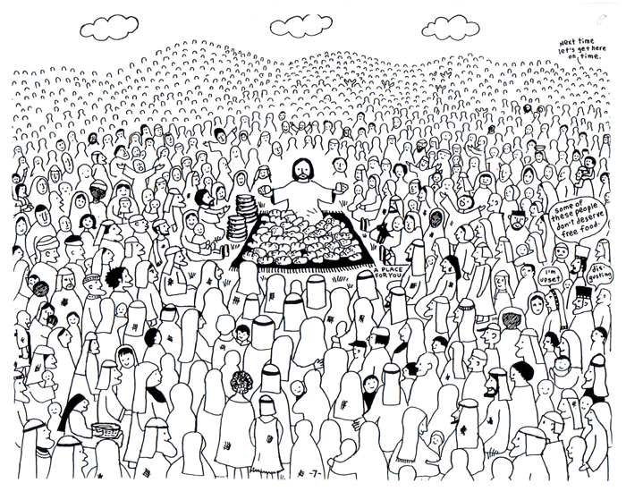
To Ponder : Sometimes we wonder, "What did I do to deserve this?" or "Why did God have to do this to me?" Here is a wonderful explanation! A daughter is telling her Mother how everything is going wrong, she's failing in school, her boyfriend broke up with her and her best friend is moving away. Meanwhile, her Mother is baking a cake and asks her daughter if she would like a snack, and the daughter says, "Absolutely, I love your cake."
Would you please let the Vicar know of people who
need visiting at home or in hospital. Thankyou
Parish of Morriston Weekly Bulletin
St. David’s Church
www.churchinwales.org.uk
www.stdavidsmorriston.co.uk
Registered Charity : 1131686
Vicar : Rev. Hugh Lervy
Tel. : (01792) 771329
Mobile : 07976 725644
e-mail : thevicar@fsmail.net

The Church is open Monday to Friday 10 a.m. to Midday for private prayer / quietness.
"Here, have some cooking oil," her Mother offers. "Yuck" says her daughter.
"How about a couple raw eggs?" "Gross!" "Would you like some flour then? Or maybe baking soda?" "Mum, those are all yucky!" To which the mother replies: "Yes, all those things seem bad all by themselves. But when they are put together in the right way, they make a wonderfully delicious cake! God works the same way. Many times we wonder why He would let us go through such bad and difficult times. But God knows that when He puts these things all in His order, they always work for good! We just have to trust Him and, eventually, they will all make something wonderful! God is crazy about you. He sends you flowers every spring and a sunrise every morning. Whenever you want to talk, He'll listen. He can live anywhere in the universe, and He chose your heart and will live there if you will only ask Jesus into your heart. I hope your day is a "piece of cake!" Life may not be the party we hoped for, but while we are here we might as well dance.

Banking : Steve walked into the bank and said to the manager, “I’d like to speak to someone about a loan.” The manager said, “I’m sorry, sir, but our Loan Arranger is out to lunch.” Steve thought it over for a moment and then asked, “Then can I see Tonto?”

