5th June 2011 Today is the seventh Sunday of Easter

Hymns at Eucharist : 12 , 814 , 773 , ( 315 , 540 , 802 ) , 727

TODAY 9.30 am Family Eucharist led by our Sunday School

Followed by tea / coffee - all welcome

4.30 pm PCC Meeting

6.00 pm Holy Eucharist

MONDAY 10.00 am Parent and Toddler group

TUESDAY 2.00 pm Mother’s Union. Speaker : Mr. D. Rogers on
Water Aid
6.30 pm Men’s Society at the Welcome Inn

WEDNESDAY 7.30 pm Bible Study Group at 2 Mynydd Garnlwydd Road
( alternate weeks)

THURSDAY 10.30 am Holy Eucharist (crypt)
Followed by a CHARITY COFFEE MORNING IN
AID OF WATER AID
6.00 pm Youth Club for school years 4,5,6 ( Crypt )
6.00 pm Clergy Surgery for booking of baptisms, banns and
weddings etc. No appointments necessary.

FRIDAY 10.00 am Church working party - all welcome

SATURDAY 1.00 pm Wedding

NEXT SUNDAY PENTECOST
Readings : Acts 2:1-21 , 1 Cor. 12:3-13 , Jn. 20:19-23
9.30 am Parish Eucharist with Sunday School
11.15 am Cymun Bendigaid
4.00 pm Pentecost Praise in the Park ( near the War Memorial) - you may like to bring a picnic.
Parish Trip to Bath This will take place on Saturday 9th July and will leave the Church at 8.30 a.m. and leave Bath at 5.30 p.m. The cost will be £10 each and names and deposits of £5 should be given to Diane Richardson (517606) as soon as possible. The bus is now full but a reserve list is being held.

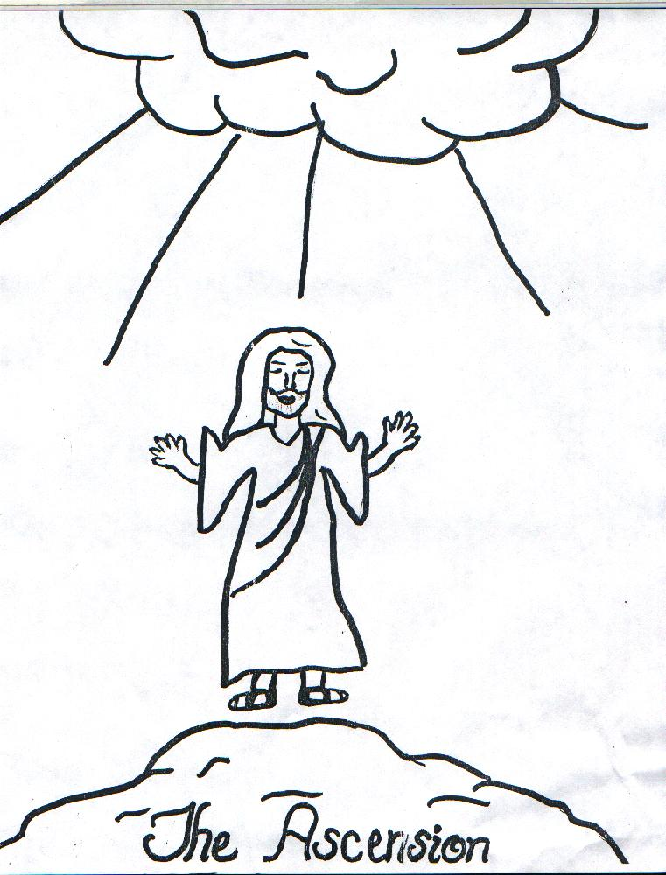
Concert : On Saturday 25 June the Morriston Orpheus Choir will be holding a concert here at St Davids. The concert is to commemorate the 50th Anniversary of the passing of the Choir’s Founder Conductor, Ivor Sims who was of course organist and choirmaster here. Also taking part will be the Choir of Pentrepoeth Junior School and Jonathan Mainwaring, who we all enjoyed listening to in our recent concert. Tickets are £5 and proceeds will go to Ty Olwen. If you want a ticket please add your name to the list at the back of the Church TODAY
Would you please let the Vicar know of people who
need visiting at home or in hospital. Thankyou
Parish of Morriston Weekly Bulletin
St. David’s Church
www.churchinwales.org.uk
www.stdavidsmorriston.co.uk
Registered Charity : 1131686
Vicar : Rev. Hugh Lervy
Tel. : (01792) 771329
Mobile : 07976 725644
e-mail : thevicar@fsmail.net

Assistant Curate:
Rev. Jeff Thomas
Tel. (01792 ) 425310
The Church is open Monday to Friday 10 a.m. to Midday for private prayer / quietness.

Charity Coffee Morning for Water Aid : THIS Thursday following the 10.30 service. Tickets are now available - please help to sell them as we raise money for this charity. Thankyou.

Swansea Interfaith Society : is holding a walk this afternoon (followed by refreshments in the Llewelyn Hall) in Penllegaer Valley Woods with members of the local Muslim community. This is an opportunity for church families and local Muslim families to get together to share in fellowship and get to know each other better. Jenny Ayres from the Penllegaer Trust will lead the walk at 2pm. Meet in the Lliw Valley Council Office car park off the A48 on Llangyfelach Road just down from the J47 roundabout.

Swansea SANDS society : are holding a Memorial Service this afternoon at 2.30 p.m. in St. Mary’s Church, Swansea for all affected by the death of a neonatal child or by miscarriage. The service service is open to any wishing to attend.

Ministry and Vocations Sunday : today has been designated a day of prayer for vocation to ministry in the Church in Wales. Please pray for new vocations - leaflets with more details are available on the table. If anyone would like to explore vocation to ordained or lay ministry ( e.g. as a licensed reader) please let me know. Heavenly Father, You have created each of us to love You and your people. You have chosen some to serve by responding to the particular call to the priesthood and religious life. Send your Holy Spirit to stir the hearts of those You have designed to follow this path of spiritual leadership. We pray this petition, faithful and most gracious God, in the name of your Son, Jesus Christ, Our Lord. Amen.

Diocesan Ordination Service : will take place at Brecon Cathedral on saturday 25th June at 12 Midday. All are welcome to attend. Please remember in prayer those to be ordained and the Parishes in which they will serve : Alison Jones , Jeremy Bevan and Denise Dempsey.

