29th May 2011 Today is the sixth Sunday of Easter

Hymns at Eucharist : 114 , 77 , 413 , ( 386 , 658 , 127 ) , 19

TODAY 9.30 am Parish Eucharist with Sunday School

4.00 pm Baptism

5.00 pm Baptism

6.00 pm Evensong

MONDAY Bank Holiday

TUESDAY 2.00 pm Mother’s Union: Speaker : Sheila Miles on
Doll’s Houses.

WEDNESDAY 6.00 pm Licensing of Rev. Edwin Phillips
(Llandaff Cathedral)
7.30 pm Bible Study Group at 2 Mynydd Garnlwydd Road
( alternate weeks)

THURSDAY ASCENSION DAY
10.30 am Holy Eucharist
Followed by refreshments in the crypt
6.00 pm Clergy Surgery for booking of baptisms, banns and
weddings etc. No appointments necessary.
7.00 pm Holy Eucharist

FRIDAY 10.00 am Church working party - all welcome

SATURDAY 12.00 pm Wedding

NEXT SUNDAY Readings : Acts 1:6-14, 1 Pet. 4:12-5:11, Jn. 17:1-11
9.30 am Family Eucharist led by our Sunday School
- followed by tea / coffee
4.30 pm PCC Meeting
6.00 pm Holy Eucharist
Friends of Brecon Cathedral : if anyone would like to join the friends for the coming year please pay Meuryl Lewis TODAY.

Parish Trip to Bath This will take place on Saturday 9th July and will leave the Church at 8.30 a.m. and leave Bath at 5.30 p.m. The cost will be £10 each and names and deposits of £5 should be given to Diane Richardson (517606) as soon as possible.

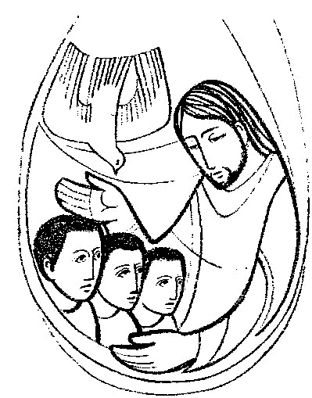
Concert : On Saturday 25 June the Morriston Orpheus Choir will be holding a concert here at St Davids. The concert is to commemorate the 50th Anniversary of the passing of the Choir’s Founder Conductor, Ivor Sims who was of course organist and choirmaster here. Also taking part will be the Choir of Pentrepoeth Junior School and Jonathan Mainwaring, who we all enjoyed listening to in our recent concert. Tickets are £5 and proceeds will go to Ty Olwen. If you want a ticket please add your name to the list at the back of the Church.
Would you please let the Vicar know of people who
need visiting at home or in hospital. Thankyou
Parish of Morriston Weekly Bulletin
St. David’s Church
www.churchinwales.org.uk
www.stdavidsmorriston.co.uk
Registered Charity : 1131686
Vicar : Rev. Hugh Lervy
Tel. : (01792) 771329
Mobile : 07976 725644
e-mail : thevicar@fsmail.net

Assistant Curate:
Rev. Jeff Thomas
Tel. (01792 ) 425310
The Church is open Monday to Friday 10 a.m. to Midday for private prayer / quietness.

Charity Coffee Morning for Water Aid : Thursday 9th June following the 10.30 service. Tickets are now available - please help to sell them as we raise money for this charity. Thankyou.

Pentecost Praise in Morriston Park : Sunday 12th June from 4 p.m. - more details soon.

200 Club Winners May 2011 : 1st no. 1 The Vicar !!!! , 2nd no. 34 Val Lloyd , 3rd no. 74 Clare Nichols.

Thankyou : to all who supported the coffee morning yesterday for Chernobyl Children’s Lifeline.

Thankyou : to all who helped with the Christian Aid Collections last week.

For your diary : a Deanery BBQ and Songs of Praise will be held at St. Michael’s Church, Trebanos on Sunday 10th July at 4.30 p.m. Tickets / details closer the time.

Logic : This is a story which is perfectly logical to all males: A wife asks her husband, "Could you please go shopping for me and buy one carton of milk, and if they have eggs, get 6." A short time later the husband comes back with 6 cartons of milk. The wife asks him, "Why on earth did you buy 6 cartons of milk?" He replied, "They had eggs."

Be careful about reading health books. You may die of a misprint.

