8th May 2011 Today is the third Sunday of Easter

Hymns at Eucharist : 646 , 580 , 716 , ( 87 , 386 , 228 ) , 573

TODAY 9.30 am Parish Eucharist with Sunday School

FOLLOWED BY OUR PARISH MEETING -

PLEASE STAY IF YOU CAN.

11.15 am Cymun Bendigaid

6.00 pm Evening Worship

MONDAY 9.45 am Clergy Chapter Meeting (Llangyfelach)
10.00 am Parent and Toddler group
6.00 pm Reading Group (crypt) - all welcome
7.30 pm Evening M.U.: Speaker: Ray Williams “Gardening”

TUESDAY 2.00 pm Mother’s Union. Speaker: Hilary Ferris on Quilting

WEDNESDAY 7.30 pm Bible Study Group at 2 Mynydd Garnlwydd Road
( alternate weeks)

THURSDAY 10.30 am Holy Eucharist
Followed by refreshments in the crypt
6.00 pm Youth Club for school years 4,5,6 ( Crypt )
6.00 pm Clergy Surgery for booking of baptisms, banns and
weddings etc. No appointments necessary.

FRIDAY 10.00 am Church working party - all welcome

NEXT SUNDAY Christian Aid Week
Readings : Acts 2:42-47, 1 Pet. 2:19-25, Jn. 10:1-10
9.30 am Parish Eucharist with Sunday School
6.00 pm CONCERT IN AID OF THE VELINDRE CANCER
CENTRE - DO TRY TO JOIN US FOR WHAT
WILL BE AN EXCELLENT EVENING.
PARISH NOTES

Thankyou : to Anne Lewis who arranged our Parish Meal at the Treetops on Friday night. Thankyou also to Gordon and the band for the entertainment. We hope you all enjoyed.

Fire Awareness ( follow up meeting) : would those who came on the Fire Awareness Training ( and any others wishing to come along), please try and join us for a meeting ( about 1 hour) on Wednesday 18th May at 10 a.m. in Church, as we draw up an action plan for our church and groups.

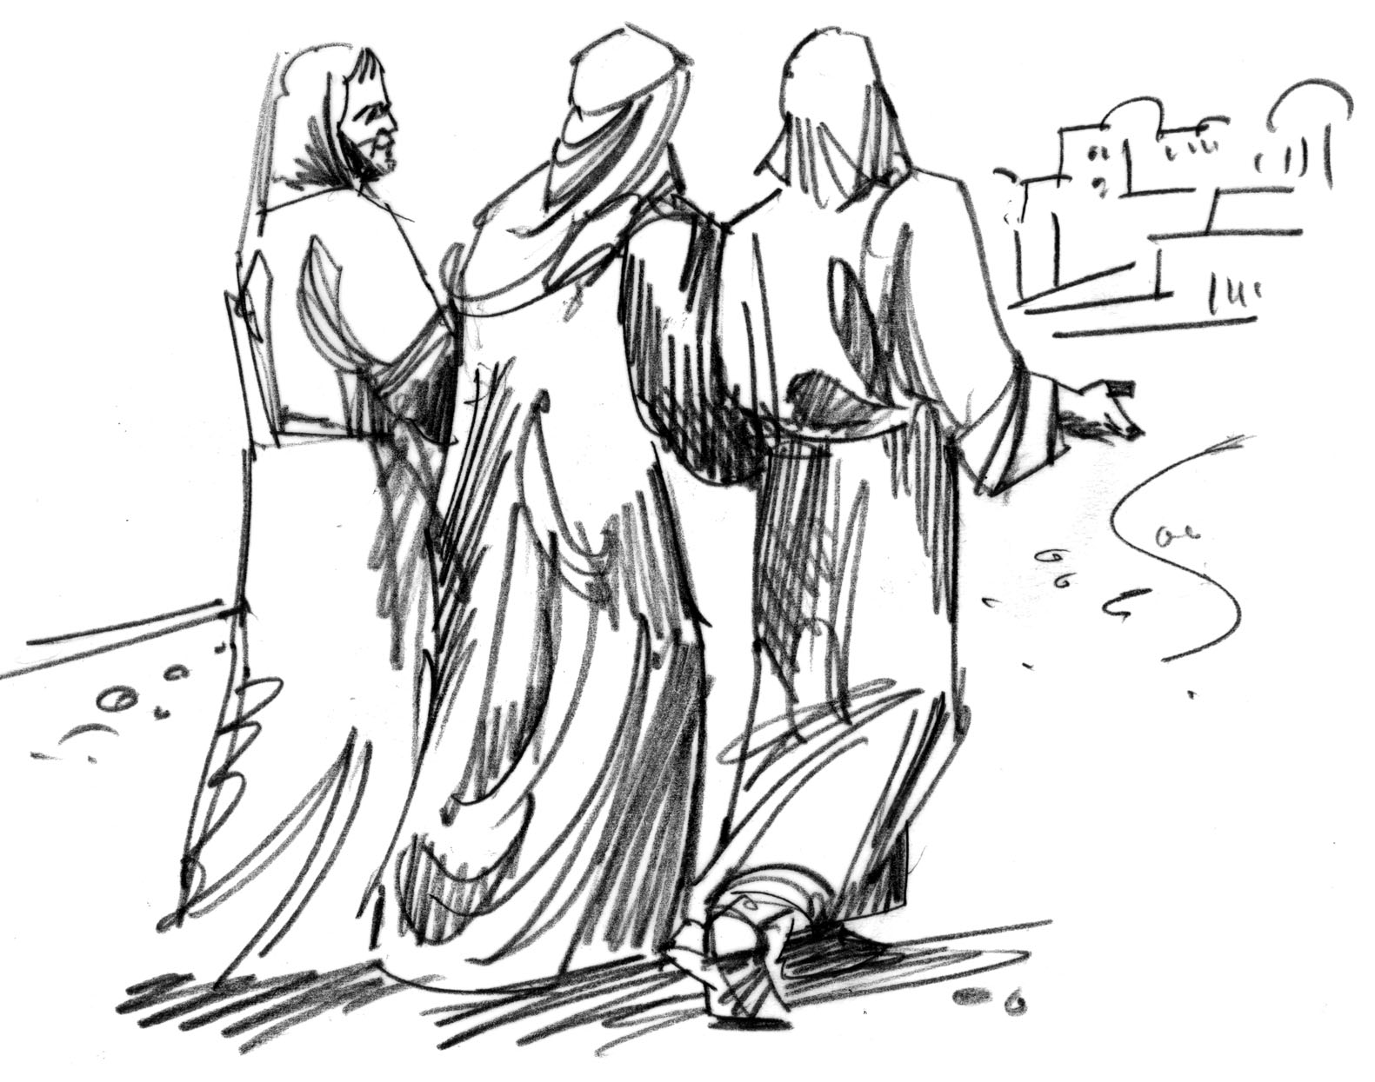
Thankyou : to all who gave to the Bishop’s Lent Appeal. A total of £617 has been raised which will be sent to the Bishop for his chosen charities.
Would you please let the Vicar know of people who
need visiting at home or in hospital. Thankyou
Parish of Morriston Weekly Bulletin
St. David’s Church
www.churchinwales.org.uk
www.stdavidsmorriston.co.uk
Registered Charity : 1131686
Vicar : Rev. Hugh Lervy
Tel. : (01792) 771329
Mobile : 07976 725644
e-mail : thevicar@fsmail.net

Assistant Curate:
Rev. Jeff Thomas
Tel. (01792 ) 425310
The Church is open Monday to Friday 10 a.m. to Midday for private prayer / quietness.

Reading Group : if anyone would like to join a reading group please come along to the crypt tomorrow night at 6 p.m. where you will be more than welcome For further details please speak to Spencer Bowen on 310159

Christian Aid week : Begins next Sunday. If you can help with the door to door collection or the Street collection on Friday (20th May) and Saturday (21st May) would you please let Harry know.

Diocesan Family Day : in Brecon Cathedral on Saturday 21st May ( 11 a.m. to 3.30 p.m.). A warm welcome to all. This should be a fun day for all the family and the theme is “Into Orbit” Please see Jill lewis for details / or to have a consent form.

Friends of Brecon Cathedral : if anyone would like to join the friends for the coming year please speak to Meuryl Lewis.

200 Club Winners April 2011 : 1st no. 39 Eira Rees, 2nd no. 97 Laurence Hughes , 3rd no. 58 Maragette Wilkinson. Congratulations to the winners.

Licensing of Rev. Edwin Phillips : on Wednesday 1st June at 6 p.m. in Llandaff Cathedral, Eucharist will be celebrated to consecrate the solitary life of Edwin, a Tertiary of the Society of St. Francis. The Bishop of Monmouth , the Rt. Rev. Dominic Walker OES will receive Edwin’s vows. An invitation is extended to anyone wishing to attend this service , and we hold Edwin in our prayers for this service and vocation.

Thankyou : to Gaynor Demery and John Stoker who compiled and prepared our Annual Report for our meeting today.

Don’t Forget your tickets for the concert next Sunday

