17th April 2011 Today is Palm Sunday

Hymns at Eucharist : 14 , 201 , 438 , ( 337 , 448 , 583 ) , 905
Psalm 31:10-18 BCP p. 480

TODAY 9.30 am Parish Eucharist with Sunday School

11.15 am Cymun Bendigaid

2.00 pm Baptism

6.00 pm Lent Talk (crypt)

MONDAY 10.00 am Parent and Toddler group
7.00 pm Stations of the Cross
7.30 pm Evening M.U.

TUESDAY 12.00 pm Chrism Eucharist (Brecon Cathedral)
2.00 pm Mother’s Union Holy Eucharist (all welcome)
7.00 pm Devotional Service

WEDNESDAY 7.00 pm Compline

MAUNDY 10.30 am Holy Eucharist
THURSDAY Followed by refreshments in the crypt
6.00 pm Clergy Surgery for booking of baptisms, banns and
weddings etc. No appointments necessary.
7.00 pm Holy Eucharist (sung)

GOOD FRIDAY 9.30 am March of Witness ( starting at Sacred Heart)
10.00 am Craft morning for children
- all welcome ( until midday)
2.00 pm HOLY HOUR ( service of prayer & reflection)
7.00 pm Devotional Service
SATURDAY 10.00 am Church and Grounds working party - if you can help prepare the
church for Easter we would be pleased to see you.
7.00 pm Devotional Service

NEXT SUNDAY EASTER DAY
Readings : Acts 10:34-43, Col. 3:1-4, Jn. 20:1-8
9.30 am Parish Eucharist - followed by tea / coffee
11.15 am Cymun Bendigaid
2.00 pm Baptism
5.00 pm EASTER SONGS OF PRAISE AT THE SALVATION ARMY (Morfydd Street)

HOLY WEEK AND EASTER SERVICES. DO TRY AND JOIN US FOR OUR SERVICES THIS WEEK - PARTICULARLY ON GOOD FRIDAY AND EASTER DAY.

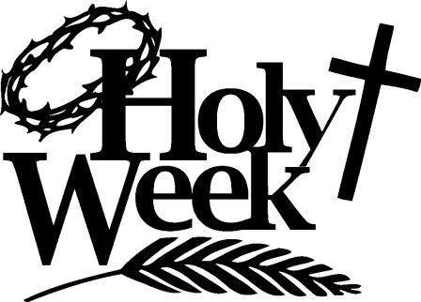
Annual Report : copies are now available. Please take a copy and any spare copies you can help to distribute. The annual Parish meeting will take place on the morning of Sunday 8th May. Nomination forms for Wardens and PCC are now at the back of church for those wishing to serve in the coming year.
Would you please let the Vicar know of people who
need visiting at home or in hospital. Thankyou
Parish of Morriston Weekly Bulletin
St. David’s Church
www.churchinwales.org.uk
www.stdavidsmorriston.co.uk
Registered Charity : 1131686
Vicar : Rev. Hugh Lervy
Tel. : (01792) 771329
Mobile : 07976 725644
e-mail : thevicar@fsmail.net

The Church is open Monday to Friday 10 a.m. to Midday for private prayer / quietness.

Parish Dinner : Friday 6th May ( 7 for 7.30). The meal will be a 3-course dinner and the cost is £10 per head. All are welcome to join us. Please see poster for details of food and place your order as soon as you can.

Bishop’s Lent Appeal : There is a special collection plate on the table near the door if you wish to give donations for the Bishop’s appeal for the charities : The Peace and Hope Trust , The Machakos Daystar Hostel Project and Shelter Cymru. This appeal will remain open throughout Lent and Holy Week.

Concert : James, Jonathan and Richard Mainwaring will give us another evening of music and entertainment. This time they will be joined by the Choir of Cwmrhydyceirw Junior School and Jamie Owen ( BBC Wales Today) as the compere for the evening. The concert will be on SUNDAY 15th MAY at 6 p.m. DO PUT THIS DATE IN YOUR DIARY. Tickets are now available at £5 and all proceeds will be for the Velindre Cancer Centre in Cardiff. IF YOU CAN HELP PUT UP POSTERS SPARE COPIES ARE ON THE TABLE NEAR THE DOOR.

A Holy Week Prayer : Lord Jesus Christ, in this sacred and solemn week when we see again the depth and mystery of your redeeming love, help us to follow where you go, to stop where you stumble, to listen when you cry, to hurt as you suffer, to bow our heads in sorrow as you die, so that, when you are raised to life again, we may share in your endless joy. Amen.

