27th February 2011

Today is the second Sunday before Lent

Hymns at Eucharist : 566 , 450 , 37 , ( 332 , 87 , 165 ) , 684

TODAY 9.30 am Parish Eucharist with Sunday School

11.15 am Cymun Bendigaid

2.00 pm Baptism

6.00 pm Evensong

MONDAY 10.00 am Parent and Toddler group
7.30 pm Evening M.U. : Speaker Major Paul Church from
the Salvation Army

TUESDAY St. David’s Day
10.00 am Holy Eucharist
2.00 pm Mother’s Union. Speaker: Ken Hannen
on St. David

WEDNESDAY 7.30 pm Bible Study Group at 2 Mynydd Garnlwydd Road
( alternate weeks)

THURSDAY 10.30 am Holy Eucharist
Followed by refreshments in the crypt
6.00 pm Youth Club for school years 4,5,6 ( Crypt )
6.00 pm Clergy Surgery for booking of baptisms, banns and
weddings etc. No appointments necessary.
7.00 pm Holy Eucharist

FRIDAY 10.00 am Church working party - all welcome

NEXT SUNDAY Readings : Ex. 24:12-end, 1 Pet. 1:16-21, Mt. 17:1-9
9.30 am Family Eucharist led by our Sunday School
11.15 am Baptism
4.30 pm RD Conference: Speaker Gill and Keith Lewis on
“Vulnerable Adult Awareness”
6.00 pm Holy Eucharist.
Celebrant : Canon Islwyn Davies ( Area Dean)
Preacher : Canon Bob Jones ( Diocesan Child Protection Officer)

PARISH NOTES

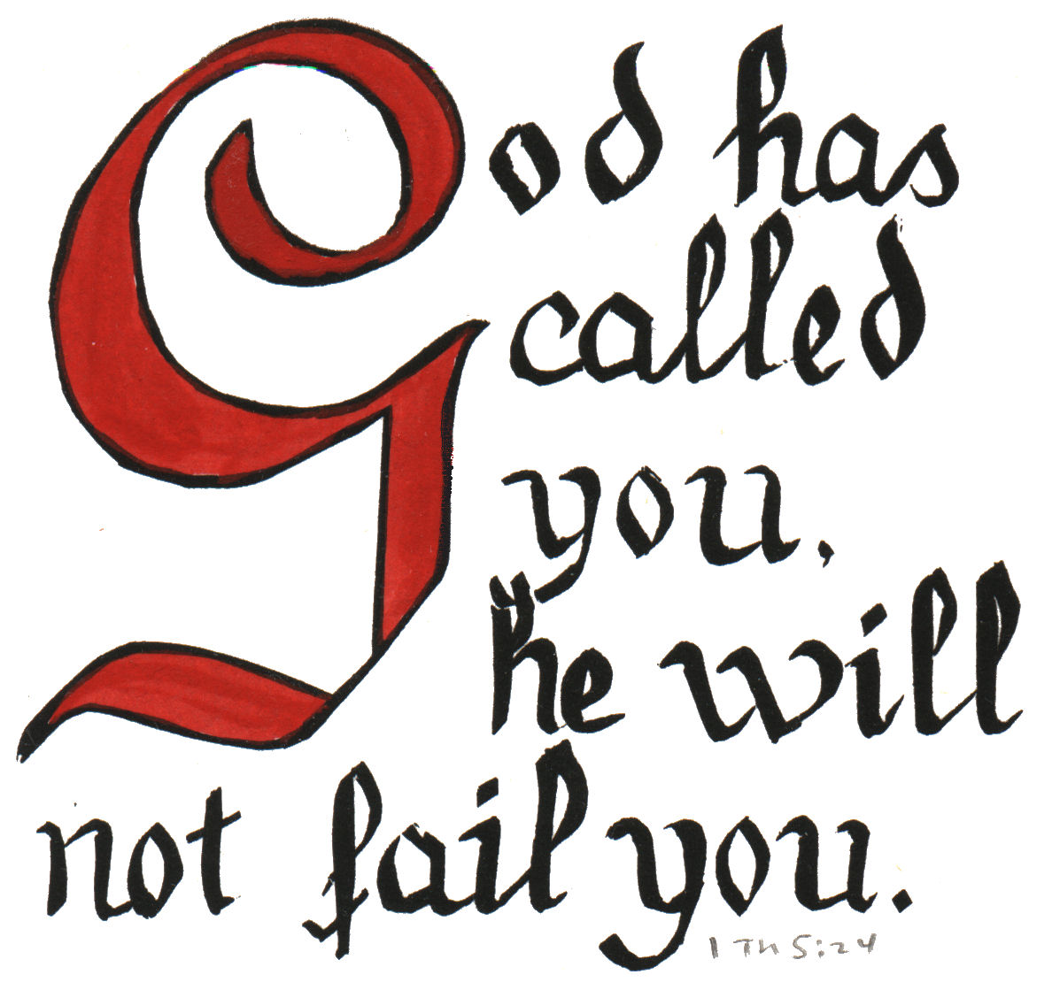
Shrove Tuesday : 8th March. A social evening will take place at 7 p.m. in the crypt. Tickets are £2 and all are welcome. Please pick up tickets TODAY if you can join us.
Would you please let the Vicar know of people who
need visiting at home or in hospital. Thankyou
Parish of Morriston Weekly Bulletin
St. David’s Church
www.churchinwales.org.uk
www.stdavidsmorriston.co.uk
Registered Charity : 1131686
Vicar : Rev. Hugh Lervy
Tel. : (01792) 771329
Mobile : 07976 725644
e-mail : thevicar@fsmail.net

Ash Wednesday : 9th March. Holy Eucharist will take place at 10.30 a.m. and 7 p.m.

Lent Talks: This year our Lent talks will follow the theme “From the Ram to the Lamb”. They will take the form of study / discussion groups in the Crypt on Sunday evenings in Lent at 6 p.m. Details of the talks can be found on the handout. The first talk will be on Sunday 13th March. Do try and join us.

St. David’s Day Celebration : at Pentrepoeth Methodist Church tomorrow at 7.00 p.m. - a varied programme and light supper included. Tickets are £2.50 on the day.

Fire Awareness Training: if you are joining us at the fire station on Thursday 17th March at 1 p.m. would you please sign the list as soon as possible.

Charity Coffee morning : in aid of the Stroke Association on Thursday 17th March following our mid-week Eucharist. Tickets are £1. Please help to sell tickets.

PCC : a short meeting will take place following our morning service on 20th March to look at the Annual report.

Thankyou : a cheque for £1032 has been given to the Welsh Dragon’s Burns club following sponsorship of our Tree of Light. Thankyou to all who gave to this cause.

It is easier to fight for one's principles than to live up to them.

