9th January 2011

Today is the Baptism of Christ

Hymns at Eucharist : 527 , 28, 636 , ( 656 , 541 , 470 ) , 716

Welcome Back :
to all who have been away for Christmas and the New Year.

TODAY 9.30 am Parish Eucharist with Sunday School

FOLLOWED BY TEA / COFFEE - ALL WELCOME

11.15 am Cymun Bendigaid

6.00 pm Evensong

MONDAY 10.00 am Parent and Toddler group
7.30 pm Evening M.U. : Speakers : Alan and Gill Figg
on Stained Glass Windows

TUESDAY 2.00 pm Mother’s Union AGM
7.15 pm Council of Churches AGM ( Aenon )

THURSDAY 10.30 am Holy Eucharist Followed by refreshments
6.00 pm Youth Club for school years 4,5,6 ( Crypt )
6.00 pm Clergy Surgery for booking of baptisms, banns and
weddings etc. No appointments necessary.

NEXT SUNDAY WEEK OF PRAYER FOR CHRISTIAN UNITY
Readings: Is. 49:1-7, 1 Cor. 1:1-9, Jn. 1:29-42
9.30 am Parish Eucharist with Sunday School
6.00 pm Evensong
Smarties Tubes : can be returned at any of our Services. We would be grateful to have them by next Sunday if possible. Thankyou.

PCC Meeting : Sunday 30th January at 4.20 p.m.

Thankyou : to Diane who organised our Social Evening last night. We hope you all enjoyed the evening !

Collection Envelopes : thankyou to all who give through our envelope scheme. The envelopes for next year are now available. If you would like to join this scheme please speak to the wardens or treasurer for details.


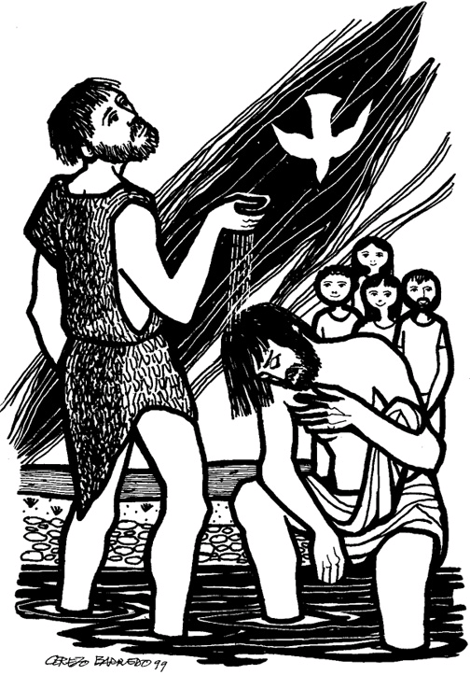
Easter Eggs : Traidcraft are selling what they call “Real Easter Eggs”. They tell the Christian Easter Story on the box. They are £4.50 each and order forms are on the table near the door. THE VERY LATEST ORDERS CAN BE TAKEN IS 24th JANUARY Please return order form and payment to Joan Lewis.
Would you please let the Vicar know of people who
need visiting at home or in hospital. Thankyou
Parish of Morriston Weekly Bulletin
St. David’s Church
www.churchinwales.org.uk
www.stdavidsmorriston.co.uk
Registered Charity : 1131686
Vicar : Rev. Hugh Lervy
Tel. : (01792) 771329
Mobile : 07976 725644
e-mail : thevicar@fsmail.net

Assistant Curate:
Rev. Jeff Thomas
Tel. (01792 ) 425310

Annual Report : it’s that time of year again. Could we please have articles for the report from our Parish Group leaders by the end of January. Thankyou.

Council of Churches Week of Prayer for Christian Unity : United Service in the NEW HOSPITAL CHAPEL ( Near the main hospital entrance) on Tuesday 18th January at 7.30 p.m. ALL ARE WELCOME.

Open Prayer Meeting for Christian Unity : Saturday 22nd January 10.30 - 11.30 a.m. here in St. David’s. There is no set structure to this prayer hour and people are welcome to call in for a little or long as you wish.

Thankyou : Elizabeth West ( and Family ) would like to thank everyone for their prayers, cards and support during their recent bereavement.

Welcome Back : to all who have been away for Christmas and the New Year.

Best Cracker Jokes

Did you hear about the two ships that collided at sea?
One was carrying red paint and the other was carrying blue paint.
All the sailors ended up being marooned.

What did the grape say when the elephant stepped on it?
Nothing. It just let out a little wine.

Why did the man get the sack from the orange juice factory?
Because he couldn't concentrate.

