19th December 2010 Today is the fourth Sunday of Advent

Hymns at Eucharist : 480 , 355 , 297 , ( 267 , 690 , 698 ) , 128

Psalm 80: 1-6, 17-19 BCP p. 556

TODAY 9.30 am Parish Eucharist with Sunday School

4.00 pm CHRISTINGLE AND NATIVITY SERVICE

- DO TRY AND JOIN US.

THURSDAY 10.30 am Holy Eucharist
Followed by refreshments in the crypt
6.00 pm Clergy Surgery for booking of baptisms, banns and
weddings etc. No appointments necessary.

FRIDAY CHRISTMAS EVE
6.30 pm FAMILY EUCHARIST
- led by our Sunday School
11.30 pm MIDNIGHT MASS

SATURDAY CHRISTMAS DAY
10.00 am Holy Eucharist with Carols

NEXT SUNDAY Readings : Is. 63:7-9 , Heb. 2:10-18, Mt. 2:13-23
9.30 am Parish Eucharist

When Father Christmas first tried his sleigh-driving test. He came skidding down in front of the toy factory. 'Have you passed?' , he was asked. Father Christmas pointed proudly to the front of the sleigh. 'See for yourself!' he called proudly. 'No-el plates!'
PARISH NOTES

Thankyou : to all who worked so hard for the Craft morning yesterday and those who helped to put the Christingles together in preparation for our service this afternoon. DO TRY AND JOIN US FOR THIS VERY SPECIAL SERVICE WHICH IS LED BY OUR YOUNG MEMBERS.

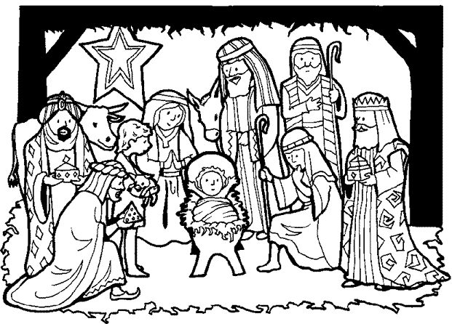

Evening Services : please note there will be no evening service next Sunday or on the 2nd January. They will resume on the 9th January.
Would you please let the Vicar know of people who
need visiting at home or in hospital. Thankyou
Parish of Morriston Weekly Bulletin
St. David’s Church
www.churchinwales.org.uk
www.stdavidsmorriston.co.uk
Registered Charity : 1131686
Vicar : Rev. Hugh Lervy
Tel. : (01792) 771329
Mobile : 07976 725644
e-mail : thevicar@fsmail.net

Assistant Curate:
Rev. Jeff Thomas
Tel. (01792 ) 425310

Thankyou : to George ( the owner of Wall to Wall Carpets on Woodfield Street ) who has once again kindly given a selection box for each of our Sunday School members.

Church Bus : don’t forget this will not be running next Sunday or on the 2nd January. If you need lifts to come to church please ask and they will be arranged.

SOCIAL EVENING : as we are holding our Parish meal in May rather than January, we are going to hold a social evening in the crypt on SATURDAY 8th JANUARY AT 7 p.m. It will be an evening of “Cheese, Wine and Entertainment”, and should be a very enjoyable evening. Tickets are £5 and we hope as many as possible will be able to join us. Family and friends are welcome to join us. Please pick up your tickets as soon as you can.

Thankyou : to all who were able to join us for our service of Christmas Praise last Sunday evening. It was a very enjoyable service and we particularly thank our friends in the Salvation Army for all they contributed to our worship.

Christmas Services : do try and join us for our Christmas services this week as we celebrate God’s gift of his son, and welcome the Christ-child afresh into our hearts and into the world.

Smarties Tubes : can be returned at any of our Christmas Services. Thankyou.

HAPPY CHRISTMAS
to you and your families from the clergy and officers of St. David’s.

