Parish of Morriston
St. David’s Church
Weekly Bulletin
www.churchinwales.org.uk
www.stdavidsmorriston.co.uk
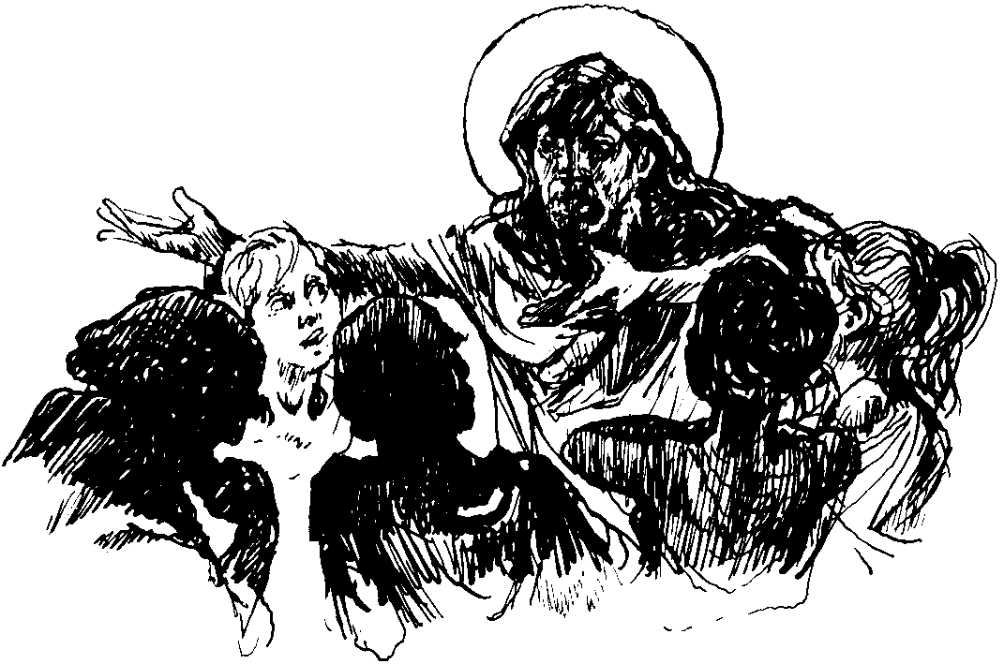

Vicar : Rev. Hugh Lervy

Tel. / Fax. : (01792) 771329

Mobile : 07976 725644

e-mail : thevicar@fsmail.net

Curate:
Rev. Edwin Phillips
(01639) 886784

Would you please let the Vicar know of people who
need visiting at home or in hospital. Thankyou
The Church is open Monday to Friday from 10 a.m. to 12 Midday those wishing to call in for a time of quiet prayer.

27th July 2008

Today is the tenth Sunday after Trinity

Hymns at Eucharist : 217 , 682 , 646 , ( 34 , 315 , 87 ) , 314

TODAY 9.30 am Parish Eucharist

11.15 am Cymun Bendigaid

2.00 pm Baptism

4.00 pm Confirmation Class

5.00 pm Youth Service and Club

6.00 pm Evensong

MONDAY 10.00 am Parent and Toddler group

THURSDAY 10.30 am Holy Eucharist
Followed by refreshments in the crypt
6.00 pm Clergy Surgery for booking of baptisms, banns and
weddings etc. No appointments necessary.

NEXT SUNDAY Readings : Is. 55:1-5 , Rom. 9:1-5, Mt. 14:13-21
9.30 am Parish Eucharist
6.00 pm Holy Eucharist

"Strength is the capacity to break a chocolate bar into four pieces with your bare hands and then eat just one piece."

PARISH NOTES

200 Club winners July : 1st no. 57 John Wilkinson, 2nd no. 2 Hayley Lervy , 3rd no. 154 Cian Oates. Congratulations to this months winners.

Thankyou : to June Dacy who invited us to her home for a coffee morning yesterday.

Thankyou : to Diane Richardson who organised our enjoyable day at the Royal welsh on Wednesday.

Ostend Trip : could those joining this trip please pay the balance of £124 per person by the end of August at the latest ( plus single room supplement if requested ) .

Open the Book Launch Service : ( advanced notice ) : Sunday 31st August at 6 p.m. The Preacher will be the Archdeacon of Gower. Please put this date in your diary – more details closer the time.

Confirmation Service : ( advanced notice ) : Sunday 7th September at 10 a.m. ( please note start time ). Again I will remind you of this closer the time.

Men’s Society : the venue has now been fixed as the Welcome Inn on Mynyddbach Common. The first meeting will take place on Tuesday 2nd September.

Flower Festival : at St. Mary the Virgin Church in Rhossili from 14th-17th August. For details please ring the vicar Canon Joe Griffin on 390456

Happy Holidays : We wish an enjoyable break to all who are going away and hope that you find it a time of refreshments and relaxation. We look forward to seeing you on your return.

Quality Conversation : One day a group of people we were sitting and talking. A not so bright woman was among the group and she even participated in the discussion. When she came up with an unusually stupid comment, one of the friends couldn't take it anymore. He said to her, "You must have vacuum in your head." This upset her greatly. She looked at him for a couple of seconds and then replied, "At least it's better than nothing."
"Change is good as long as I don't have to do anything differently."

