28th November 2010 Today is the first Sunday of Advent

Hymns at Eucharist : 263 , 734 , 70 , ( 196 , 195 , 456 , 87 ) , 405

A WARM WELCOME TO BISHOP JOHN AND THE
FAMILIES OF THOSE TO BE CONFIRMED

TODAY 10.00 am Parish Eucharist (and Sunday School) with

Baptism and Confirmation.

Preacher and Celebrant : Bishop John
Followed by tea / coffee - all welcome
6.00 pm ADVENT SERVICE OF PRAYERS / HYMNS
AND READINGS - do try and join us.

MONDAY 10.00 am Parent and Toddler group

TUESDAY 2.00 pm Mother’s Union. Speaker : John Stoker

THURSDAY 10.30 am Holy Eucharist
Followed by refreshments in the crypt
11.30 am Bible Study group - all welcome
6.00 pm Youth Club for school years 4,5,6 ( Crypt )
6.00 pm Clergy Surgery for booking of baptisms, banns and
weddings etc. No appointments necessary.
7.00 pm Holy Eucharist

FRIDAY 4.30 pm Switching on the “Tree of Light”
5.00 pm CHRISTMAS FETE

NEXT SUNDAY Readings : Is. 11:1-10, Rom. 15:4-13, Mt. 3:1-12
9.30 am Parish Eucharist with Sunday School
11.30 pm Sunday School Trip to see Santa at the
Gower Heritage Centre ( returning c. 3 p.m.)
6.00 pm Holy Eucharist
Confirmation : please hold in your prayers those to be confirmed today : Paul , Lorraine , Conor , Kelly , Alys , Zoe , Thomas and Charlotte. Those being confirmed today will come to the altar rail first to receive communion.


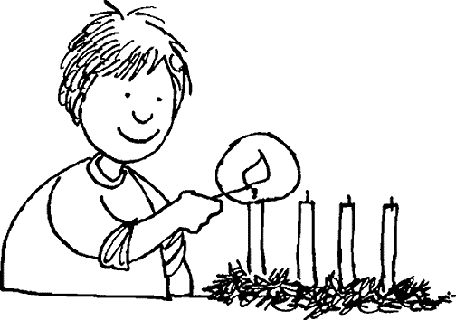
CHRISTMAS FETE : please try and give your support this Friday for our Fete ( help on the stalls would be appreciated ). The crypt will be open from 10.30 - 12 and then from 3 p.m. onwards for items to be brought for the stalls. We need tins / cakes / toiletries / crafts etc. Could Raffle tickets be returned ( folded if possible ) by Friday.
Would you please let the Vicar know of people who
need visiting at home or in hospital. Thankyou
Parish of Morriston Weekly Bulletin
St. David’s Church
www.churchinwales.org.uk
www.stdavidsmorriston.co.uk
Registered Charity : 1131686
Vicar : Rev. Hugh Lervy
Tel. : (01792) 771329
Mobile : 07976 725644
e-mail : thevicar@fsmail.net

Assistant Curate:
Rev. Jeff Thomas
Tel. (01792 ) 425310

Advent Collection : do take a tube of Smarties with you today. Enjoy the chocolate and then through Advent collect your 20p pieces in the tube which should them be returned at our Christmas Services. Money raised will be given to local children’s Charities.

Thankyou : to Diane who organised our trip to Cheltenham yesterday.

Bay Choir : an evening of Christmas Music, Old and New on Monday 6th December at 7 p.m. (here in St. David’s). Light refreshments will be provided and a raffle will be held after the concert. Admission is £4. Tickets are available from Craig ( our deputy organist ), or on the door on the evening of the 6th.

Philharmonic Choir : Christmas Concert at the Brangwyn Hall on Saturday 11th December at 7.30 p.m. For tickets / details please speak to Eira on 528322

Christmas Praise Service : we will be joined by the Salvation Army band and songsters on Sunday 12th December at 6 pm. for our service of celebration. Do invite family and friends - all are welcome. Always an enjoyable service !!

Morriston Comprehensive School Carol service : Monday 13th December at 7 p.m. here in St. David’s - all welcome.

Hospital Trust Carol service for the bereaved : Wednesday 15th December at 7 p.m. here in St. David’s - open to all wishing to come to this service.

Christmas Craft Morning for children : Saturday 18th December from 10 a.m. to 12 midday - all children welcome - there is no charge.

Christingle and Nativity Service : Sunday 19th December at 4 p.m.

Advent and Christmas Service Information leaflets : Do take as many copies as you can distribute to family / friends and neighbours.

The first restaurant on the moon will never do very well. It might have great food, but will never have any atmosphere

