7th November 2010

Today is the Third Sunday before Advent ( Kingdom 2)

Hymns at Eucharist : 887 , 620 , 819 , ( 734 , 802 , 285 ) , 741

TODAY 9.30 am Family Eucharist led by our Sunday School -
followed by tea / coffee
6.00 pm Holy Eucharist ( BCP )

MONDAY 10.00 am Parent and Toddler group
7.30 pm Evening M.U. : Helen’s Hat Studio

TUESDAY 2.00 pm Mother’s Union. Speaker : Mrs. Elaine Kidwell on
“Swansea at War”
7.00 pm Council of Churches meeting ( Aenon)

THURSDAY 10.30 am Holy Eucharist
Followed by refreshments in the crypt
6.00 pm Youth Club for school years 4,5,6 ( Crypt )
6.00 pm Clergy Surgery for booking of baptisms, banns and
weddings etc. No appointments necessary.
7.30 pm Diocesan Training Evening on Vulnerable Adult
Awareness ( at St. Illtyd’s, Fforestfach)

NEXT SUNDAY REMEMBRANCE SUNDAY
Readings : Mal. 4:1-2, 2 Thes. 3:6-13, Lk. 21:5-19
9.30 am Parish Eucharist with Sunday School
11.15 am Cymun Bendigaid
2.00 pm Baptism
6.00 pm Evensong

Bible Study Group : this new group will begin meeting in Advent and will take place on Thursdays at 11.30 a.m. The dates will be the 25th November , then 2nd , 9th and 16th of December. All are welcome to attend. For more details please speak to Jeff.

Thankyou : Roy Gambold and family would like to sincerely thank the so many people who gave prayers, cards and messages following the passing away of Diane. They would also like to thank everyone who attended the funeral.

Charity Coffee Morning : in aid of Treat Trust Wales will take place on Thursday 25th November at 11 a.m. Please help to sell the tickets. Thankyou.


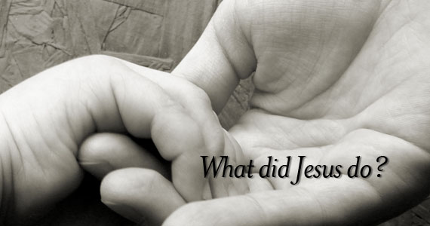
Harvest Collection : we have received a letter from “Send a Cow” thanking us for the £750 we sent from our Harvest Collection. Thankyou to all who contributed to this appeal.
Would you please let the Vicar know of people who
need visiting at home or in hospital. Thankyou
Parish of Morriston Weekly Bulletin
St. David’s Church
www.churchinwales.org.uk
www.stdavidsmorriston.co.uk
Registered Charity : 1131686
Vicar : Rev. Hugh Lervy
Tel. : (01792) 771329
Mobile : 07976 725644
e-mail : thevicar@fsmail.net

Assistant Curate:
Rev. Jeff Thomas
Tel. (01792 ) 425310

Christmas Fete : Friday 3rd December at 5 p.m. Ideas / items for the stalls would be much appreciated. Please speak to the Churchwardens if you have ideas to share or can help in any way. RAFFLE TICKETS ARE NOW AVAILABLE -PLEASE HELP TO SELL THEM. THANKYOU.

Santa Trip : to the Gower Heritage Centre. On Sunday 5th December for our Sunday School and other children who would like to come along. Please speak to Jill Lewis for details.

Diocesan Talk on Vocation : called “Here I am - tell me more” will take place on Saturday 20th November in Brecon Cathedral from 10.30 to 12.30. All are welcome.

PCC Meeting : a short meeting of the PCC will take place on Sunday 21st November at 5 p.m.

Hats, Scarves and Gloves : are needed by the sisters of Charity on the Strand for their work with the homeless over the winter months. If you would like to help with this please speak to Ingrid.

Parish Meal : due to the problems experienced with the weather in the last couple of years we have decided to hold our Parish Dinner later in the year ( Friday 6th May ) rather than January - further details will be given closer this date.

200 Club winners October : 1st. no. 161 Judith Scott, 2nd no. 5 Mike Godrich, 3rd no. 66 Gwyn Lewis. Congratulations to this months winners.

Confirmation Service : Bishop John will be joining us in the Parish for a service of Confirmation on Advent Sunday ( 28th November ). The service will begin at 10 a.m. that Morning. Do try and join us.

Advent and Christmas Service Information leaflets : are now available on the table near the door. Do take as many copies as you can distribute to family / friends and neighbours.

