10th October 2010

Today is the nineteenth Sunday after Trinity

Hymns at Eucharist : 573 , 28 , 617 , ( 661 , 332 , 297 ) , 695

TODAY 9.30 am Parish Eucharist with Sunday School
11.15 am Cymun Bendigaid
4.30 pm RD Conference ( Ystradgynlais)
6.00 pm Deanery Harvest Service ( Ystradgynlais)
Speaker and Preacher : Bishop Michael Doe (USPG)
6.00 pm Parish Evensong

MONDAY 10.00 am Parent and Toddler group
4.30 pm Confirmation Class
7.30 pm Evening M.U. : Speaker : Mr Peter Ricketts on the
Neath / Aberdulais Canal

TUESDAY 2.00 pm Mother’s Union. Speaker : Rev. Jeff Thomas

THURSDAY 10.30 am Holy Eucharist
Followed by refreshments in the crypt
6.00 pm Youth Club for school years 4,5,6 ( Crypt )
6.00 pm Clergy Surgery for booking of baptisms, banns and
weddings etc. No appointments necessary.

FRIDAY 10.00 am Diocesan Clergy Synod Day at Penllegaer.

SATURDAY 7.00 pm Cambrian Male Choir Annual concert

NEXT SUNDAY Readings : Gen. 32:22-31, 2 Tim. 3:14-4:5, Lk. 18:1-8
9.30 am Parish Eucharist with Sunday School
6.00 pm Evensong

PARISH NOTES

Congratulations: to John and Joan Lewis who are celebrating their Ruby Anniversary today.


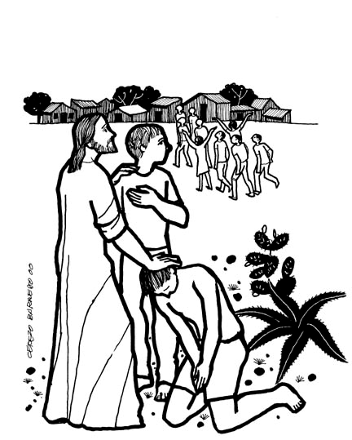
Thankyou : to all who helped make our Harvest celebration go so well. Particularly to our Sunday School who led our morning worship , Jean and the ladies who prepared our lunch, and Canon Keith Evans who preached at Harvest Evensong. Thankyou to all who gave gifts for our nominated charities.
Would you please let the Vicar know of people who
need visiting at home or in hospital. Thankyou
Parish of Morriston Weekly Bulletin
St. David’s Church
www.churchinwales.org.uk
www.stdavidsmorriston.co.uk
Registered Charity : 1131686
Vicar : Rev. Hugh Lervy
Tel. : (01792) 771329
Mobile : 07976 725644
e-mail : thevicar@fsmail.net

Assistant Curate:
Rev. Jeff Thomas
Tel. (01792 ) 425310

Welsh Blood Service : are in Tabernacle on Monday and Thursday this week from 10 a.m. to 6 p.m. if you wish to give Blood.

Bible Study Group : beginning in Advent we are hoping to start a new Bible Study group that will meet in the church during the daytime on a weekday. This will be led by Jeff. Forms are available now to indicate the level of interest if we were to start this group. Please complete and return the form to Jeff if this is something you would be interested in attending.

Traidcraft : the Christmas Catalogue is now available. Orders will be taken until the end of October.

Parish Shopping Trip : to Cheltenham on Saturday 27th November. The trip is now full. The cost is £10 each - could this please be paid to Diane as soon as possible. Thankyou.

200 Club : We are now collecting membership money for the coming year. It is £20 for the year - all welcome to join. Could membership be paid by NEXT SUNDAY please.

All Souls’ Eucharist : Tuesday 2nd November at 10.30 a.m. A list is now available if you wish any of the departed to be remembered by name during this service.

Christmas Fete : just a quick note to say this will be taking place on Friday 3rd December at 5 p.m. Ideas / items for the stalls would be much appreciated. Please speak to the Churchwardens if you have ideas to share or can help in any way.

“A bus station is where a bus stops, a train station is where a train stops and on my desk I have a work station . . .”

