29th August 2010

Today is the thirteenth Sunday after Trinity

Hymns at Eucharist : 450 , 212 , 114 , ( 620 , 343 , 297 ) , 503

TODAY 9.30 am Parish Eucharist with Sunday School

Followed by choir practice - all welcome

6.00 pm Evensong

MONDAY Bank Holiday

WEDNESDAY 7.00 pm Sunday School Teacher’s Meeting

THURSDAY 10.30 am Holy Eucharist
Followed by refreshments in the crypt
6.00 pm Clergy Surgery for booking of baptisms, banns and
weddings etc. No appointments necessary.
7.00 pm Holy Eucharist

FRIDAY 4.00 pm Wedding Blessing

SATURDAY 4.00 pm Wedding Blessing

NEXT SUNDAY Readings : Deut. 30:15-20 , Phil. 1-21, Lk. 14:25-33
9.30 am Parish Eucharist with Sunday School
Followed by refreshments
and choir practice
2.00 pm Baptism
4.00 pm Church wardens meeting with the Area Dean
4.30 pm P.C.C. Meeting (we are joined by the Area Dean)
6.00 pm Holy Eucharist
Church Choir Practice : begins next Sunday morning following the 9.30 service ( adults and children welcome). Do come and join us.

Celebration of Lay ministry : there will be a Diocesan service of celebration for those involved in lay ministry on Saturday 11th September at 12 midday in Brecon Cathedral. Could those attending this service let me know so we can let the Bishop know numbers.

Mother’s Union Festival : here in St. David’s on Wednesday 8th September at 7 p.m. led by Rev. Tim Williams ( Vicar of Killay ).

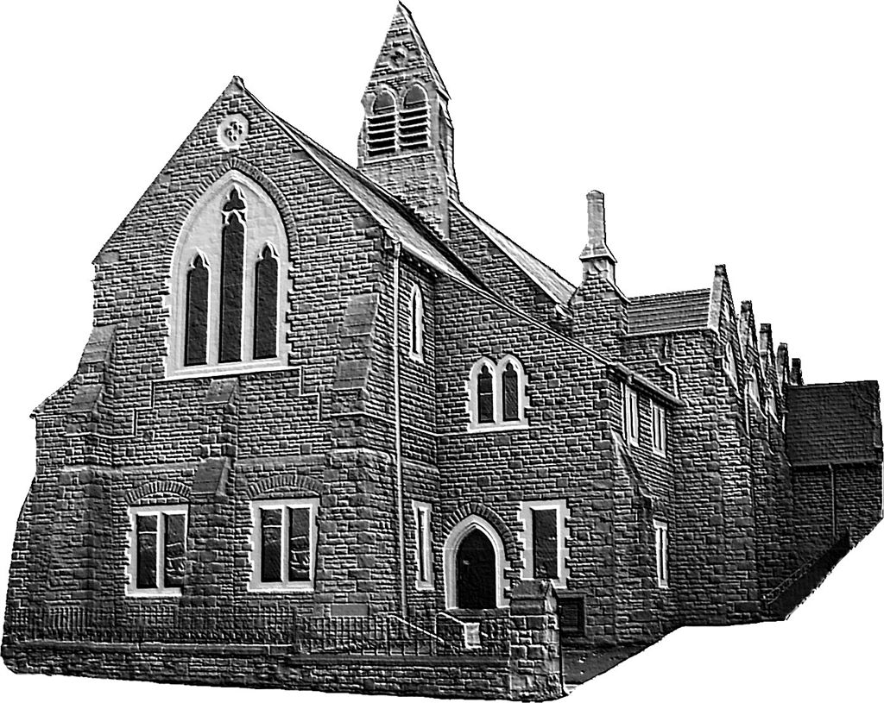

Sunday School Teacher’s Meeting : this Wednesday at 7 p.m. in the church. If anyone would like to become involved with our Sunday School work you would be welcome at this meeting or please speak to Jill Lewis on 310048. SUNDAY SCHOOL RESTARTS NEXT SUNDAY WITH A PARTY.
Would you please let the Vicar know of people who
need visiting at home or in hospital. Thankyou
Parish of Morriston Weekly Bulletin
St. David’s Church
www.churchinwales.org.uk
www.stdavidsmorriston.co.uk
Registered Charity : 1131686
Vicar : Rev. Hugh Lervy
Tel. : (01792) 771329
Mobile : 07976 725644
e-mail : thevicar@fsmail.net

The Church is open Monday to Friday 10 a.m. to 12 Midday for private prayer / quietness.
All are welcome to come in.
Assistant Curate:
Rev. Jeff Thomas
Tel. (01792 ) 425310

Confirmation Classes : will begin on Monday 6th September ( 4.30 - 5.15 p.m. ) The Confirmation service is Sun. 28th November at 10 a.m.

Men’s Society : our next meeting will be on Tuesday 7th September at 6.30 p.m. in the Welcome Inn. Please speak to John Richardson to book your meal. All men are welcome.

Disaster Box : thankyou to those who give regularly through the Disaster Box and those who have given donations in aid of the flood victims in Pakistan. Further donations given through the disaster box will be sent as soon as possible as we continue to respond to the ongoing tragedy in Pakistan.

Council of Churches Meeting: Tuesday 14th September at 7 p.m. in Aenon - all welcome.

Charity Coffee Morning : on Thursday 23rd September from 11 a.m. in aid of “The Smile Team” ( helping children with cleft Palette in developing countries. Tickets £1 ( please help to sell them ).

Congratulations : to Sheila and Mansel Thomas who are celebrating their Golden Anniversary, and to Geoff and Sue Thorpe who are celebrating 30 years.

200 Club Winners : 1st. no. 146 J & E Hughes, 2nd. no. 15 Myra James, 3rd no. 89 Margaret Davidson. Congratulation to this months winners. September is the last draw for this year’s subscription. We are now collecting for the coming year. It is £20 for the year and all are welcome to join - do invite family and friends.

