30th May 2010

Today is Trinity Sunday

Hymns at Eucharist : 286 , 436 , 413, ( 82 , 685 , 167 ) , 684

TODAY 9.30 am Parish Eucharist with Sunday School
11.15 am Baptism
2.00 pm Baptism
6.00 pm Evensong

MONDAY Bank Holiday

TUESDAY 2.00 pm Mother’s Union : Speaker : Helen Williams on
“Send a Cow”

THURSDAY 10.30 am Holy Eucharist
Followed by refreshments in the crypt
6.00 pm Youth Club for school years 4,5,6 ( Crypt )
6.00 pm Clergy Surgery for booking of baptisms, banns and
weddings etc. No appointments necessary.
7.00 pm Holy Eucharist

FRIDAY 12.00 pm Wedding
2.00 pm Wedding

NEXT SUNDAY Readings : 1 Kings 17:17-24, Gal. 1:11-24, Lk. 7:11-17
9.30 am Parish Eucharist with Sunday School
Followed by refreshments – all welcome
2.30 pm City and County of Swansea Babies
Remembrance Service at Crematorium Chapel.
6.00 pm Holy Eucharist
Friends of Brecon Cathedral : subscriptions are now being collected for the coming year. If you would like to join please speak to Meuryl for details. Those wishing to join should do so by next Sunday please.

Men’s Society : our next meeting will be on Tuesday 8th June at 6.30 p.m in the Welcome Inn. All men are welcome - Please see John Richardson.

R.D. Conference : Sunday 13th June here in St. David’s at 4.30 pm followed by Deanery Evensong at 6 p.m. The Speaker ( and evensong preacher) will be Rev. Tim Hewitt on the subject of Vocation.

Charity Coffee Morning : on Thursday 17th June at 11 a.m. in aid of the Muscular Dystrophy Support Group. Tickets are £1 and help to sell them and your support for this coffee morning would be appreciated.

PCC Meeting : Sunday 27th June at 4.30 p.m.

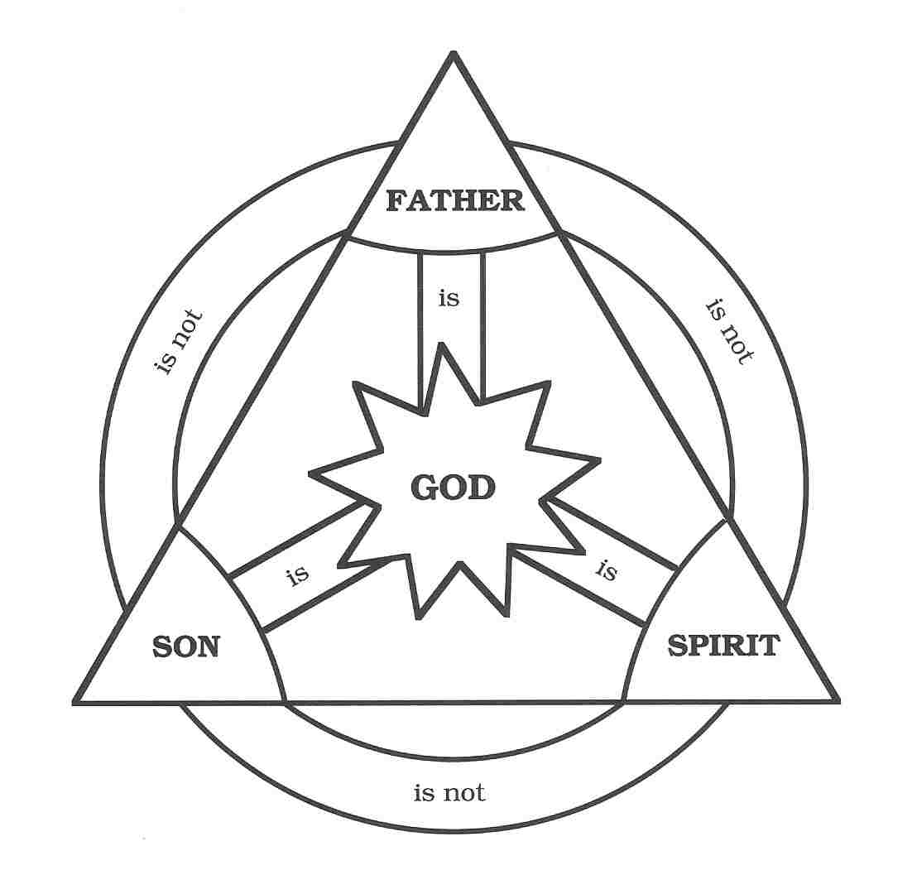

Ordination Service : at Brecon Cathedral on Saturday 26th June at 12 Midday. All are welcome to attend.
Would you please let the Vicar know of people who
need visiting at home or in hospital. Thankyou
Parish of Morriston Weekly Bulletin
St. David’s Church
www.churchinwales.org.uk
www.stdavidsmorriston.co.uk
Registered Charity : 1131686
Vicar : Rev. Hugh Lervy
Tel. : (01792) 771329
Mobile : 07976 725644
e-mail : thevicar@fsmail.net

The Church is open Monday to Friday 10 a.m. to 12 Midday for private prayer / quietness.
All are welcome to come in.

Christian Aid 2010 : Thankyou to all who contributed to Christian Aid this year and to all who helped with the collection ( esp. Harry who co-ordinates our Parish collections for the week ). This year the door to door street collection was £249 and the envelopes collected in church raised £190. The collection on Woodfield Street by our members was £209 – giving a total this year ( so far ) of £648 ( about £100 more than we raised last year ). Thankyou very much.

Late Arrival : A local priest was being honoured at his retirement dinner after 25 years in the parish. A leading local politician and member of the congregation was chosen to make the presentation and to give a little speech at the dinner. However, he was delayed so the priest decided to say his own few words while they waited: "I got my first impression of the parish from the first confession I heard here. I thought I had been assigned to a terrible place. The very first person who entered my confessional told me he had stolen a television set and, when questioned by the police, was able to lie his way out of it. He had also stolen money from his parents, embezzled from his employer and taken illicit drugs. I was appalled. "But as the days went on I learned that my people were not all like that and I had, indeed, come to a fine parish full of good and loving people." Just as the priest finished his talk, the politician arrived full of apologies for being late. He immediately began to make the presentation and said: "I'll never forget the first day our parish priest arrived. In fact, I had the honour of being the first person to go to him for confession."
Moral: Never, never, NEVER-EVER be late.

