2nd May 2010

Today is the fifth Sunday of Easter

Hymns at Eucharist : 114 , 386 , 359 , ( 517 , 277 , 420 ) , 219

TODAY 9.30 am Parish Eucharist with Sunday School

The affirmation prayers for wardens and PCC

members will take during our service.

Refreshments at the end of the service

– all welcome to stay.

6.00 pm Holy Eucharist

MONDAY BANK HOLIDAY

TUESDAY 2.00 pm Mother’s Union: Speaker : Georgina Scannell MBE
6.30 pm Men’s Society ( Welcome Inn )
7.00 pm Council of Churches Meeting ( Aenon )
7.30 pm EMU Trip to Grand Theatre

WEDNESDAY 3.30 pm Wedding

THURSDAY 10.30 am Holy Eucharist
Followed by refreshments in the crypt
6.00 pm Youth Club for school years 4,5,6 ( Crypt )
6.00 pm Clergy Surgery for booking of baptisms, banns and
weddings etc. No appointments necessary.
7.00 pm Holy Eucharist

SATURDAY 10.30 am Wedding
NEXT SUNDAY Readings : Acts 16:9- , Rev. 21:10-22:5, Jn.5:1-9
9.30 am Parish Eucharist with Sunday School
11.15 am Cymun Bendigaid
2.00 pm Baptism
3.00 pm Baptism
4.00 pm Deanery Sunday School Teacher’s meeting (Ystradgynlais )
6.00 pm Evensong

PARISH NOTES

Christian Aid Week : begins next Sunday. If you can help with the door to door collection or the street collection on Friday( 14th) or Saturday (15th) please speak to Harry.

200 Club winners April : 1st no. 10 Sharon Davies , 2nd no. 120 Nessie Isaac , 3rd no. 100 Stephen Waby. Congratulations to this months winners.


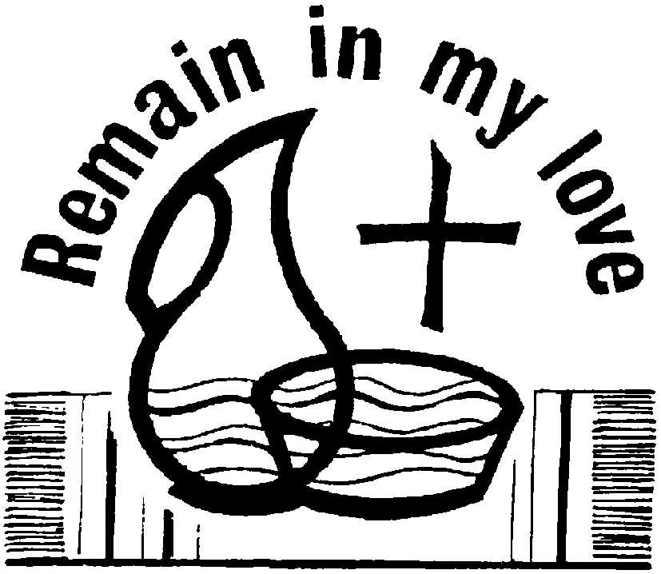
Ordination : The Ordination of our new curate ( Jeff Thomas ) will take place at our Cathedral in Brecon on Saturday 26th June at 12 midday. Please let us know TODAY if you will be joining us and if you would be taking a car or would prefer a bus. If you are taking a car can you please indicate if you would be able to offer lifts if a bus is not needed.
Would you please let the Vicar know of people who
need visiting at home or in hospital. Thankyou
Parish of Morriston Weekly Bulletin
St. David’s Church
www.churchinwales.org.uk
www.stdavidsmorriston.co.uk
Registered Charity : 1131686
Vicar : Rev. Hugh Lervy
Tel. : (01792) 771329
Mobile : 07976 725644
e-mail : thevicar@fsmail.net

The Church is open Monday to Friday 10 a.m. to 12 Midday for private prayer / quietness.
All are welcome to come in.

CHILDREN'S DAY AT THE CATHEDRAL : Saturday 15th May from 11a.m to 3.30 p.m. Children and parents who wish to attend please see Diane Richardson TODAY so that you can be booked in.

Ascension Day : Thursday 13th May : Holy Eucharist will be celebrated at 10.30 a.m. and 7 p.m.

Pentecost Praise in the Park : Sunday 23rd May at 4 p.m. Meet by the war memorial ( or in St. David’s if wet ). Bring a chair and a picnic – organised by the Council of Churches – all are very welcome to join us.

Friends of Brecon Cathedral : subscriptions are now being collected for the coming year. If you old like to join please speak to Meuryl for details.
A prayer for the General Election ( Thursday ) : Loving God, thank you for caring about how our country is run, and that we have the right to vote for our politicians and government. But in the run-up to this general election there are so many policies to understand, and so many different points of view to consider . As I choose who I am going to vote for, help me to remember that my vote can make a difference, and help me vote for those people who will protect the poor and vulnerable, and do all they can to make our nation a place of fairness and peace. Because you call us to act justly, love mercy and walk humbly with you, our God. Amen.

