18th April 2010 Today is the third Sunday of Easter

Hymns at Eucharist : 433 , 120 , 652 , ( 379 , 752 , 658 ) , 756

Psalm : 30 BCP p. 478

TODAY 9.30 am Parish Eucharist FOLLOWED BY OUR
ANNUAL PARISH MEETING - PLEASE TRY
AND JOIN US
6.00 pm Evensong

MONDAY 10.00 am Parent and Toddler group
7.30 pm Evening M.U. : Speaker : Eleanor Smith on the
Welsh Blood Service

TUESDAY 2.00 pm Mother’s Union: Speaker : Mr. Tom John on
Beekeeping

THURSDAY 10.30 am Holy Eucharist
Followed by refreshments in the crypt
6.00 pm Youth Club for school years 4,5,6 ( Crypt )
6.00 pm Clergy Surgery for booking of baptisms, banns and
weddings etc. No appointments necessary.

NEXT SUNDAY Readings : Acts 9:36-43, Rev. 7:9-17, Jn. 10:22-30
9.30 am Parish Eucharist with Sunday School
11.15 am Cymun Bendigaid
6.00 pm Evening Worship

Ordination : The Ordination of our new curate ( Jeff Thomas ) will take place at our Cathedral in Brecon on Saturday 26th June at 12 midday. We hope as many as possible from the Parish will be able to join us for this service. We would like an indication of those who think they may wish to attend so we can see if a bus is required. Please let us know if you will be joining us and if you would be taking a car or would prefer a bus. If you are taking a car can you please indicate if you would be able to offer lifts if a bus is not needed. Because of the timing of the service we will take a picnic lunch to eat before the service starts in Brecon.

Sunday School : restarts NEXT Sunday after our Easter break - we look forward to welcoming back our you members.


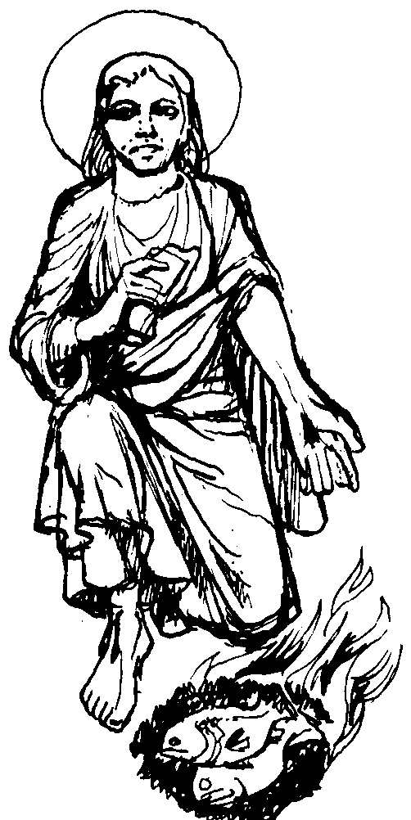
CHILDREN'S DAY AT THE CATHEDRAL : What fun we are going to have!! We have been invited to the Cathedral on Saturday 15th May from 11a.m to 3.30 p.m. The event is called Cathedral Chaos and promises to have a Bouncy Castle, exciting crafts and lots of fun! We are unable to provide a coach this year but maybe we could double up in cars. Help is needed with the Craft activities so if you feel able please volunteer. Children and parents who wish to attend please see Diane Richardson a.s.a.p. so that you can be booked in.
Would you please let the Vicar know of people who
need visiting at home or in hospital. Thankyou
Parish of Morriston Weekly Bulletin
St. David’s Church
www.churchinwales.org.uk
www.stdavidsmorriston.co.uk
Registered Charity : 1131686
Vicar : Rev. Hugh Lervy
Tel. : (01792) 771329
Mobile : 07976 725644
e-mail : thevicar@fsmail.net

The Church is open Monday to Friday 10 a.m. to 12 Midday for private prayer / quietness.
All are welcome to come in.

Deanery Sunday School Teacher’s Meeting : Sunday 9th May at 4 p.m. in Ystradgynlais Church. All are welcome - please speak to Diane Richardson for details.

Council of churches Meeting : Tuesday 4th May at 7 pm. in Aenon Chapel. All welcome.

Annual Meeting : our service today will be a said Eucharist with hymns. At the end of the service we will have a quick cup of tea/ coffee and then proceed with the business of our Annual Parish meeting during which we will look at the report , the church finances and make the necessary elections of Church representatives. We do hope as many as possible will be able to stay today for this important meeting in the life of our Parish. The affirmation prayers will take place for our Churchwardens and PCC members during the morning service on 2nd May.

The show goes on : Meteorological experts predicted a massive flood that would destroy the world. The Pope went on worldwide TV and said, "This is punishment from God. Prepare to meet your maker." The president of America went on TV and announced, "Our scientist have done all they can. The end is near." The mayor of Neath came on and said, "Due to inclement weather, this year's Carnival will be moved to the top of Gnoll Park."

