21st February 2010 Today is the first Sunday of Lent

Hymns at Eucharist : 190 , 372 , 687 , ( 67 , 45 , 212 ) , 114
Psalm 91 vv 1-2 and 9 – end BCP p. 571

TODAY 9.30 am Parish Eucharist with Sunday School

6.00 pm Lent Talk on “Abraham”

MONDAY 10.00 am Parent and Toddler group
7.30 pm Evening M.U. : Speaker Mike and Melanie Davies
on Treat Trust Wales – ALL WELCOME : this is
one of our nominated charities this year.

TUESDAY 2.00 pm Mother’s Union : Speaker : John Stoker on
Abraham

WEDNESDAY 7.00 pm Bible Study Group at 2 Mynydd Garnlwyd Rd.
- every fortnight – please ask for details

THURSDAY 10.30 am Holy Eucharist
Followed by refreshments in the crypt
6.00 pm Youth Club for school years 4,5,6 ( Crypt )
6.00 pm Clergy Surgery for booking of baptisms, banns and
weddings etc. No appointments necessary.

FRIDAY 10.00 am Prayer Fellowship Group ( crypt)
- all welcome

SATURDAY 4.30 pm Wedding

NEXT SUNDAY Readings : Gen. 15:1-18, Phil 3:17-4:1, Lk. 13:31-35
9.30 am Parish Eucharist with Sunday School
11.15 am Cymun Bendigaid
6.00 pm Lent Talk on “Moses”
Electoral Roll : this year we have to COMPLETELY renew our electoral roll. Could completed forms should be returned by NEXT SUNDAY please.

St. David’s Day : Monday 1st March. Our Area Dean Canon Islwyn Davies will celebrate a Welsh Eucharist here at 10 a.m. – all are welcome to join us for this service.

Open Church : beginning in March we are hoping to open the church again on weekday mornings 10-12. If you can help on a rota please speak to John Richardson 517606. Thankyou.

Mothering Sunday Cream Tea : Sunday 14th March at 4 p.m. – all are welcome. Please take an invitation and return the slip if you are able to join us . Family and friends are very welcome.

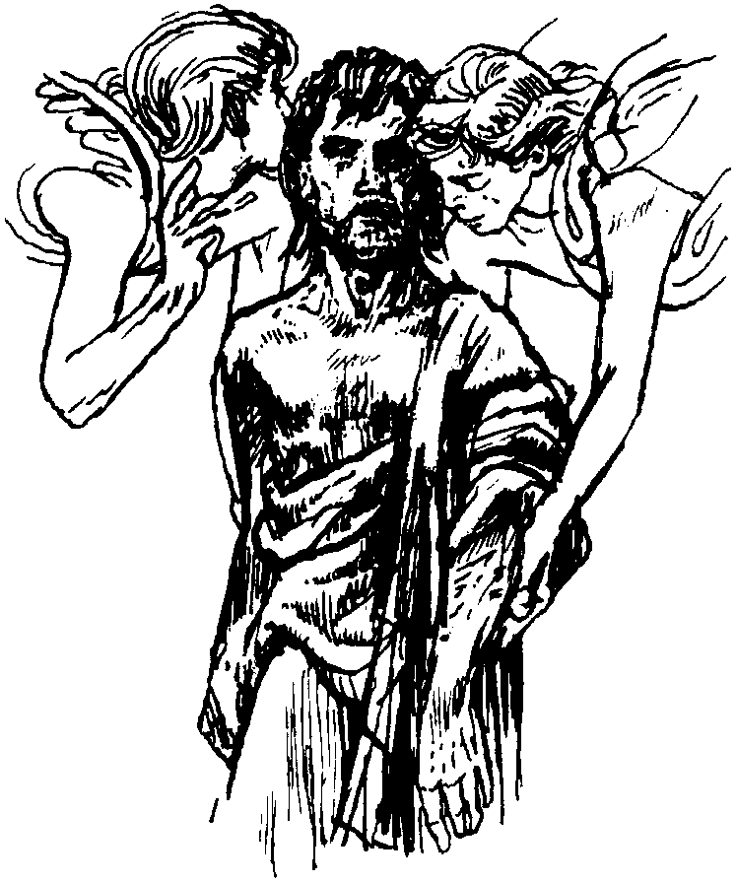

Lent Collection : during lent donations placed in the Disaster Box will be collected to be sent to a Diocesan Lent collection which will be distributed by the Bishop to his chosen charities : Healthcare for all in Bangladesh and DEC Haiti collection.
Would you please let the Vicar know of people who
need visiting at home or in hospital. Thankyou
Parish of Morriston Weekly Bulletin
St. David’s Church
www.churchinwales.org.uk
www.stdavidsmorriston.co.uk
Registered Charity : 1131686
Vicar : Rev. Hugh Lervy
Tel. : (01792) 771329
Mobile : 07976 725644
e-mail : thevicar@fsmail.net

Summer Trip : to Bath on 17th July. The coach will leave the Church at 8.30 a.m. and leave Bath at 5.30 p.m. The cost will be £10. Please give names and £5 deposit to Diane Richardson if you wish to secure a seat.

Charity Coffee morning : on Thursday 18th March from 11 a.m. in aid of the Ethan Perkins Trust ( fighting childhood brain tumours ). Tickets £1 – please could you help to sell them. Thankyou.

New Curate : the Bishop has asked if we will receive a new curate in the parish from June. His name is Jeff Thomas and he is married with 5 children. We look forward to welcoming them into the Parish. We will give you more details closer to June and also details of the ordination service in Brecon to which we will run a bus on Saturday 26th June. This year a new training scheme begins in the Church in Wales for new curates and we must realise from the very beginning that this position is one of training for ministry and strict time will be made in Jeff’s ministry for this purpose.

RD Conference : Sunday 21st March at 4 p.m. here in St. David’s to explore the theme “Child of God”

World Women’s Day of Prayer : Friday 5th March. Service at 2.30 p.m. in Sacred Heart Church – see Anne Lewis for details.

Thankyou : the money collected through the Smartie tubes at Advent has now been given to the nominated charities namely The Diocesan Family Centre in Bonymaen and The Welsh Dragon’s Burns Club – they each received £400. The Burns Club also received just over £1200 from the Christmas Tree Sponsorship. Thankyou to all who gave generous support.

