24th January 2010

Today is the third Sunday of Epiphany

Hymns at Eucharist : 225 , 365 , 540 , ( 437 , 590 , 420 ) , 646

TODAY 9.30 am Parish Eucharist with Sunday School

11.15 am Cymun Bendigaid

6.00 pm Evensong

MONDAY 10.00 am Parent and Toddler group
10.45 am Deanery Clergy Chapter ( Llansamlet )
7.30 pm Evening M.U. : Holy Eucharist

TUESDAY 12.30 pm Mother’s Union Meal at the Golf Club

WEDNESDAY 7.00 pm Bible Study Group at 2 Mynydd Garnlwyd Rd.
- every fortnight – please ask for details

THURSDAY 10.30 am Holy Eucharist
Followed by refreshments in the crypt
6.00 pm Youth Club for school years 4,5,6 ( Crypt )
6.00 pm Clergy Surgery for booking of baptisms, banns and
weddings etc. No appointments necessary.

FRIDAY 10.00 am Prayer Fellowship Group (crypt)
– all welcome

NEXT SUNDAY Ez. 43:27 – 44:4, 1 Cor. 13:1-13, Lk. 2:22-40
9.30 am Parish Eucharist with Sunday School
6.00 pm Evensong

Bible Study Notes 2010 : Please could payments be made as soon as you can. Thankyou.

PCC Meeting : Sunday 7th February at 4.30 p.m.

Confirmation 2010 : the Bishop has kindly agreed to join us later in the year for a service of confirmation ( date to be arranged ). If anyone else would like to be confirmed please let me know as soon as you can ( minimum age is 11 ).

Charity Coffee Mornings : at the meeting of the PCC we will be deciding which charities to support this year. If you have suggestions please write them down and let me have it with contact details and short description of the charity. Thankyou.

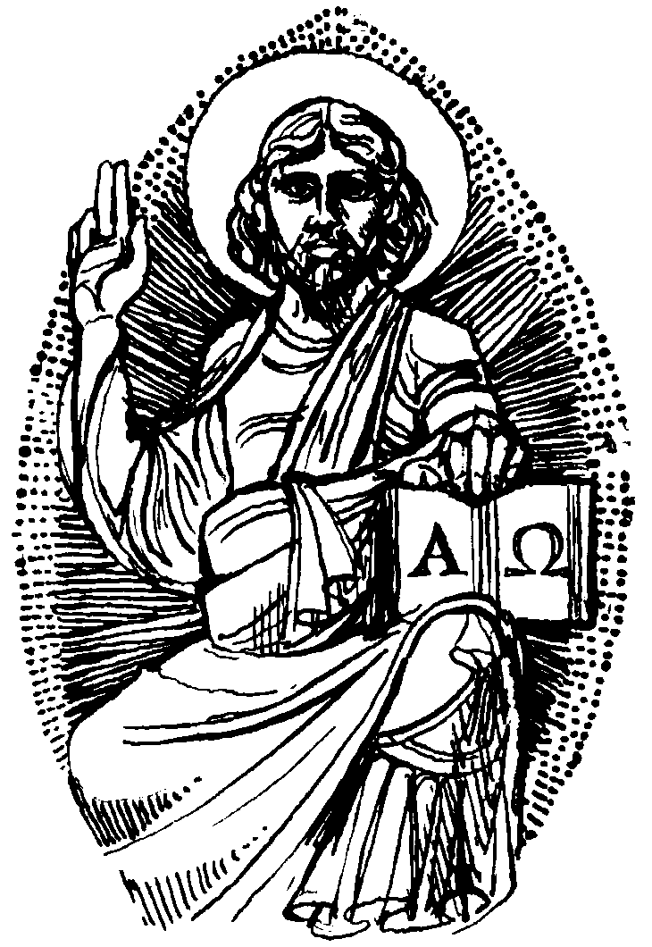

Annual Report : I would be grateful to receive articles from those who run our various church groups as soon as you are able.
Would you please let the Vicar know of people who
need visiting at home or in hospital. Thankyou
Parish of Morriston Weekly Bulletin
St. David’s Church
www.churchinwales.org.uk
www.stdavidsmorriston.co.uk
Registered Charity : 1131686
Vicar : Rev. Hugh Lervy
Tel. : (01792) 771329
Mobile : 07976 725644
e-mail : thevicar@fsmail.net

Would you please let the Vicar know of people who
need visiting at home or in hospital. Thankyou
Vicar : Rev. Hugh Lervy
Tel. : (01792) 771329
Mobile : 07976 725644
e-mail : thevicar@fsmail.net

Parish Meal : our Parish Meal will be on Friday 5th February at 7 p.m. in the Old Barn. If there are any alterations to the list or anyone else would like to join us please speak to Anne Lewis by NEXT SUNDAY. All are welcome.

Men’s Society : Tuesday 2nd February at 6.30 p.m. in the Welcome - all men are welcome - please speak to John Richardson.

Haiti : we have sent a donation to this appeal from our disaster box fund as well as from donations given last Sunday. Thankyou to all who give so regularly through the disaster box enabling us to respond so quickly.

Electoral Roll : this year is the year we have to COMPLETELY renew our electoral roll. All communicants ( over 18) are eligible. Please see reverse of form for full details. The Bishop has also asked for an audit of skills that you may wish the Diocese to be aware of. Please complete and return this form if you wish and we will send them to the Bishop. If you are not eligible to join the electoral roll I would be grateful if you would complete a Parish membership form so I can check I have your up to date details.

Shrove Tuesday Social evening : Tuesday 16th February at 7 p.m. Tickets are now available and all are welcome. Ash Wednesday : 17th February Holy Eucharist will be celebrated at 10.30 a.m. and 7 p.m. Lent Course : this year our theme is “Old Testament Men”. The talks will take place in Lent on Sunday at 6 p.m. – details on the handout available near the door. Do try and join us.

Eucharistic Assistants Licences : could those who hold licences please return them, to me so the P.C.C. can confirm the list before they are returned to the Bishop for signing.

