20th December 2009

Today is the fourth Sunday of Advent

Hymns at Eucharist : 630 , 655 , 740 , ( 486 , 152 , 493 ) , 631

Psalm 80:1-8 BCP p. 556

TODAY 9.30 am Parish Eucharist with Sunday School

4.00 pm CHRISTINGLE AND NATIVITY SERVICE

- DO TRY AND JOIN US

THURSDAY CHRISTMAS EVE
No. 10.30 service this morning

6.30 pm FAMILY EUCHARIST

11.30 pm MIDNIGHT MASS

FRIDAY CHRISTMAS DAY
10.00 am HOLY EUCHARIST

NEXT SUNDAY St. John, Apostle and Evangelist
Readings : Ex. 33:7-11, 1 Jn. 1 , Jn. 21:19-25
9.30 am Parish Eucharist

PARISH NOTES

Advent Smarties tube Collection : Smarties tubes can be returned at any of our Christmas Services. The money collected at Christmas through the tubes will be donated to local children’s charities.


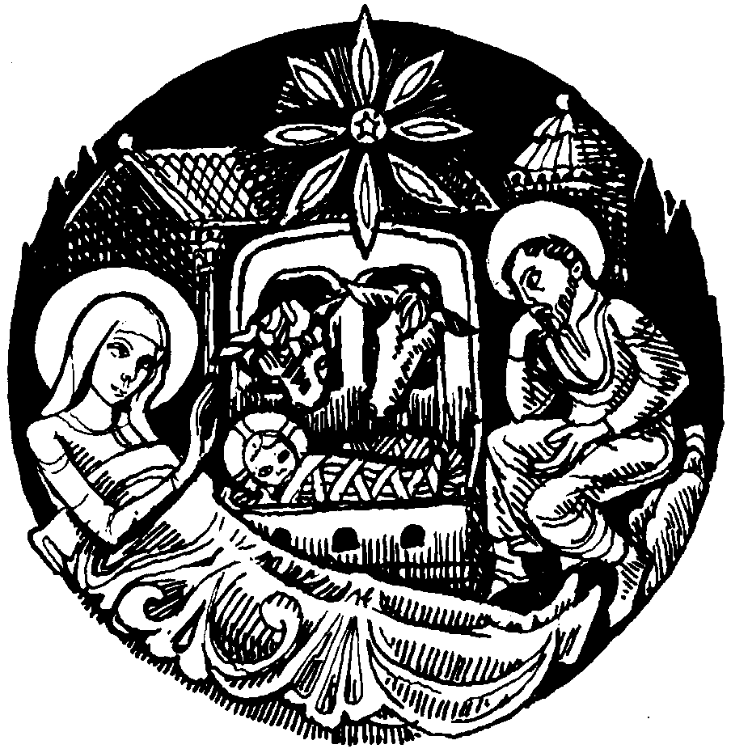
Parish New Year Meal and entertainment : Friday 8th January 2010 in THE OLD BARN (behind the Hospital) 7 for 7.30 p.m. All are welcome ( do invite family and friends to join us ) : the cost is £12 per head. Starters : soup or melon. Main course : Turkey / Beef or Vegetarian. Desert : Christmas Pudding or Fudge Cake. Please sign the list TODAY with the choice of your food. Could payment for this meal please be made as soon as you can.
Parish of Morriston Weekly Bulletin
St. David’s Church
www.churchinwales.org.uk
www.stdavidsmorriston.co.uk
Registered Charity : 1131686
Would you please let the Vicar know of people who
need visiting at home or in hospital. Thankyou
Vicar : Rev. Hugh Lervy
Tel. : (01792) 771329
Mobile : 07976 725644
e-mail : thevicar@fsmail.net

Verdi’s Requiem : is to be performed in the Brangwyn Hall by the Swansea Philharmonic Choir on Sunday 17th January. Tickets for this concert are FREE and can be obtained fro Eira on 528322.

Thankyou : to the nearly 200 people who joined us for the wonderful service of Christmas Praise last Sunday night. Particular thanks to our friends in Morriston Salvation Army who always bring something special to this service.

Thankyou : to all who worked so hard for our Children’s Craft morning yesterday and also to all who helped to put together the Christingles for our service this afternoon.

Christmas Worship : please do your very best to join us for one of our Christmas services this week as we welcome the Christ-child into the world and our lives.

Best wishes : to all who will be away for the Christmas Season. We look forward to seeing you on your return and wish you well for your celebrations.

The vIcar and Officers of St. David’s join in wishing you and your families a very Happy Christmas

